Community Council Meeting

Date: 9th June 2026 Location: Cove Burgh Hall, Small Hall

- Fire Alarms and Housekeeping
- Present
John Auld (Convenor), Kenny Barlas, Sheena Lamont, James McLean, Linda MacKenzie, Ellen McVey, Sheelagh O’Reilly (Secretary), Anne Strachan (Treasurer)
Cllr Maurice Corry, Cllr Shonny Patterson
3 members of the public including press
- Apologies
Nick Davies, Derek Fowlis, Kathy Gostick, Christine Murdoch (Vice Convenor) and Cllr Mark Irvine
- Declaration of interest (financial and non-financial interests)
John Auld (Convenor): As the convenor I have had discussions with the Governance Officer at Argyll and Bute Council regarding my ownership of land that is identified for possible development in LDP2. LDP2 forms part of Argyll and Bute Council’s statutory plans for the area and has now been adopted by them. As the landowner for one parcel of land I would follow the current guidance on Declarations of Interest and would not chair the section of any CC meeting dealing with issues specific to that parcel of land.

General DoI form see below. No additional DoI raised in the meeting.

- GDPR Matters
- The Convenor raised the issue of a possible breach of GDPR by a member of the CC. The Convenor did not name the individual nor the person to whom a BCC email meant that all the addresses used by the CC members as part of the agreed ‘group’ email were made public and forwarded onto others.
- Following a discussion it was agreed unanimously that the Community Council would ‘self-report’ to the Information Commissioners Office concerning this breach. The Secretary will write to the ICO on this matter. Lessons have been learnt about the use of BCC function on email and care is requested by all members to ensure this does not happen again.
- The Community Council member responsible for this matter apologized to other councillors.
- The result of this email being BCC was a number of emails which contained offensive swear words. More care and attention in communications could reduce these risks.

- Police Report
Report sent and attached below. At the last moment the police were not able to attend due to an urgent incident. No questions were raised on the report.
- Minutes of the CC meetings as follows:
- Adoption and signature of minutes from 12th May 2026. Minutes were agreed for signature (KB / SL) but AS wish to have noted that she objected to the minutes.
- There were no actions / items not on the agenda.

- Convenor
- Cove Burgh Hall Beer Festival: It was agreed to make the customary £100 donation to this major local event.
- Community Council Elections 2026: The elections schedule was noted – see below. The Election Day is 20th August and following that date the new Community Council will be convened by Argyll & Bute Council for the inaugural meeting. Officers and members are in place to conduct normal business until the 20th August. The Community Council would like to encourage young people onto the Community Council (from age of 16). In the future the CC will also approach the Youth Café for young people to attend meetings to enable their viewpoints to be heard.
- Update on War Memorial:
  - The CC was updated on the work done by local people, including the Scouts, on the War Memorial. Donation from the Community Council has been spent on flowers etc. The judging of the competition will be at the end of month, and the team are looking at daily visits to minimize risks around litter, damage, bird droppings and deer attacking the new plants. Planters are also being prepared and will be installed shortly. The memorial bench family is coming from Ayr to renovate the bench as don’t want it removed from the site. To date around 175 hours of volunteer time has been put in – a great effort.
  - The Community Council agreed that post-election the longer-term management of the War Memorial should be discussed by the CC. This could involve all stakeholders including A&B Council (Kevin McIntosh), British Legion, Scouts, C&K Trust etc to ensure careful management, including any addition of newnames. The Community Council recognized that this is a sensitive issue that will require careful handling on a personal level and with Listed Building Consent etc. The Community Council also highlighted the historical work undertaken by Tony Belk on the local names which is held in a large file and lodged in the Cove Community Library.
- Update on Memorial for Alistair McIntyre. The MOD have now given permission for a new bench area to be established on the back path in the PNR as a memorial site. This site draws together key issues of important to Alistair including nature, military history, archaeology and heritage. It is hoped that work will take place later this summer / early Autumn. .
- Youth Café event: 21st June in Craigrownie Park. Being organized by the young people themselves. All are welcome to attend. New committee working on issues of the building / lease etc.
- MOD Expansion and Community Benefit: This is an important issue but was postponed until after the 20th August 2026 elections. Issue is how to engage with MOD contracting around community / social benefit. Cllr Corry indicated that recently it has been agreed that the Council Leader attend meetings of A&B Council officers with the MOD.
- Treasurer
- Update from Treasurer: The statement of accounts submitted to the AGM is given below. Currently the CC accounts have £2011.13p in account. CHEP £369.92.
- The Community Council agreed unanimously to submit the formal request for A&B Council Administrative Grant
- Update on Our Community Project under RPWCDT
- The RPWCDT was not present and no written update presented.
- The Community Council noted that the original water fountain which is being renovated (Richard Reeve made a presentation on this at an earlier meeting) has been taken to a specialist foundry for renovation work.
- Community and Household Emergency Planning update
The issue of drainage on the B833 Shore Road has been again raised with A&B Council including areas to the south of CBH, by Claremont and near Knockderry hotel. Looking for the relevant machinery to remove the debris in the pipes (including ‘sheddings’ from road, grit, building material, leaves etc) and perhaps identification of the ‘outfall’ that enables water to flow through the system effectively.
- Planning Applications & Enforcement (details of applications on A&B website)
- Giants Burn – Energy Consents Unit under consideration https://www.energyconsents.scot/ApplicationDetails.aspx?cr=ECU00005007
- Rosneath Forest Consultation: Secretary to communicate the following key points to Tilhill:
  - Ensuring the Core Path remains open during operations
  - Horse friendly gates
  - Issue of Blanket Bog site (AS to send more details).
- Ardpeaton 24/01321/PPP: Currently these is no timeline on this decision.

Enforcement matters
The following is based on material received on the 9th June from the planning department.
- Fort Road:– this is ongoing and we are working with the lawyers with regard to this. A top priority.
- Kyle View: Work has apparently started (CC members) but planning is not aware of this. The developer has been asked for an update.
- Walls around South Ailey / Craigrownie Castle and along Shore Road:
  - South Ailey: No further work is being undertaken with regard to this. JM indicated that there is an enforcement notice which sits with the land which is now owned by the house owners in that area.
  - Craigrownie Castle: CC member reported that there is work being undertaken, including the recruitment of gardeners to deal with the issue.
  - JM was requested to send full details of the enforcement notices /location / landowner and other relevant details to the Secretary so that individual follow up can be undertaken if required. .
- Strathlee: There has been correspondence between Cllr Corry / Peter Bain and Head of Planning on this issue. No meeting has taken place with senior staff. JM (who is advising the householder who has raised the issues) is not content with the response. For the Community Council the important issue is the siting of the Septic Tanks and whether the new tank conforms to the requirements given the burn that flows down the side of the property and the risks of leakage. This is of wider concern as the burn issues onto Cove Bay which is widely used. It appears, but not confirmed, that a building warrant has been issued for the septic tank. The issue to be followed up by JM and the householder with SEPA.
- Achnashellach: There are no outstanding planning applications. One person claimed that waste is being burnt on the glamping pods site but no actions were discussed.
- Cove and Kilcreggan Conservation Area: Breached and damaged wall opposite Ferndene. The issue of ownership of the wall to be established between A&B Council and C&K Trust.
- Roads / Paths / Lighting / Drainage etc
- Craigrownie parking: Focus was on disabled parking. The Secretary to follow up on this issue with Cllr Patterson. Additional issues were raised regarding Fairfield and Kilcreggan Car Park. Parking bays need to have sufficient space to enable safe access through doors and rear opening.
- ‘Works’ List update:
  - Kilcreggan Bus Shelter repair: Work is ongoing and will include the guttering and the two back downpipes which need replacing. A meeting on the 10/06/26 on this and related issues in Kilcreggan (crash barriers, white lines, tree removal etc) to be held with Cllr Corry & A&B Council. – ongoing. Guttering and back downpipes need replacing. The issue of Japanese Knotweed in the wall near the Pier was also mentioned. This has been regularly sprayed in the past by the Harbour Master. It was noted that A&B Council parks department has been spraying the verges along Shore Road. JM raised the issue of notification to the Community Council prior to this type of work.
  - Bus Shelter at the bottom of Temperance Brae. This had been raised in the past, but no action taken. The Secretary to write to SPT to see what the issues are (space? Land ownership?)
- Street Furniture (Benches, Notice Boards, Phone boxes etc).
  - Bench opposite Cove Shop: Temporarily in place to test the exact location and access and suitability with local residents. When permanent position agreed a photo will be sent to A&B Supporting Communities Fund for information. .
  - SL reported on the painting and repair of Kilcreggan benches. One bench in Cove has been removed as dangerous.
- 20 mph in Cove & Kilcreggan Area. No update – consultation with bus service ongoing.
- Ferry and Pier (ND)
- No change.
- Communications
- No change – website update deferred until after the election.
- Community Council Planning Policy
- Report from Directors of C&K Trust regarding management of land to the shore side of Shore Road. It was noted that there may be a meeting of the C&K Trust in June, but date not set yet.
- LDP 3 engagement: for post August 2026 Community Council.
- Housing Strategy development and Housing Needs Survey: Survey completed awaiting analysis.
- A&B Council Repopulation work: Request from JM that the work of A&B Council on repopulation be added to future agendas. This is a research project at this stage collecting data and evidence and the report will be published in due course. Issue for post August 2026 election Community Council. JM interested in the number of ‘development’ sites around Rosneath Peninsula and no obvious strategic plan.
- Licensing
No issues raised.
- Any Other Competent Business (To be notified to the Chair 48 hrs prior to the meeting )

Cllr Corry raised the following points:
- Discussions are ongoing with the 316 bus operators regarding the 20 mph limits and the timings to meet the trains etc. Options are under consideration.
- Cllr Corry had that evening learnt that the company Carers Direct had ceased trading. This has implications for workers, people being cared for and for families. A&B Council working on ensuring suitable cover is in place.
- Swimming for primary school children is to be brought in as a statutory requirement in Scotland. Important for Coastal Communities but it was pointed out we need a working swimming pool to ensure that it can be delivered.
- Date of Next Meeting 14th July 2026. Meeting commences 1915.
Note that following the discussion at the AGM this meeting is under review. The dates through to end of 2027 (which may be changed post August 2026 election are given below for information).
POST MEETING NOTE: THIS MEETING WILL BE HELD AT COVE SAILING CLUB.

Accounts 25/26 as presented to the AGM

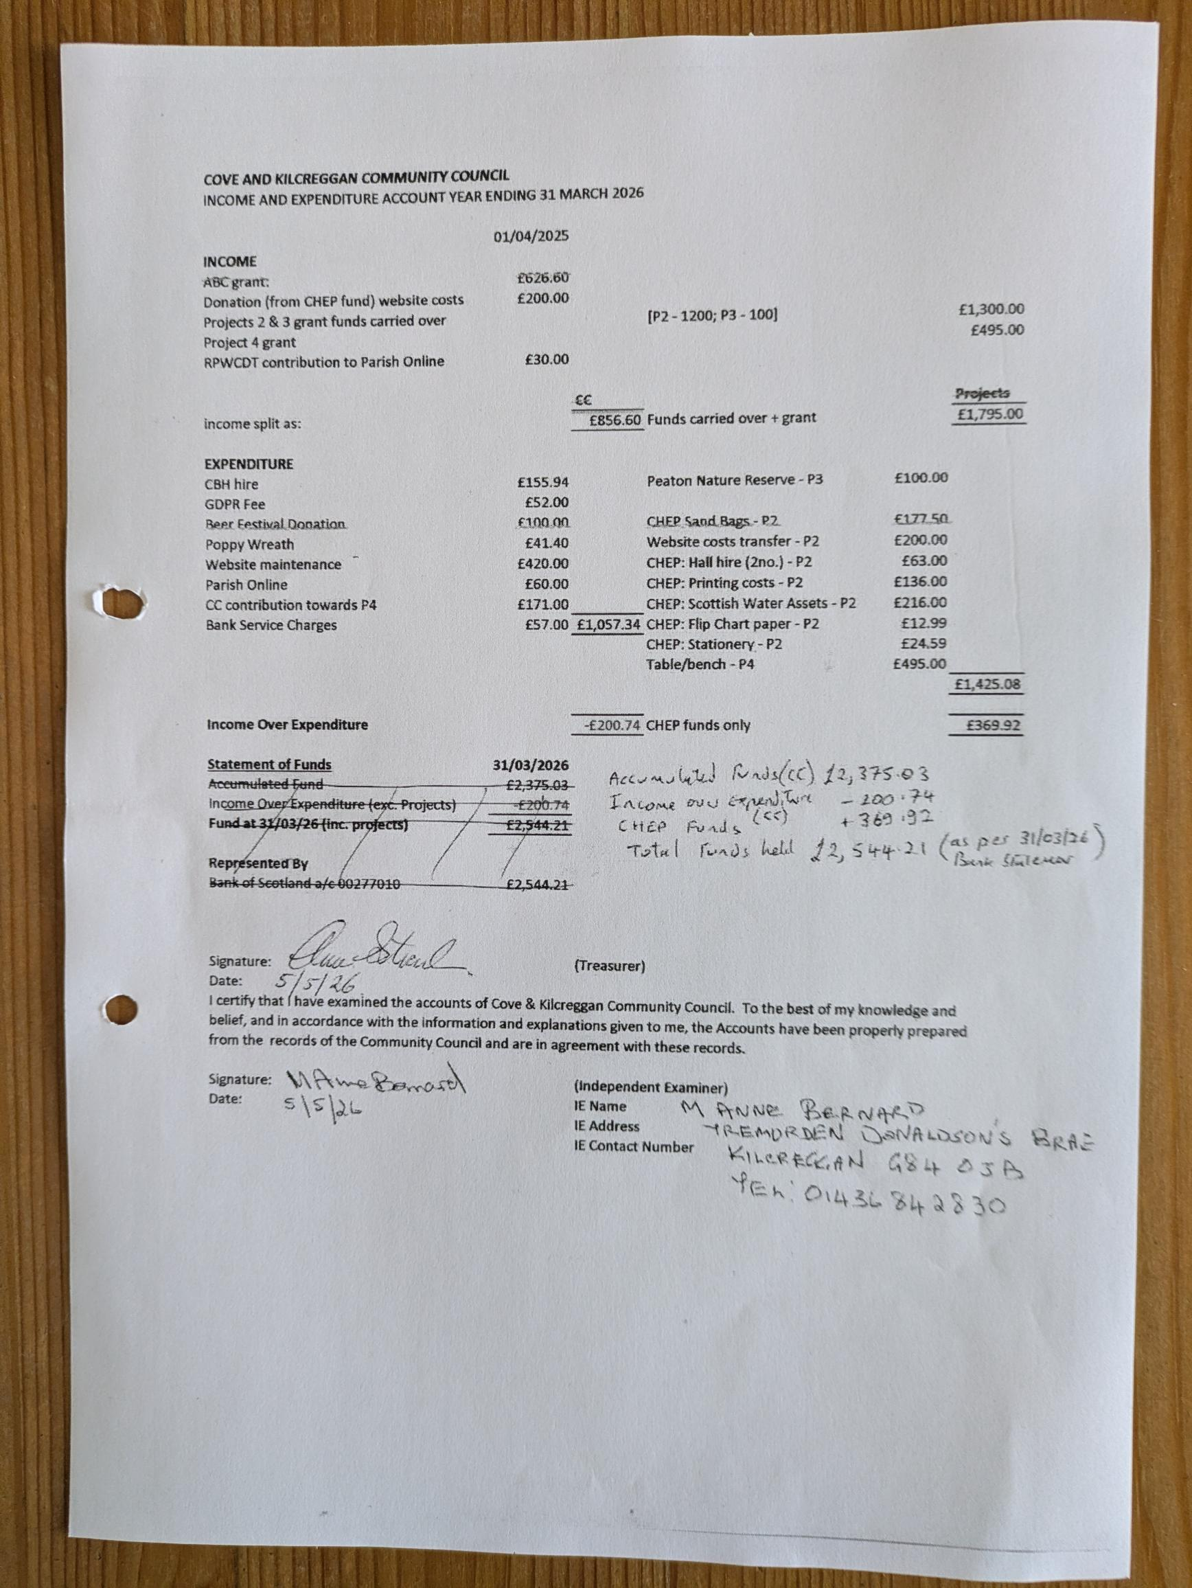

Agreed Dates for CC meetings through to end of 2027
NOTE 1: THAT ALL MEETINGS START AT 1915 EXCEPT JUNE which takes place after the AGM
Note 2: The newly constituted Community Council post the August 2026 election could vary the dates / timing of meetings.
LOCATION: SMALL HALL COVE BURGH HALL
Every second month on second Tuesday of the month (odd months) PLUS AGM in June. (7 Meetings a year)
Date | Comments
2026
9 Jun | AGM & CC Meeting
14 Jul | CC Meeting (School Holiday)  To be held in Cove Sailing Club
8 Sept | CC Meeting
10 Nov | CC Meeting
2027
12th January | CC Meeting
9th March | CC Meeting
11th May | CC Meeting
8th June | AGM & CC Meeting
13 July | CC Meeting (School Holiday)
12 September | CC Meeting
9th November | CC Meeting

ARGYLL AND BUTE
COMMUNITY COUNCIL ELECTIONS 2026

TIMETABLE

Register in Force 1 June 2026
Publish Notice of Election 4 June 2026
Nominations Open 5 June 2026
Close of Nominations and last date for withdrawal 25 June 2026 (4pm)
Publish Notice of Poll or Uncontested Elections 2 July 2026
Issue postal votes 16 July 2026
Election day/last day for receipt of postal votes 20 August 2026 (4pm)
Count 21 August 2026


Argyll & West Dunbartonshire Division
Cove & Kilcreggan Community Council
Dates Covered in this Report 11/05/2026-08/06/2026
Report completed by PC Cameron MacPherson
Cowal, Bute & Helensburgh Priorities 2023-2026

The priorities for your area are decided by data from our strategic assessment which details threats and risks, and also from feedback from local authorities, partners, and residents in the Local Policing Survey. The current priorities are:
- Serious and organised crime
- Crimes of theft and dishonesty (acquisitive crime)
- Road safety and road crime
- ASB & Violent crime
- Public protection.
Serious and Organised Crime
We continue to look for ways to disrupted and target those criminals’ intent on causing misery to those most vulnerable within our communities. We remain resolute in targeting the illegal drug trade ensuring that we seek support from partners across the country in doing so.
We have been upskilling officers across our policing division, ensuring they understand and appreciate the importance of community intelligence and information. Through intelligence led policing, officers are able to apply to the courts for Sheriff search warrants and take positive action in the detection and disruption of those involved in the sale and supply of controlled drugs. Across the division we have had successful outcome seizing drugs and money suspected to be from the proceeds of crime.
Community information is key for us and may just provide us with the last piece of evidence required to apply to the courts for a warrant. We encourage our communities to share concerns and suspicions around drug dealing either by calling 101 or by reporting anonymously via Crimestoppers on 0800 555 111 or via their website and online form (https://crimestoppers-uk.org/give-information/forms/pre-form).
Acquisitive Crime
Acquisitive crime remains a local priority. Figures across the country are on an upward trajectory, which in part is a result of the cost-of-living crisis. We are working with our Preventions team looking at maximising our crime prevention opportunities and looking at innovative ways to increase local awareness.
We are working with our communities to identify areas of vulnerability where we can engage with our partners to maximise our response.
In Helensburgh Our community policing officers are engaging with local businesses in the retail sector to reduce shoplifting. Officers are taking ownership by identifying those responsible, collating information and seeking bail conditions restricting access by the perpetrators.
In the area of Kilcreggan and Cove police will continue to provide high visibility patrols to deter potential thieves. If there are any areas of note that you think Police Scotland should patrol, please don’t hesitate to let us know. We are keen to keep the communities safe and protect property.
Road Safety
Overall, there continues to be a reduction in the number of casualties involved in road traffic collisions within A&B compared to last year.
Speeding and driving complaints remain prevalent across A&B. We continue to support community concerns in this area through direct action, prevention and intervention work. Proactive speed checks have been carried out across hot spot areas. We continue to work with partners including A&B council looking for innovative ways to positively influence road users.
Our preventions team continue to work with partners across our communities at road safety planned events. These events have been well received and allow a multi-agency approach to improving safety on our roads. where we can positively influence driver behaviour and understand community concerns.
As we approach our peak time across our road’s networks our national Roads Policing Team will be providing a high visibility presence across Argyll, they will also be delivering initiatives such as ‘Operation Close Pass’ which is aimed at tackling dangerous overtaking of cyclists and raising cyclist awareness amongst other road users.
Our national motorcycle unit will be out supporting local policing across Argyll in the coming period as the weather will start to get better. They will specifically focus on encouraging safe and responsible road use by motorcyclists. There focus will be engagement, education and enforcement.
ASB/Violence
In the heart of our communities, we pro-actively visit problematic tenancies along with housing partners to positively impact on ASB at the earliest possible opportunity. This information is then briefed out to local policing to ensure they are aware of ongoing demand and intelligence.
The Preventions Team at Dumbarton are in daily contact with the ASB and Housing Teams across A&B. Requests can range from a single email to a full disclosure which is required when legal action is being taken against a resident.
Public Protection
We continue to support individuals through a victim centred approach our officers receive regular training and guidance to ensure that we are supporting those affected with a professionalism and empathy.
Domestic and gender-based violence remains a priority and we robustly manage these investigations, safeguarding victims and targeting those responsible.
We have engaged with GP surgeries in the area providing advice and guidance on the Herbert Protocol which is a pre-prepared information pack for those living with dementia who are at a higher risk of going missing. We have asked the pack to be provided or discussed with families at diagnosis. The information can be provided immediately to police should the person go missing.
Community Engagement
Youth Engagement Officer PC Kirsty Lyall has been very active with inputs and engaging with schools in the local area with various issues. High Schoolers had inputs on drug and vape awareness and primary schools including Kilgreggan Primary have had the following inputs: Primary 1-3 Road Safety and P4-7 on Internet Safety. Our new Community Pollice Officer PC Jack Deans also attended Kilcreggan Primary for a Careers Fair.
Cove and Kilcreggan Crimes of note

Between 11th of May and 8th of June 2026 and Wednesday the 25th of February 2026 a total of 5 incidents were reported to Police Scotland.

Useful Links/Contacts

- Argyll and Bute Communtiy Directory - https://abcd.scot/ including warm spaces information
- Crimestoppers – Crimestoppers in Scotland | Crimestoppers (crimestoppers-uk.org) 0800 555 111
- Scottish Partnership Against Rural Crime – www.scottishparc.co.uk
- Women’s Aid - Home - Women's Aid (womensaid.org.uk)
- Citizens Advice – 0808 164 6000
- Argyll and Bute Council Trading Standards – 01546 605 519
- Argyll and Bute Council – https://www.argyll-bute.gov.uk/my-council/how-contact-us
- Transport Scotland – road related incidents and road closures - https://www.traffic.gov.scot/traffic-information/incidents
- Scottish Water - https://www.scottishwater.co.uk/Help-and-Resources/Contact-Us 0800 0778 778
- NHS24 (including mental health support) – 111 or https://www.nhsinform.scot/

Follow us on Social Media and help share loacl appeals and education messages
- Facebook - Police Scotland Argyll and West Dunbartonshire
- X (formerly Twitter) – PSOSArgyllBute and PSOS ArgWestDunb

Sign up to Neighbourhood Watch to receive local alerts and bulletins for your community area - https://neighbourhoodwatchscotland.co.uk/#0

Have your say on your local policing priorities - Your Police 2024-2025 - Police Scotland - Citizen Space

C&K Community Council: Declaration of Interest in relation to trusteeship, directorship, membership of bodies that may have a bearing on CC agenda items. Plus personal objections to live planning applications that are on CC agenda.
As after meeting of 9 June 2026
 | Community Councillor Name | RPW-CDT Director | OC Working Group (Name) | Cove and Kilcreggan Trust Director | CBH Director | Professional or business group | OTHER – name organisation | Planning Applications as per A&B C website
1 | John Auld |  | Business |  |  | NFU | KVA
2 | Kenny Barlas |  |  |  |  | Taxi
3 | Nick Davies
4 | Derek Fowlis |  | Business |  |  |  | Creggans
5 | Kathy Gostick |  | Green
6 | Sheena Lamont |  |  | X
7 | Lynda McKenzie |  |  |  |  |  |  | Strathlee
8 | James McLean |  | X | X |  |  |  | Auchengower / Achnashellach / Strathlee
9 | Ali Mills | X | Arts / Green
10 | Christine Murdoch |  |  |  |  | Minister Craigrownie Church
11 | Ellen McVey
12 | Sheelagh O’Reilly |  | Housing |  |  |  | C&K RNLI  KVA
13 | Anne Strachan |  | Green |  |  |  |  | Auchengower / Strathlee
14 | Vacant
15 | Vacant
16 | Vacant

