Annual General Meeting 9th June 2026
1915 Small Hall, Cove Burgh Hall
Minutes
Fire Regulation Notice
- Attendance
John Auld (Convenor), Kenny Barlas, Sheena Lamont, James McLean, Lynda McKenzie, Ellen McVey, Sheelagh O’Reilly (Secretary), Anne Strachan (Treasurer)

Cllr M. Corry, Cllr S. Patterson
Apologies:
Nick Davies, Derek Fowlis, Kathy Gostick, Christine Murdoch
Cllr Irvine
4 Members of public including one member of the press
- Declarations of Interest: None
- Adoption of the Cove and Kilcreggan Community Council AGM Minutes from 10th June 2025. The minutes of the meeting held on the 10th June 2025 were adopted - Proposed EM / SL
- Convenors Annual Report and questions from the floor. Report previously circulated – see attached. No questions were raised.
- Secretary’s Annual Report and questions from the floor. Report previous circulated – see attached. No questions were raised.
- Treasurer’s submission of Balance Sheet and Annual Accounts duly independently examined and certified correct, and questions from the floor. The accounts were accepted. Report attached. The Community Council specifically wished to thank our independent examiner Anne Bernard and the treasurer for the work on the accounts.
- Election of Office Bearers
As there are CC elections on the 20th August and there were two meetings after the AGM (9th June and 14th July) it was proposed and agreed unanimously that the current office bearers continue until the election. The officers are therefore as follows until the 20th August:
a) Vice Convenor: Christine Murdoch
b) Hon Treasurer: Anne Strachan
c) Convenor: John Auld
d) Hon Secretary: Sheelagh O’Reilly
8. Dates of Community Council meetings 2026/27
These had been previous circulated (see below) and agreed at the community council held on the 12TH May 2026. This follows the changed patterns agreed in 2025 i.e. that meetings would be held on the ‘odd’ months so that more meetings would be held outside school holidays. NOTE that the dates may change following the August 2026 elections.
The dates were agreed but it was noted that there has been a request from the CBH booking secretary regarding the 14th July. The Cove Sailing Club wish to use the main hall for a Ceilidh as part of the Loch Long week.
It was unanimously agreed that the Secretary will confer with the CBH Booking Secretary whether the Sailing Club can provide suitable meeting space (for up to 20 people). If that is not possible then the Community Council meeting will be cancelled.
- Community Council Election Dates (see below for details)
Nominations are open with the election date being 20th August.
- Any other competent business
None raised.

Convenors report AGM June 2026
In looking at the minutes on the website to see what we have discussed in the last year, I am struck by the variety of matters that we cover and convey back and forward to the community to which I thank everyone for their work, input, patience and for understanding others views. Thank you to Sheelagh for her efforts in updating the communications as well as Anne for looking after the finances.
We are now in a changing world and with that change will come to the community along with many other communities in the west of Scotland who are facing similar challenges as we do.
One thing that should be acknowledged is that we are now in an Argyll & Bute resettlement zone and this needs to be welcomed in combatting our concerns for the falling school roll. Therefore, we need positive actions to retain and bring the younger generation into the area as they are such a valuable resource for the future as having a community made up purely of retirement/holiday homes builds up long-term problems, for example council funding and services.
Some of the changes that will certainly happen will be the MOD investment to the bases such as Programme Euston. This will undoubtedly affect the community in some ways. In addition, we need to be mindful of the concerns around the ferry cancellations and the new infrastructure that will be needed in future for new ferries, to which I must thank Christine and Nick for their work in keeping us updated.
Those of us on the CC work with our local councillors to get the best service from the council in bringing local services to the area and for this, thanks must go to Derek (Titch), Nick and Sheena for their work in Kilcreggan village and also for the Christmas tree. Also, thank you to everyone else for their endeavours around the community. At times the progress can be slow and difficult, especially with the councils budget constraints.
Looking at the minutes we cover many things; we benefit seeing how OC feeds into preparing its projects and the efforts of Sheelagh and other CC members building on the emergency planning and resilience work, which I fear may be more depended upon in future. We all cover a lot and learn what our community needs as we go along gaining. Members are involved in attending events such as the area community planning meetings by A&B Council or representing the CC at the Remembrance service to supporting the local volunteers and British Legion in the War Memorial competition. So as we head into a new session of the CC with the community council election day on 20th August we can hope some diverse and new fresh faces join us. This will help to ensure that things are better for everyone by all being more involved and taking time to fully understand the various issues facing us all.
We need to remain mindful of our responsibilities as we are here to represent the whole community, not just select parts or groups, and understand in times of change how the different concerns of our community must evolve and keep supporting all within the community to make our villages viable in these challenging and changing times in order to make our villages sustainable for the future.
John Auld June 2026

Secretaries report for the 12 months to 9th June 2026
Prepared: 1 June 2026
The last 12 months have been busy and included work preparing for, and responding to actions for 1 AGM and 6 normal Community Council meetings. Agendas are published on the website with the link put on Facebook. A hard copy is placed in a prominent position in the Cove Library. Follow up letters / actions circulated to members and discussed, where appropriate, at the following meeting.
The current ‘works list’ has been shared with A&B Council and some works have been taken forward. Several meetings have been held with A&B Council on this, and on the blocked drains on the B833 and some progress is being made. Kilcreggan village saw work undertaken by Scottish Water on the sewage system which will also require ‘white lining’ along with zebra crossing, car park and road mid-lines. The lack of notification of the road closure was followed up with Scottish Water.
Engagement with the A&B Council Helensburgh & Lomond planning department takes place regularly. Following meetings the Secretary sends through questions and objections and prior to subsequent meetings ‘checks-in’ to ensure the Community Council has the most up to date information on planning applications and enforcement issues.
The Secretary, along with the ‘bench group’ were able to obtain an agreement for the new bench in Cove based on the location outside the Bus Shelter which is an Argyll & Bute Community Asset. The Secretary provided relevant support to the OC Green Group in their application for a Polytunnel at the Craigrownie Community Garden as applications from a Community Council are charged at a discounted rate.
The Secretary has attended a number of the Helensburgh & Lomond Community Planning Partnership meetings held in Helensburgh. An opportunity to meet other people from other community councils and key service delivery / third sector agencies. These meetings have also enabled follow up on issues such as the Ferry / Pier with Transport Scotland, 20 mph enforcement with Police Scotland and ongoing engagement in A&B work on Climate Resilient Communities.
The secretary attended a number of online training sessions (details circulated to all CC members) including around renewable energy, LPP, planning etc. Very interesting and help to ensure that C&K Community Council are up to date regarding changes in say planning regulations around renewable energy.
The Secretary continues to post on Facebook – primarily events and factual notices and some local events. The Facebook page now has close to 1000 followers. Key posts are ‘cross-posted’ to the Cove and Kilcreggan Community Hub (around 3000 followers) to increase reach around the peninsula and neighbouring communities.
The Secretary continues to use the Website for posting formal documents e.g. minutes / agendas which cannot be posted through Facebook. We have a ‘live’ email related to the website which is used by members of the public who don’t use Facebook. Review of the use / purpose of the website is ongoing and striking a balance between low cost and professional maintenance seems to be a challenge and one that has been postponed until after the 2026 election.
Accounts as presented
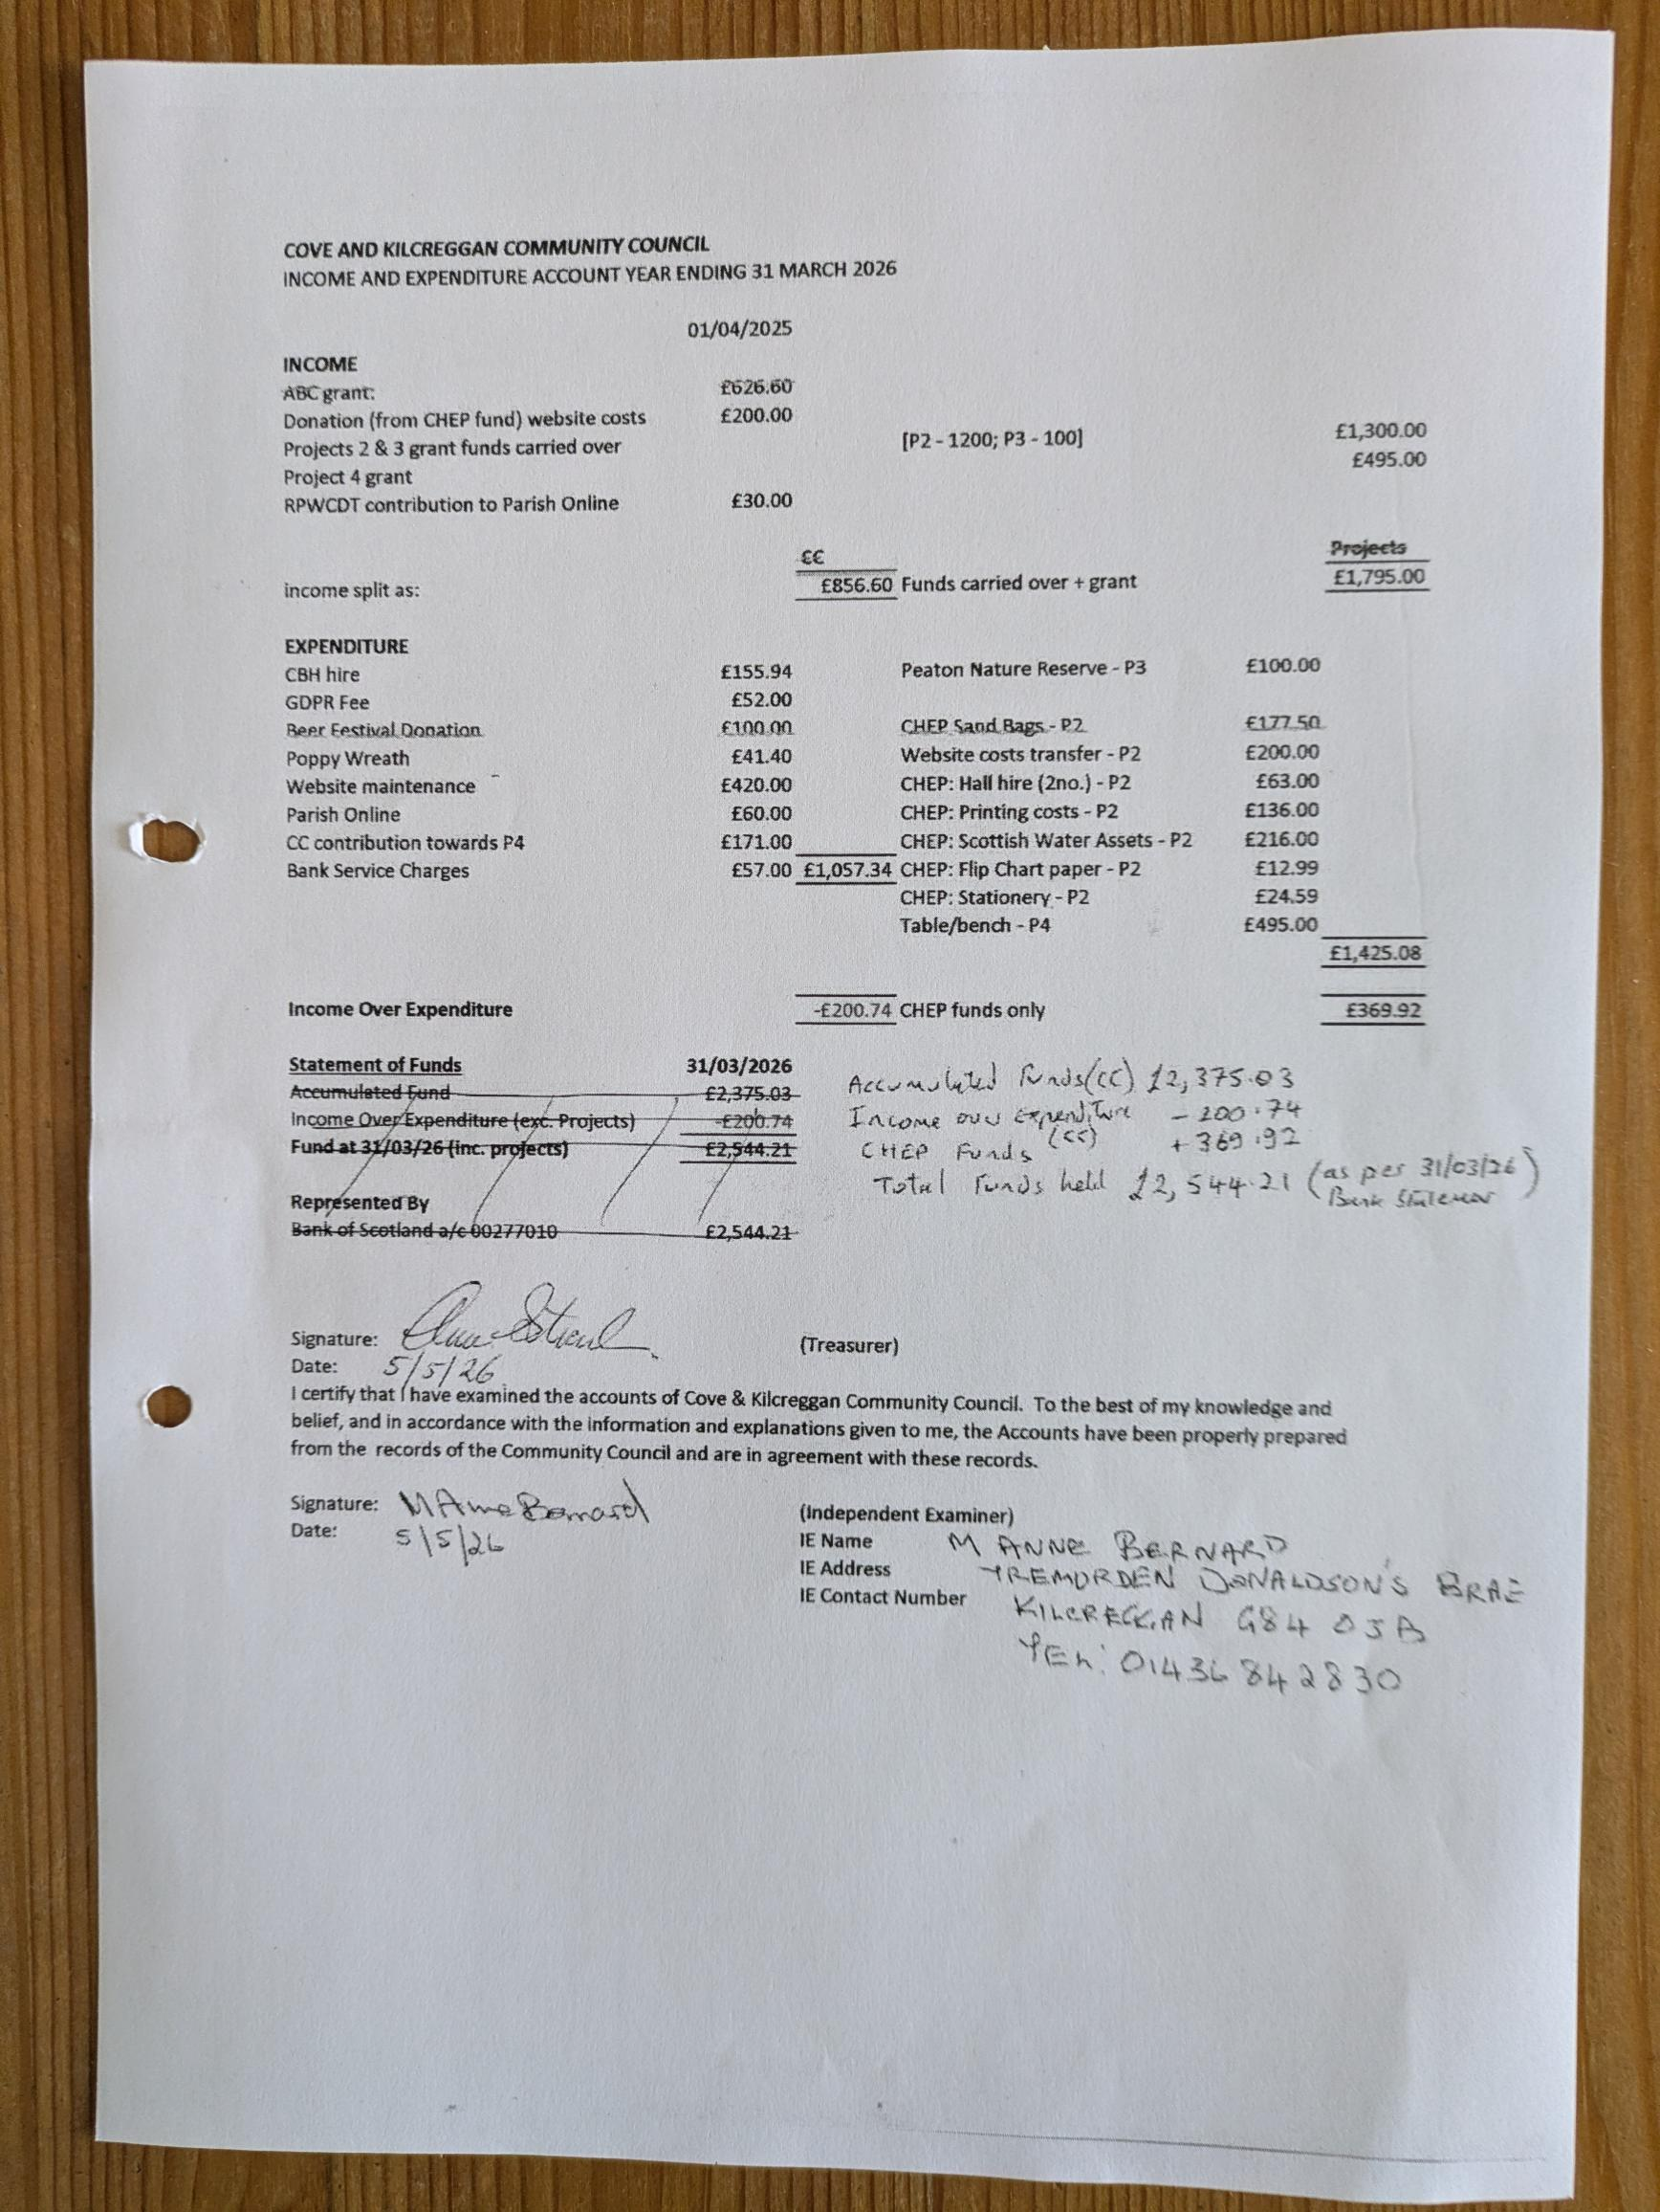

Agreed dates for CC meetings through to end of 2027
NOTE 1: THAT ALL MEETINGS START AT 1915 EXCEPT JUNE which takes place after the AGM
Note 2: The newly constituted Community Council post the August 2026 election could vary the dates / timing of meetings.
LOCATION: SMALL HALL COVE BURGH HALL
Every second month on second Tuesday of the month (odd months) PLUS AGM in June. (7 Meetings a year)
Date | Comments
2026
9 Jun | AGM & CC Meeting
14 Jul | CC Meeting (School Holiday) (UNDER REVIEW)
8 Sept | CC Meeting
10 Nov | CC Meeting
2027
12th January | CC Meeting
9th March | CC Meeting
11th May | CC Meeting
8th June | AGM & CC Meeting
13 July | CC Meeting (School Holiday)
12 September | CC Meeting
9th November | CC Meeting

ARGYLL AND BUTE
COMMUNITY COUNCIL ELECTIONS 2026

TIMETABLE

Register in Force 1 June 2026
Publish Notice of Election 4 June 2026
Nominations Open 5 June 2026
Close of Nominations and last date for withdrawal 25 June 2026 (4pm)
Publish Notice of Poll or Uncontested Elections 2 July 2026
Issue postal votes 16 July 2026
Election day/last day for receipt of postal votes 20 August 2026 (4pm)
Count 21 August 2026

