Community Council Meeting

Date: 12th May 2026 Location: Cove Burgh Hall, Small Hall

- Fire Alarms and Housekeeping
- Present
John Auld (Convenor), Kenny Barlas, Nick Davies, Derek Fowlis, Sheena Lamont, James McLean, Linda MacKenzie, Ali Mills, Christine Murdoch (Vice Convenor), Sheelagh O’Reilly (Secretary), Anne Strachan (Treasurer)
Cllr Maurice Corry
6 members of the public and 2 staff from BT Open Reach
- Apologies
Kathy Gostick, Ellen McVey and Cllr Mark Irvine
- Declaration of interest (financial and non-financial interests)
Updated DoI adding in ‘live’ planning application public objections to the table. (See below)
John Auld (Convenor): As the convenor I have had discussions with the Governance Officer at Argyll and Bute Council regarding my ownership of land that is identified for possible development in LDP2. LDP2 forms part of Argyll and Bute Council’s statutory plans for the area and has now been adopted by them. As the landowner for one parcel of land I would follow the current guidance on Declarations of Interest and would not chair the section of any CC meeting dealing with issues specific to that parcel of land.
No additional DoIs made at the meeting.
- Police Report
No police presence. Report was circulated and provided below for information.
- Presentation by Open Reach
Open Reach team made a short presentation on the ongoing work on Full Fibre network in this area. This work is being undertaken as part of a recent Scottish Government programme to enable upgrades to the system for rural communities. Work goes exchange by exchange. Coulport live, Kilcreggan ongoing and Clynder exchange in progress. Most property should be able to connect to ‘full fibre’ in the next few months. Properties can check the progress using www.openreach.co.uk/updateme/ . This enables updates to be sent if full fibre not yet available.
Discussion also took place about the PSDN network (old copper wire) switch off i.e. the switch to Digital Voice which is now planned for January 2027. This does poses issues for resilience planning including issues of battery back up (too short) and access to mobile masts for long outages when their power systems are not capable of handling long power downtimes e.g. during Storm Eowyn where people in Kilcreggan were out for 2+ days. Telecare etc remains difficult as well as the current battery backups can be too short for rural outages.
The CC thanked the team for coming and the clear presentation. Additional material will be sent to the Secretary for posting more widely on social media, website etc.
[Note that the Craigrownie parking issues were discussed here – see below]
- Minutes of the CC meetings as follows:
- Adoption and signature of minutes from 10th March 2026. Proposed ND / KB and signed. Actions / items not included on the agenda.
  - Contact with HMNB Clyde – Coulport. There will be a new Commodore of HMNB in a couple of months. The Secretary did meet the local person designated to liaise with the CC. Agreed and the CC accepted that the engagement with Coulport should be picked up post August 2026 election.

- Convenor
- Glasgow University Transformative Action for Resilient Coastal Communities (TRACC): The Secretary had an Interview with the researchers (Greenwich, Glasgow and Strathclyde) on issues of community council engagement. Pointed out the differences of Scottish Community Councils and English Parish Councils. Work is ongoing on their revised research protocol. The OC Clearwater group will be kept ‘in the loop’ as work moves forward. Critical issue will be engagement, in due course, with the Clyde Marine Management Plan due shortly now the SG elections are over.

- Community Council Elections 2026: A&B Council will be publishing key material shortly. The timetable is given below. CC will publish material / links on FB / Website for local residents. Posters will also be displayed in the usual places once info (web links / QR codes) are available. CC can use their personal networks to discuss the CC roles and responsibilities and elections process to encourage participation.
During the process from 4th June to 21st August the community council remains in place. See below from A&B Council and previously circulated (Dec 2025)

The current Community Council remains in place until the date of the Election, which is 20 August 2026 and can continue with the normal/core functions until this date. From this date, until the first meeting, which will be called by the Returning Officer and will take place within 21 days of the date of the Election, or as soon as practicable thereafter, no business can be conducted. The Community Council can operate fully following this meeting where the business will include the adoption of a Constitution and Standing Orders and the appointment of office-bearers.

The Secretary will write to the A&B Governance team indicating that we have a planned meeting booked on the 8th September and that they may wish to use that date / booking for the inaugural meeting (within the 21 day post-election period).

- The Secretary attended the Helensburgh and Lomond Community Planning Partnership meeting on the 12th May. Key issues raised (some overlap with the CC agenda):
  - Transport Scotland Ferry Report – as below.
  - Car-pool sharing study being proposed and suggested that it include an analysis of the impact on bus service provision, especially in rural areas.
  - Climate Ready Region – Argyll & Bute. Study just being finalized and asked if this material would be included in the A&B Climate Evidence Paper for LDP3. That is to be explored.
  - Work on Community Wealth Building to progress now that the necessary legal framework is in place. Could be an important topic for business / regeneration / repopulation and HMNB expansion so that benefits of procurement, expenditure etc remain, as far as practical in the local area.
  - Next meeting of H&L CPP on the 18th August. The minutes of the 12th May and future agenda will be circulated to CC members in due course.

- Dates for the CC 2026/27 sessions (which can be modified post 2026 CC elections) are given below.. These will be submitted to the AGM on the 9th June with the caveat that the new CC could adjust the dates.

- Meeting with A&B Council Repopulation research team – small group meeting at request of the research team (two from CC, two from OC and 1 from Business Group). Note that JM felt that a wider inclusion from the CC should have been available. Online info sessions on the 12th and 14th May. JM /AS raised a concern that the research team had, in the 12th online meeting said that there had been consultations with the community council. The question was asked as to how the CC would ensure wider consultation with the community. The Secretary indicated that as she is attending the meeting on the 14th she will make sure this impression is corrected. The OC team forwarded the LPP and related documents. It is recognized that discussions of re-population is an issue that raises strong emotions but there are people who would like to see local growth including housing for young people and those who are averse to any growth in housing. The Housing Need Survey will be shared, in due course, with the research team. Questions of growth of population to HMNB Clyde expansion cannot be overlooked. This is the start of a new phase of the A&B Council repopulation research work (initial meeting were held over 3 years ago and the outline report was not made available publicly) but the process can be used to start a conversation locally on housing and population growth to enable a diverse demographic that includes people for all services including retained firefighters, carers, medical / educational services as well as local businesses.

- War Memorial; Communication from Helensburgh British Legion indicates ownership / management issues resolved and application has been submitted. Requested the agreed £100 CC donation which has been sent. An issue has been raised about possible missing names from the War Memorial. JM has received (as a Director of C&K Trust) an email from A&B Council. It was also suggested that there are other missing names. It was hoped that updating the War Memorial names during the current upgrade would be included – although it is recognized that this is often an on-going process as more names come to light from past and more recent conflicts. JM / SL as Directors of C&K Trust (who own the land) to liaise with Helensburgh British Legion and A&B Council who manage the War Memorial.

- Treasurer’s Report for 12th May 2026
The Convenor thanked the Treasurer for the work in preparing the accounts.
Annual accounts for 2025-2026 now signed off. As previously intimated our accounts are more complex this year due to the number of projects, the funds for which are separate from the CC’s funds, although all are held in the same account.

Depending on what happens in the future, the project entries may have to be grouped, which means overall the entries will not be in date order – not the usual way for accounts.

There have been several occasions where there is no invoice or other supporting documentation for expenditure. Consequently, I’m introducing a cheque receipt for signing by the recipient in order to have a document reflecting outgoings. This is to ensure there is a supporting document when it comes to audit as well as confirmation of receipt of cheque.

A criticism of this CC is that the Treasurer does not appear responsible for a lot of the expenditure, and in fact is operating more as a banker than a treasurer. This is not usual practice and my recommendation is that the Treasurer should be responsible for all payment as recommended by Argyll and Bute Council Community Council Handbook.

Current financial position

There is currently £2016.88 in the CC’s budget and £369.92 remaining for the CHEP project.

Note that the previous financial year has ended and been signed off. A new financial year has started, and all subsequent transactions will be the responsibility of whoever becomes Treasurer post elections later this year. I’ll just be providing basic figures from now on.

Points raised in the discussion:

- End of Year Accounts (see below). CM raised a point about the hand-written amendments and that section not being specifically initialed. The Treasurer is comfortable with the accounts as is and has not issue with them being submitted to the AGM and from there (if agreed) to A&B Council for the annual administrative grant request.

- Managing the Accounts – Some points for the Community Council.
  - For project grants will need to ‘group’ if grant financing continues.
  - Need to formally have ‘cheque receipts’ to ensure clarity in the accounts etc.
  - If the Treasurer is to make all payments relating to the use of the admin grant from A&B Council, including online payments say for GDPR / Parish online / Website, then consideration on how to operate will be required. Case by case basis. CC will review post elections.

- Update on Our Community Project under RPWCDT
- Update from the RPWCDT Convenor – written report circulated and presented below.
- Grant approved by CEIS for one more year to support issues of grant applications etc. .
- Housing Needs Survey – live and placed on relevant social media and posters.
- Gala day Craigrownie park. If the application for public funding for the day is not forthcoming then the Community Council agreed that it would provide £100 to support the event.
- RPWCDT/OC next board meeting will review issues of LPP revision as new date is end of January 2027. The CC Secretary asked if it was possible to draw out the text from the main documents so that it could be more easily edited and used. This will be considered. Evidence such as from the Housing Needs Survey and from the A&B Council discussion around HMNB Clyde expansion could be included in any revision. Even if, with HMNB is it more of a ‘marker’ given the limited information currently available. The RPWCDT/OC Convenor indicated that he thought there would be few changes to the LPP due to public consultation constraints.

- Community and Household Emergency Planning update
- Secretary and Convenor met with David Hutchinson of A&B Council regarding flooding on Shore Road. A&B Council have no maps of their surface water drainage system and where it meets the Scottish Water Combined Sewage / Surface water system. Secretary had an initial exploration of culverts between School Road & CBH. There are 3 ‘formal’ culverts which appear to be operational but take ‘clean water from burns / cundy systems except the one by the War Memorial. Other more ‘informal drainage to the shore exist but are partially / completely blocked by tree roots / debris / litter. This means that the B833 drains, if not draining into the SW sewage system, has no-where to go and that any shedding from uphill is not being ‘flushed’ through in major rainfall events. This leads to surface water flooding which is dangerous and causes problems for pedestrians. It is also likely that this is the issue around Knockderry corner (from a short inspection) and further work is required to track the culverts. Beyond the sewage processing station by the Cove Fire Station this is not linked into the Scottish Water System (we now have their maps).
Whilst consideration of the catchments from the top of the hill to the shore would be wise long term, combined with Sustainable Urban Drainage e.g. management of driveways with hard / soft ground works, the immediate priority is on the Shore Road (B833) drainage due to possible danger to road users. Further work, using the remaining money from the A&B Council Supporting Communities Grant will be undertaken including wider information regarding ‘riparian rights’ of households / land-owners.

- Planning Applications & Enforcement (details of applications on A&B website)
- Community Garden - agreed
- Giants Burn – Energy Consents Unit under consideration
- Ardpeaton 24/01321/PPP This is still pending. Officer to prepare a report but has had other priorities.
- Enforcement matters (update from planning – previously circulated)

  - Fort Road – we understand the requirement is to start from the Shore Road end but that there maybe some hold-ups. Can you confirm the approach on this please. Yes the road must be the next step in this development before they can do any further work on the houses. On Wednesday when I was out, all works have ceased which is what was expected as they are currently applying for their amended Roads Construction Consent so they cannot start work on the road until they get this approval and a Road Bond is in place. This is likely to take a minimum of 6-8 weeks so work is likely to be on hold for a while until this is sorted out.

  - Kyle View retaining wall and fencing (the temporary metal fencing has blown down several times in recent windy conditions) – I inspected the plans and then visited the site on Wed. They said the retaining wall has been priced up and the engineers have been to site to measure everything. It should be started soon but I will seek an update from the architect. The wooden fencing to the rear is all fine and is what is required as per the Landscape Plan and it looks like there is a good enough set back off Barbour road.

  - South Ailey – the ‘missing’ wall – No further update on this. Wall rests on land that has been sold. To the houses in the Paddock.

JM indicated that there are a number of issues regarding walls in and around South Ailey / Castle. The CC requested that he prepares a short table and map with the sites, the current status and key issues.

  - Strathlee – is this still being monitored given the NMA agreement? - Yes this is being monitored and they have had their NMA and variation of permission and they are currently discharging the conditions. When I was on site they were fitting the windows which are those that have been agreed. We are still awaiting information on final finished ground levels.

JM indicated that the neighbour has had no communication from SEPA (re Septic Tank) or from Planning. The CC indicated that if there was harassment then this should be reported to Police Scotland.

  - Achnashellach – issue outstanding of the garage but you are content that there are no plans to run a commercial business from the site that is in the LDP2 settlement zone. I didn’t visit this site, but Emma Jane has fully investigated and we are content that there is no commercial operations. We have kept the enforcement case open until all works on the property renovations and the glamping pods is completed and then another check will take place and it is likely the case will be closed if there is no evidence of any commercial activity.

  - Auchengower 25/00516/PP approval with conditions. (18th February 2026) How will this be monitored? I have now visited the site on Wednesday and I will be checking all the condition requirements and writing to the owner. They are in breach of Condition 4 that required a habitat survey to be submitted within a month of the decision (so was due 19th March) but this has been due to finding it difficult to get an ecologist as it is such a busy time of year for them. We are sympathetic to this as we know it can be very busy this time of year. I’ve therefore given them an extension of time to get this submitted by end June 2026.

This has a knock on effect on meeting Condition 5, 6, 7 in relation to the biodiversity statement, final landscape plan and INNS plan so they have an extension on those until end June 2026 (they had been due 19th May, so no breach of these ones yet).
When they do submit the information to discharge the conditions then a new file called 25/00516/DOC01 will be created and the public will be able to view the plans, but not be able to comment as there is no process for this.

JM indicated that Charlotte McLean has written a paper on this issue . The CC noted that that both CM & JM had previously objected to the Auchengower planning application. It was agreed by the CC that JM can circulate the paper and a ‘no-objection’ on-line process can be initiated. Alternatively JM/ CM can submit the paper to A&B Council as private individuals.

As both JM and AS attended the planning meeting (18th February 2026) JM wanted the following noted:
    - That the local councillor did not attend the planning meeting.
    - That the C&K Community Council was seen to be supporting. (POST MEETING FACT CHECK see minutes of the A&B Planning meeting at https://www.argyll-bute.gov.uk/moderngov/ieListDocuments.aspx?CId=199&MId=16733&Ver=4 – need to scroll down where it states that “ There is also an objection from Cove and Kilcreggan Community Council. “ )

  - Other Enforcement Issues
    - JM also raised the issue of ground levels and planning. The CC indicated that he should produce a suitable paper for discussion (this is a technical matter) before the CC starts any ‘lobby’ process on what is a regulatory matter. He should also take up with local Councillors (example of Fort Road driveways).

- Roads / Paths / Lighting / Drainage etc
- Tigh Dearg . Other than some small matters above Tigh Dearg this is now resolved.
- Craigrownie parking: Three residents from Craigrownie presented a short paper on options for the resolution of the parking issues / enforcement problems. It was noted that some local disabled residents park on the pavement due to the lack of disabled parking options. So far the residents have had no response from A&B Council.
The Community Council agreed that it would formally write to A&B Council to arrange an on-site meeting that would cover two issues:
  - First: – options for increasing the level of parking in the area (see below for details)
  - Second : – request to suspend the enforcement of current regulations whilst this matter is resolved.
  - The CC Secretary to send a copy of the proposal to A&B Council (Kirsty Flanagan and Hugh O’Neil) with copy to the 3 elected councillors. The CC holds the details of residents who have signed the petition.
- ‘Works’ List update:
  - Overhanging trees / mossy pavements including South Ailey. Owner of key property recently died so issue has been paused.
  - Kilcreggan Bus Shelter repair – not yet fixed. Cllr Corry to again follow up. It was noted that someone has been removing ‘live’ posters from the bus shelter which is not helpful.
  - Leaking sewage system by Bowling Club. Currently the system seems to be working OK following the start of the new season.
- Street Furniture (Benches, Notice Boards, Phone boxes etc).
  - Bench opposite Cove Shop and planning - work to be undertaken soon. -
- 20 mph in Cove & Kilcreggan Area.
  - 316 timetable an issue. Garelochhead Coaches have an online survey on the service. (post meeting link circulated to CC members and placed on the FB page as survey closes on 13th May). A&B Council in consultation with the bus providers (affects more than the 316).
  - Issue of enforcement: Police Scotland have not (yet?) been given extra resources around the 20 mph limit enforcement. Any changes would be subject to necessary legal orders being agreed. The decision rests with A&B Council and level of alignment with the current legislation and criteria for 20 mph zoning.
- Ferry and Pier (ND)
- Update on current situation regarding Pier / Ferry – see below for details of an email received on the 12th May from Transport Scotland. Transport Scotland are working on the Outline Business Case for replacement vessels which is due for completion ‘later this year’. Once a decision on replacement vessels is made, work will start on identifying options for berthing infrastructure at Kilcreggan
- Christine Murdoch indicated that C&K Community Council does not have a ‘seat’ on the CalMac Ferries Community Board https://corporate.calmac.co.uk/en-gb/communities/ferries-community-board . When vacancies arise there is a public application process. Need to monitor this process as having a voice ‘from the Clyde’ can be helpful.
- Communications
- Secretary has spoken with a local website developer who has done work for the local church and CBH. The Community Council agreed to defer decisions until after the August 2026 elections. The current website provider contract expires in November 2026.
- Community Council Planning Policy
- Report from Directors of C&K Trust regarding management of land to the shore side of Shore Road. No change.
- LDP 3 engagement. Post August election CC to decide process going forward given revised time frame for evidence report etc.
- Housing Strategy development and Housing Needs Survey: Survey is currently live covering three surveys. One for residents, one for non-residents and one for businesses/ service providers. Will provide evidence to help inform a discussion on housing needs and a housing strategy for the future. It is noted that this is a contentious topic with highly diverse views. The survey has been posted on Facebook and notices have been placed in the usual places.
- Licensing
No issues.
- Any Other Competent Business
Secretary raised the issue that the Community Council is not receiving notification of local road closures e.g. A814 from A&B Council. Cllr Corry indicated that the person to contact is Donna Lawson in A&B Council. re road closures. Secretary to write to request road closure notifications for this area.
- Date of Next Meeting 9th June 2026. This will follow on from the AGM which commences at 1915.

C&K Community Council: Declaration of Interest in relation to trusteeship, directorship, membership of bodies that may have a bearing on CC agenda items. Plus personal objections to live planning applications that are on CC agenda.
As after meeting of 12 May 2026
 | Community Councillor Name | RPW-CDT Director | OC Working Group (Name) | Cove and Kilcreggan Trust Director | CBH Director | Professional or business group | OTHER – name organisation | Planning Applications as per A&B C website
1 | John Auld |  | Business |  |  | NFU | KVA
2 | Kenny Barlas |  |  |  |  | Taxi
3 | Nick Davies
4 | Derek Fowlis |  | Business |  |  |  | Creggans
5 | Kathy Gostick |  | Green
6 | Sheena Lamont |  |  | X
7 | Lynda McKenzie |  |  |  |  |  |  | Strathlee
8 | James McLean |  | X | X |  |  |  | Auchengower / Achnashellach / Strathlee
9 | Ali Mills | X | Arts / Green
10 | Christine Murdoch |  |  |  |  | Minister Craigrownie Church
11 | Ellen McVey
12 | Sheelagh O’Reilly |  | Housing |  |  |  | C&K RNLI  KVA
13 | Anne Strachan |  | Green |  |  |  |  | Auchengower / Strathlee
14 | Vacant
15 | Vacant
16 | Vacant

DRAFT: Proposed dates for CC meetings through to end of 2027 to go to the AGM on 9th June
NOTE 1: THAT ALL MEETINGS START AT 1915 EXCEPT JUNE which takes place after the AGM
Note 2: The newly constituted Community Council post the August 2026 election could vary the dates / timing of meetings.
LOCATION: SMALL HALL COVE BURGH HALL
Every second month on second Tuesday of the month (odd months) PLUS AGM in June. (7 Meetings a year)
Date | Comments
2026
9 Jun | AGM & CC Meeting
14 Jul | CC Meeting (School Holiday)
8 Sept | CC Meeting
10 Nov | CC Meeting
2027
12th January | CC Meeting
9th March | CC Meeting
11th May | CC Meeting
8th June | AGM & CC Meeting
13 July | CC Meeting (School Holiday)
12 September | CC Meeting
9th November | CC Meeting

ARGYLL AND BUTE
COMMUNITY COUNCIL ELECTIONS 2026

TIMETABLE

Register in Force 1 June 2026
Publish Notice of Election 4 June 2026
Nominations Open 5 June 2026
Close of Nominations and last date for withdrawal 25 June 2026 (4pm)
Publish Notice of Poll or Uncontested Elections 2 July 2026
Issue postal votes 16 July 2026
Election day/last day for receipt of postal votes 20 August 2026 (4pm)
Count 21 August 2026


Argyll & West Dunbartonshire Division
Cove & Kilcreggan Community Council
Dates Covered in this Report 02/03/2026-11/05/2026
Report completed by PC Cameron MacPherson
Cowal, Bute & Helensburgh Priorities 2023-2026

The priorities for your area are decided by data from our strategic assessment which details threats and risks, and also from feedback from local authorities, partners, and residents in the Local Policing Survey. The current priorities are:
- Serious and organised crime
- Crimes of theft and dishonesty (acquisitive crime)
- Road safety and road crime
- ASB & Violent crime
- Public protection.
Serious and Organised Crime
We continue to look for ways to disrupted and target those criminals’ intent on causing misery to those most vulnerable within our communities. We remain resolute in targeting the illegal drug trade ensuring that we seek support from partners across the country in doing so.
We have been upskilling officers across our policing division, ensuring they understand and appreciate the importance of community intelligence and information. Through intelligence led policing, officers can apply to the courts for Sheriff search warrants and take positive action in the detection and disruption of those involved in the sale and supply of controlled drugs. Across the division we have had successful outcome seizing drugs and money suspected to be from the proceeds of crime.
Community information is key for us and may just provide us with the last piece of evidence required to apply to the courts for a warrant. We encourage our communities to share concerns and suspicions around drug dealing either by calling 101 or by reporting anonymously via Crimestoppers on 0800 555 111 or via their website and online form (https://crimestoppers-uk.org/give-information/forms/pre-form).
Acquisitive Crime
Acquisitive crime remains a local priority. Figures across the country are on an upward trajectory, which in part is a result of the cost-of-living crisis. We are working with our Preventions team looking at maximising our crime prevention opportunities and looking at innovative ways to increase local awareness.
We are working with our communities to identify areas of vulnerability where we can engage with our partners to maximise our response.
In Helensburgh Our community policing officers are engaging with local businesses in the retail sector to reduce shoplifting. Officers are taking ownership by identifying those responsible, collating information and seeking bail conditions restricting access by the perpetrators.
In the area of Kilcreggan and Cove police will continue to provide high visibility patrols to deter potential thieves. If there are any areas of note that you think Police Scotland should patrol, please don’t hesitate to let us know. We are keen to keep the communities safe and protect property.
Road Safety
Overall, there continues to be a reduction in the number of casualties involved in road traffic collisions within A&B compared to last year.
Speeding and driving complaints remain prevalent across A&B. We continue to support community concerns in this area through direct action, prevention and intervention work. Proactive speed checks have been carried out across hot spot areas. We continue to work with partners including A&B council looking for innovative ways to positively influence road users.
Our preventions team continue to work with partners across our communities at road safety planned events. These events have been well received and allow a multi-agency approach to improving safety on our roads. where we can positively influence driver behaviour and understand community concerns.
As we approach our peak time across our road’s networks our national Roads Policing Team will be providing a high visibility presence across Argyll, they will also be delivering initiatives such as ‘Operation Close Pass’ which is aimed at tackling dangerous overtaking of cyclists and raising cyclist awareness amongst other road users.
Our national motorcycle unit will be out supporting local policing across Argyll in the coming period as the weather will start to get better. They will specifically focus on encouraging safe and responsible road use by motorcyclists. There focus will be engagement, education and enforcement.
ASB/Violence
In the heart of our communities, we pro-actively visit problematic tenancies along with housing partners to positively impact on ASB at the earliest possible opportunity. This information is then briefed out to local policing to ensure they are aware of ongoing demand and intelligence.
The Preventions Team at Dumbarton are in daily contact with the ASB and Housing Teams across A&B. Requests can range from a single email to a full disclosure which is required when legal action is being taken against a resident.

Public Protection
We continue to support individuals through a victim centred approach our officers receive regular training and guidance to ensure that we are supporting those affected with a professionalism and empathy.
Domestic and gender-based violence remains a priority and we robustly manage these investigations, safeguarding victims and targeting those responsible.
We have engaged with GP surgeries in the area providing advice and guidance on the Herbert Protocol which is a pre-prepared information pack for those living with dementia who are at a higher risk of going missing. We have asked the pack to be provided or discussed with families at diagnosis. The information can be provided immediately to police should the person go missing.

Community Engagement
Youth Engagamet Officer PC Kirsty Lyall has been very active with inputs and engaging with schools in the local area with various issues. High Schoolers had inputs on drug and vape awareness and primary schools including Kilgreggan Primary have had the following inputs; Primary 1-3 Road Safety and P4-7 on Internet Safety. Our new Community Pollice Officer PC Jack Deans also attended Kilcreggan Primary for a Careers Fair.
Cove and Kilcreggan Crimes of note

Between the 2nd of March 2026 and the 11th of May 2026 a total of 16 incidents were reported to Police Scotland.

Calls of interset:

On the 9th of March 2026 police attended a farm in Cove after reports of a theft whereby 3 containers had been broken into and about £27000 of gardening tools had been stolen. Enquiries are still ongoing to trace the suspects involved.

On the 26th of March 2026, Polcie attended Rosneath Road after reports of an RTC involving a van, Police attended and located the van off road in a wooded area, the driver was traced safe and well and had no injuires. Police carried out checks and no criminality was established.

On the 18th of April 2026, police attended an andress in Kilgreggan after reports of an assault, enquiries where conducted and the person resposnible was given a Recorded Police Warning.

Useful Links/Contacts

- Argyll and Bute Communtiy Directory - https://abcd.scot/ including warm spaces information
- Crimestoppers – Crimestoppers in Scotland | Crimestoppers (crimestoppers-uk.org) 0800 555 111
- Scottish Partnership Against Rural Crime – www.scottishparc.co.uk
- Women’s Aid - Home - Women's Aid (womensaid.org.uk)
- Citizens Advice – 0808 164 6000
- Argyll and Bute Council Trading Standards – 01546 605 519
- Argyll and Bute Council – https://www.argyll-bute.gov.uk/my-council/how-contact-us
- Transport Scotland – road related incidents and road closures - https://www.traffic.gov.scot/traffic-information/incidents
- Scottish Water - https://www.scottishwater.co.uk/Help-and-Resources/Contact-Us 0800 0778 778
- NHS24 (including mental health support) – 111 or https://www.nhsinform.scot/

Follow us on Social Media and help share loacl appeals and education messages
- Facebook - Police Scotland Argyll and West Dunbartonshire
- X (formerly Twitter) – PSOSArgyllBute and PSOS ArgWestDunb

Sign up to Neighbourhood Watch to receive local alerts and bulletins for your community area - https://neighbourhoodwatchscotland.co.uk/#0

Have your say on your local policing priorities - Your Police 2024-2025 - Police Scotland - Citizen Space

End of Year Account
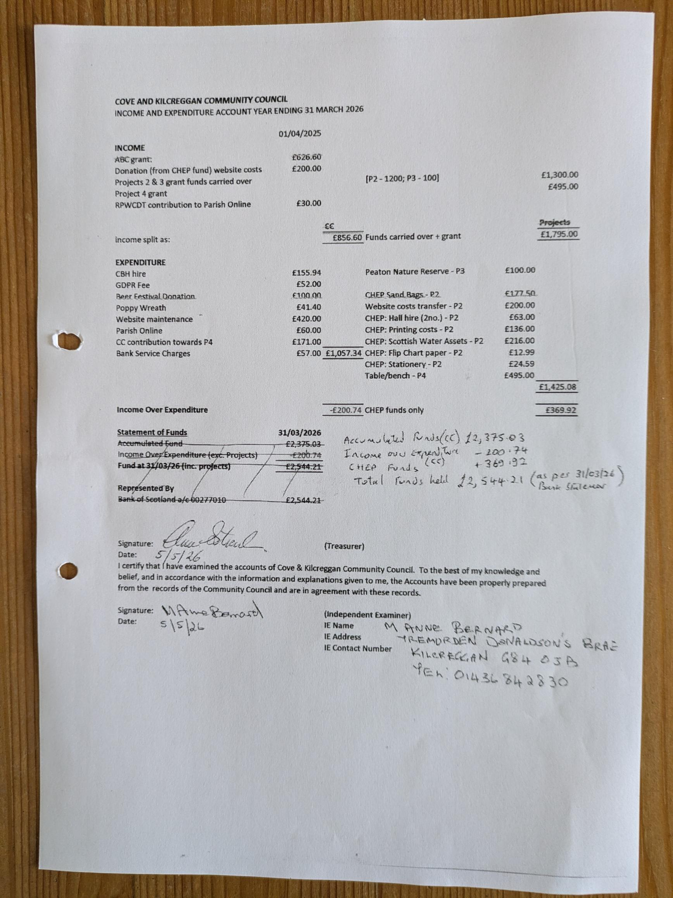

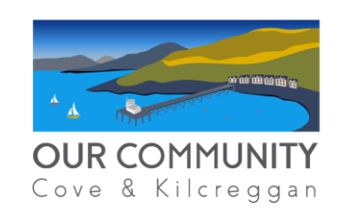
OUR COMMUNITY UPDATE FOR COMMUITY COUNCIL
12 MAY 2026
OC/RPWCDT BOARD
Laurence Slavin (Convener), Euan Wright (Vice Convener), Paul Munro (Treasurer), Mairi Benton (Secretary), Sheena Edwards, Christine Menhennet, Gauri Raje, Karen Clayton, Tom Walker, Ali Mills, Tim Drew
WEBPAGE - www.coveandkilcreggancommunity.com
RECENT ACTIVITY
Craigrownie Project

- Feasibility Study completed. Draft report issued to Our Community Board. Will be finalised and put on Our Community website shortly.

- Expression of interest submitted to Argyll and Bute Council for £35k CLLD funding for detailed design phase for the community hub element of the project. EOI has been approved and we are now working on full application with submission deadline of 15 May 2026.

- Expression of interest submitted for £750k of capital funding to Argyll and Bute community hub element of the project. Response outstanding

Community Enterprise
CE Session held on 25th April. Invite event to discuss the four projects set out in draft CE delivery plan.
CEIS Funding Update
- Further year of funding approved in principle (£42k).
- Grant letter being prepared; reporting requirements (tasks/outputs/milestones) has been submitted.

INCOME
Total Years 1-4 Funding | £207,500 | 1
Total Drawn Down | £196,250 | 2
Still to Draw Down | £11,250 | 3=1-2
EXPENDITURE
Spent to Date | £179,219
Committed to Community Enterprise | £15,420
Committed to Housing Study | £5,000
Total Spent and Committed | £199,639 | 4
Total Uncommitted | £7,861 | 5=1-4
POTENTIAL FUTURE SPEND
Misc Admin Expenses | £3,436 | 6
Residual | £4,425 | 7=5-6

Local Housing Needs Assessment
Being taken forward by Housing Group. 5/5/26 - Poster advertising survey ready to be circulated and added to social media sites and on local notice boards etc. This will have been actioned by time of CC meeting.
Gala Day – Saturday 22 August – Craigrownie Park
Time: Parade 12:00 → Event finishes 16:00
Funding scenarios:
  - Plan A: Applied for circa £9k Awards for All Grant (decision due July).
  - Plan B: Circa £4k community-scale event using locally raised funds and community lottery money
Parade
- Theme - “Playful Characters” (Books / films / stories – flexible, child-friendly, inclusive). Start: Medical Centre at 12 (meet at 11.30)
- Walking parade only (no floats).
- Pipe band secured to lead parade
Site
- Primary site: Craigrownie Park, also make use of Bowling Club, Youth Cafe and Church Grounds
- CBH for evening event (Ceilidh – BYOB – maybe open mic as well)
- CBH as plan B for daytime event if weather not good
- Toilets available via Bowling Hall / Youth Café.

Programme (Indicative – further planning to come)
Daytime
- Community stalls
- Youth Café, Scouts, School engagement.
- BBQ
- Games: tug-of-war, races, space hoppers.
- Facepainting
- Bouncy castle
- Choir performance
- Races
- Fire Service / MOD demo
- Craft demos / children’s crafts:

Community Lottery Update
- Next beneficiary Gala Fun Day (see above)
OC Board also approved
- £400 to local young person embarking on voluntary work in Honduras
- £2,000 to CBH refurbishment programme

Other Updates
Community Garden
- Polytunnel erected
- £1,400 Mushroom Trust application submitted - Trustee visit scheduled
Clearwater Group - Open Day 16 May (1600-1930)

Quarterly Event Listing to be Progressed
- Quarterly, simple events listing (no articles)
- Covers all community/social events (not just OC).
- Clear submission mechanism for people
Phone Boxes
- Cove Village - Listed - Telephone Removed- Adopted by RPWCDT. Currently used a book swap.
- Fairfield Gardens - Not Listed - Telephone Removed - Adopted by RPWCDT
- Kilcreggan Village - Listed - Still used as a telephone box, with functioning phone. Low call volume. Consultation due to complete on 22/06/2026. Note of interest from RPWCDT re adoption, if available.
Funding required to make safe / wind/water tight. Full restoration looks like as much as £5k per box but possible option to do cheaper locally if just making water tight and a bit of a clean up. We will:
- Gather formal quotes
- Seek informal estimate from local contractor
- Report back with cost options and implications.

Craigrownie Parking: Residents Proposals for discussion

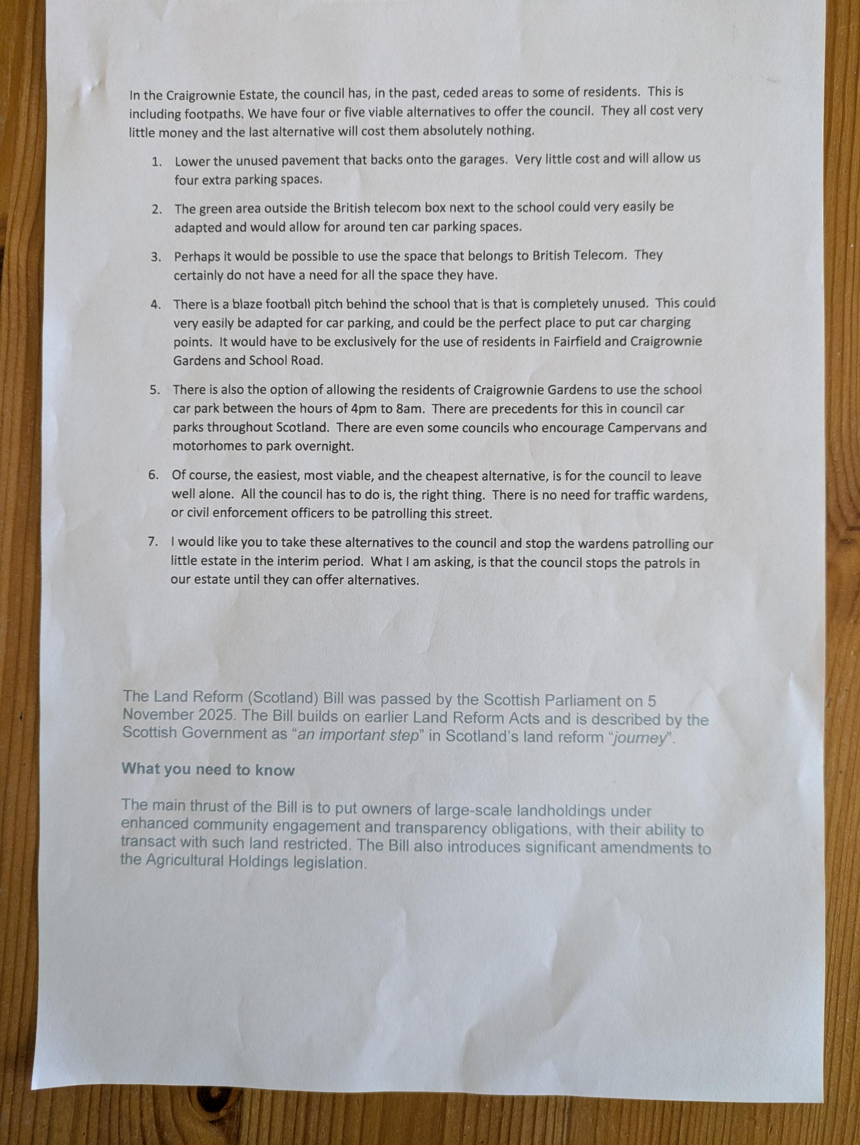

Ferry Email received from Transport Scotland on 12th May 2026
Please see below update from Transport Scotland Ferries Strategy Team on the Gourock-Kilcreggan Community Needs Assessment.
Gourock-Kilcreggan Community Needs Assessment
A community needs assessment (CNA) report for the Gourock-Dunoon and Kilcreggan routes was published on 11 September 2024 Cowal and Rosneath Community Needs Assessment | Transport Scotland
The CNA report noted, based on the methodology used:
- A ‘marginal under-provision’ in the number of sailing days, given the absence of a Sunday service;
- A ‘marginal over-provision’ in terms of the length of the operating day.
Follow-up community engagement by Transport Scotland, CMAL, CalMac and Argyll & Bute Council took place in October. This enabled us to understand better:
- The potential benefits to residents, local businesses and visitors of a Sunday service;
- The potential benefits of a longer operating day, in terms of reducing the risk of missed connections for people, particularly commuters, travelling home by train and ferry from Glasgow;
- The community aspiration for a revival of a ferry connection to Helensburgh.
The initial focus of follow-up work was on addressing identified over-provision on the Gourock-Dunoon service. This was concluded with changes to the timetable introduced from Winter 2025/26.
We are now returning to assess the options to deliver enhancements to the Gourock-Kilcreggan service, either a later sailing and/or a Sunday sailing, noting that none of these have a straightforward solution as the MV Chieftain is currently fully deployed within the limits of her crew working hours. This will focus on what could be done currently, ahead of delivery of a replacement vessel and any associated port works, and will be undertaken as part of the twice-yearly review of CalMac timetables.
In terms of moving forward with replacement vessels and port works, approvals from Transport Scotland’s Investment Decision Board and Ministers will be required following completion of the Outline Business Case (OBC). This will be subject to budget considerations and investment priorities across the transport network. The Gourock-Dunoon/Kilcreggan Programme Working Group (CalMac, CMAL, Transport Scotland and Argyll and Bute Council) is actioning efforts to complete the OBC later this year and future delivery timescales will be dependent on the approvals process, available budgets and procurement processes for the preferred solution.

