Community Council Meeting

Date: 13th January 2026 Location: Cove Burgh Hall, Small Hall

- Fire Alarms and Housekeeping
- Alterations to Agenda
- It was agreed to add the following items to the agenda under Planning (new Item 13 – formerly Item 12):
  - Planning matters at Ardnahane, Achnashellach and surrounding area.
  - South Ailey – enforcement and wall damage.
- Present
John Auld (Convenor), Kenny Barlas, Kathy Gostick, Ellen McVey, Sheena Lamont, Linda MacKenzie, Christine Murdoch (Vice Convenor), James McLean, Sheelagh O’Reilly (Secretary), Anne Strachan (Treasurer)
Cllr Shonny Patterson, Cllr Mark Irvine, Cllr Maurice Corry
1 member of public present.
- Apologies
Nick Davies, Derek Fowlis, Ali Mills
- Declaration of interest (financial and non-financial interests)
General Declarations of Interest
Table of interest present below.
John Auld (Convenor): As the convenor I have had discussions with the Governance Officer at Argyll and Bute Council regarding my ownership of land that is identified for possible development in LDP2. LDP2 forms part of Argyll and Bute Council’s statutory plans for the area and has now been adopted by them. As the landowner for one parcel of land I would follow the current guidance on Declarations of Interest and would not chair the section of any CC meeting dealing with issues specific to that parcel of land.

Additional issues related to specific agenda items
James McLean – all planning issues under agenda item 13
Anne Strachan – Auchengower / Strathlee
Sheelagh O’Reilly – School Road
Kathy Gostick – Fort Road
Lynda MacKenzie – Strathlee
Ellen McVey – land next to George V playing field

- Community Council and GDPR
The Secretary had circulated an information note on GDPR and the Community Council (see below). Two points from the discussion:
- Secretary to check with the owner of the C&K Community Hub Facebook page re mechanisms for ensuring people understand that when they comment their names are visible. Are there ways to enable ‘anonymous’ posting? What are the risks?
- Cllr Patterson to take forward with A&B Council the issue of training for Community Counillors on GDPR. This issue of of particular importance given the A&B wide CC elections to be held in 2026.

- Police Report
No officer was present. The material below was emailed and circulated to CC members in advance of the meeting.
Between Monday, the 1st of December 2025 and Tuesday, the 6th of January 2026 there has been 8 incidents reported to the police in the Cove and Kilcreggan area.
Two of which were road traffic incidents. One of the incidents was reported by a male who advised police that he reversed into a lamppost, however there was no damage to his vehicle. On police attendance no damaged lampposts were found.
Two crime reports were submitted following reports of indecent messages being sent by means of public electronic communications by un unknown individual. Enquiries continue to establish a suspect.
An attempted fraud incident with no financial loss took place in the area and as a result a crime report has been submitted. The crime report will be forwarded to the MET Police.
A female contacted police to report that her 4-year-old child had been missing for 30 minutes. The boy has been found safe and well prior to police attendance. The boy was hiding in a storage footstool playing hide and seek. Police attended to ensure that everything was in order.
A female contacted police to report that a male has been hostile towards her whilst in Helensburgh, however she further stated that the male was not abusive or threatening.
- Minutes of the CC meetings as follows:
- Adoption and signature of revised minutes from 9th September 2025. Following a short discussion the EM / CM proposed that the revised minutes (following online vote) were adopted and signed.
- Adoption and signature of minutes from 11th November 2026. SL / EM proposed that the minutes were adopted and signed. AS requested that it be noted that she did not think the minutes reflected the [conduct] of the meeting.
- Actions / items not included on the agenda. No items not on the agenda.

- Convenor
- Notes from the meeting with new Boat Yard owner. This note below was read out at the meeting and subsequently sent to the Secretary so that the Facebook link could be included:

With respect to the action at the November meeting to invite the new owners/developers of the Fort Road and boatyard site to a meeting an opportunity arose to have an introductory meeting with him.
Nick Davies and I (Convenor John Auld) met Barry Robertson of Ecosave construction (Facebook link https://www.facebook.com/reel/3835313386773011 and https://www.facebook.com/ecosaveinstallationsuk/ ) and the Fort Road site manager; it is early days in this location, and they seem to be from a progressive, experienced company with high eco focus. From looking at the social media posts they are currently promoting their site as well as the area, and what he was saying at the meeting it seems clear that they are looking to be part of the community for a long time.
They are currently engaging with local residents to get some resolutions, although some may take time and may be implemented later in the process, there also seems to be a willingness to resolve a lot of the issues and I believe that they are working with the planning dept to that end as well. That being said, I am sure that they will also be looking to work with the planning dept on developing the developments, but they are only at the initial stages.
There is interest to work alongside the community and I feel we have to work with that in a positive manner so we have put them in the direction of Our Community housing group to see if together they can consider some of the local needs and slightly later in the year, perhaps July, when they have found their feet to then bring to the CC any ideas or plans that they may be looking to take forward.
A short discussion took place and it was agreed (following a discussion under item 13) to again invite the developers to the next Community Council meeting when it is hoped that they would have had time to sort out issues with the recent site purchases. It was also suggested that the Fort Road site and the Camsail works form part of a larger ‘development’ and that, if the developers agreed to attend the CC meeting that Rosneath and Clynder (in whose area Camsail Works site lies) should be invited to the discussion. It was noted that work on Fort Road is progressing well and work has been undertaken to resolve issues left by the previous developer.
- Convenor to send a letter of thanks to the family of Gordon McKechnie regarding the memorial bench in Kilcreggan. Very timely given the state of the old bench!
- The Community Council noted with thanks, the donation of the Kilcreggan Village Christmas Tree by the MOD.
- Playpark update: Cllr Patterson to follow up with A&BC officials regarding the implementation of the procured services to ensure this moves forward. The Play Park management along with OC are looking for a 10-year party to be held in summer 2026. A request was made that this does not conflict with the normal Craigrownie Church event held in early summer.
- Glasgow University Transformative Action for Resilient Coastal Communities (TRACC): 2nd meeting to be held on 20th January. JM raised the issue of the meeting to be held by – next meeting to be held on 20th January. Secretary has contacted the Clearwater group regarding this work. JM raised the issue of a Lochgoilhead meeting on Coastal Communities, Marine Planning & Fish Farming to be held on 19th Jan 7 – 9 (in person and on Zoom).
- The CC thanked OC for the Highland Boundary Fault ‘stile’ and the successful event held in December.
- Helensburgh Outdoor Museum Design Panel: No volunteer from the CC to join the team. Volunteer groups are being approached separately – this was a specific request to the CC.
- PNR and memorial for Alistair McIntyre Memorial: Site meeting held on 13th January with MOD and members of other groups involved. Outline preferred site / design agreed and material to be sent to MOD for agreement and the necessary planning (if required) sought through them.
- Medical Centre: A one-page briefing note from HSCP has been circulated to CC members (and see below). This has been put on the Facebook page (and the Community Hub) and it is an issue of local concern. Good communication will be the key to this. It was noted that Rosneath & Clynder CC had not been included in any discussion to date. The Secretary to include R&C Secretary in any future correspondence to ensure effective consultations. Cllr Patterson indicated that the Integration Joint Board (IJB) member Cllr Dougie McFadzean has reassured him that the merger is going ahead and there will be no detrimental effect to the community, Dougie is optimistic that there will be a better service provision and the service will be enhanced by this merger. He is very much of the opinion that this will be a benefit to the community also, he has also said that if any members of the community have concerns that they can contact him direct , his email is dougie.McFadzean@argyll-bute.gov.uk. A further issue was noted re the ability of the medical centres to be able to manage additional patients given the ongoing developments in Rosneath and Fort Road.
- Community Council Elections 2026: All Community Councillor positions come up for election in 2026. The timetable is as follows which means that the current Community Councillors remain in position until 20th August so that meetings in June / July would go ahead as normal, and other matters continue to be actioned.
Register in Force 1 June 2026
Publish Notice of Election 4 June 2026
Nominations Open 5 June 2026
Close of Nominations and last date for withdrawal 25 June 2026 (4pm)
Publish Notice of Poll or Uncontested Elections 2 July 2026
Issue postal votes 16 July 2026
Election day/last day for receipt of postal votes 20 August 2026 (4pm)
Count 21 August 2026

Agreed to revisit this issue at the March meeting.
- Treasurer
- Update from Treasurer - presentation of accounts (see below). As not all the members of the Community Council are experts in reading accounts the Community Council requested the treasurer to provide some short annotation / footnotes regarding the document to aid understanding.
- It was agreed that the Secretary can renew the Community Map Scotland license when this becomes due in February. It was also noted that the the OC team wish to use the CMS software and have agreed to pay 50% of the license fee for the year 2026/27. Permission to pay for CMS (?£60) with 50% coming from OC?

- Update on Our Community Project under RPWCDT
- Update from the RPWCDT Convenor – written report presented below.
- The CC agreed to the request from OC to use the CMS licensed software and gratefully accepted the 50% feed contribution as proposed. Secretary to liaise regarding access.
- Community and Household Emergency Planning update
- Local Flooding Response: The issue of local flooding across the Peninsula has become a significant issue and this was supported by the inputs from a local resident. The CC agreed to hold a ‘drop-in’ session on documenting flood risk areas on Saturday 14th February. It is noted that some residents may be away on half-term but grant requirements / hall availability mean this date is accepted (but repeat sessions may be held). This will allow an update of the work undertaken 2 years ago and help to develop approaches that combine community / public and private responses to the local situation. It was agreed that flooding ‘works’ would be specifically drawn out on the next ‘works-list’ submission to A&B Council as there are a range of under road culverts which are blocked around Shore Road which leads to localized flooding and dangers to traffic / access – including the bus route. It is noted that a member of the public raised the issue of A&B Schedule for the road gulley cleaning machine (and for unblocking under-road culverts) and planned use in a consistent manner on the Peninsula to reduce flooding on the B833.
- Meeting to be solution focus and mention was made of Sustainable Drainage Systems (SUDS https://www.bgs.ac.uk/geology-projects/suds/ ), as well as blocked gulleys, gravel driveways….. Possible outputs:
  - How can we create a community engagement around ‘micro-catchments’ that draws in, and utilizes for maximum efficiency, the resources from public bodies (A&B Council, SEPA, SW), private land / house owners and community management.
  - Priority list for A&B Council regarding under road culverts that are blocked as well as identification (where possible) of surface water drainage water flows so that ‘pinch-points’ can be monitored by residents.
- Planning Applications (details of applications on A&B website)
- Giants Burn - no update.
- Auchengower 25/00516/PP – Planning indicate that this is likely to go to the February 2026 PPSL meeting.
- Ardpeaton 24/01321/PPP : Officers working on this application. JM raised the issue of why planning applications do not need to include anything on the topography and hence possible drainage challenges.
- Fort Road: As indicated above the CC will invite the developer to the March 2026 meeting. Also include Rosneath & Clynder if to consider the multiple development in the local area.
- Achnashellach and surround area. JM raised the concern that a commercial operation was being put in place in a residential area (Note LDP2 designation is Settlement). The CC noted that Achnashellach is the registered office of CRC Joiners and Builders https://find-and-update.company-information.service.gov.uk/company/SC581403 ).
The Community Council agreed that the Secretary should write to Planning to ask the following two questions:
  - Is it necessary for the owners to apply for ‘change of use’ permission for a property in a settlement area (as per LDP 2)?
  - If so what criteria e.g. scale of the alterations to suit specific business that might be used to make an assessment of the position given the LDP2 Spatial and Settlement Strategy?
- Use of private land near George V playing field. A question was asked around the use of private land for storage of waste material. The situation is to be ‘watched’ and examination of what actions, if any can be progressed regarding waste management on private land.
- Wider enforcement matters including:
  - Strathlee: Issues remain with outstanding planning applications. Community Council to monitor the situation.
  - Kyle View retaining wall. Planning department to visit and investigate further including the ‘waterfall’ from blocked gulleys on Barb our Road. Site appears still to be owned by Portkill.
  - South Ailey listed wall. JM indicated that the wall should have been reinstated by the previous owner but this has not happened. Current owners being contacted. CC will monitor.
  - South Ailey Road and overhanging trees which may damage listed wall (and be a danger to road / pedestrians). The Community Council to write to A&B Council (Hugh O’Neill / Cllr Corry) requesting that the initiate the relevant process to enforce action regarding overhanging branches / hedges.

- Roads / Paths / Lighting / Drainage etc
- Tigh Dearg: Cllr Corry reported that issues of signage, bin lorry access and gritting is in hand.
- Craigrownie parking: From Cllr Patterson by email: Craigrownie Gardens Incident Ref No 260112-000879. I have met with residents from Craigrownie Gardens Before Christmas regarding the issues with parking and the concerns of the community that they are been unfairly penalised I am still waiting for a response to the [proposals the residents have put to the council in addressing this issue..
- ‘Works’ List update: ALL members of the Community Council are asked to send any material (location, problem, extent of problem... ) so that the works list can be kept up to date.
  - Overhanging trees / mossy pavements.
  - Kilcreggan Bus Shelter repair – contractor procured. One of 3 jobs done.
  - Drainage and flooding: to be considered in more detail at the drop-in session on the 14th February.
  - Leaking sewage system by Bowling Club – no further update
  - Fort Road bins – still not resolved and issue of ‘secondary’ roads gritting (machine / local gritting bins) needs to be considered.
  - Reporting / glitch in the Report It system – to be taken up by Cllr Corry as when a ‘duplicate’ issue is raised i.e. more than one member of the public raises the issue a message is received that the issue has been dealt with when it hasn’t. Wording needs to be changed to ensure that this is noted as a duplicate request, but that work is ongoing. Current wording sows confusion and causes great concern.

- Street Furniture (Benches, Notice Boards, Phone boxes etc.).
  - Bench opposite Cove Shop and planning. SL reported that the CC has now received money for bench £495 from the A&B Council Supporting Communities Fund. Will now order the bench. The issue of planning has been resolved and agreement in writing has been given, by the Planning Department, for the installation of the ‘hard standing’ for the bench adjacent to the Cove Shelter which is an A&B Council Community Asset. No costs to the CC for planning.
  - New bench in Kilcreggan provided by the Coulport MOD Guard Service as the Gordon Mc Kechnie Memorial Bench. Convenor to write to the family conveying our thanks. The previous bench was very rotten and collapsed when was being removed.
- 20 mph in A&B and what this means for Cove and Kilcreggan? Secretary to again reach out to A&B Council officer on this topic. The CC wants active consultations on this issue, including the question of bus / train timetables and transport connectivity.
- Ferry and Pier (ND)
- ND indicated by email of 13/1 /26 that he had spoken with Scott Reid, the lead in A&B Council for harbours & port infrastructure. There is no news at present regarding the replacement ferries for the Gourock – Dunoon – Gourock Kilcreggan service. However it is expected that Transport Scotland will make an announcement soon. Once the go ahead for replacement ferries is announced, A&B intend launching consultations with the community regarding infrastructure options.
- Ferry Cancellations: The increased numbers of cancellations of the Ferry in December / January due to issues of tides was briefly discussed. There are implications of tides / tidal surges/ and rising sea levels for design of ferries / infrastructure. The numerous cancellations affect passenger numbers on all routes.
- Communications
- Secretary is starting work to update the website and ensure that documentation, including for CHEP, is up to date.
- Community Council Planning Policy
- By email from Cllr Patterson re Community Benefit Scheme
The Community Benefit scheme has been running since September 2020, the council is committed to delivering wider benefits for its communities when purchasing the required goods, services and supplies for Argyll and Bute, and have been working closely with their suppliers to deliver additional social, economic and environmental benefit to our communities, this allows community groups to request help. This can include things like sponsoring a local sports team, community halls and facilities, donations of labour or materials, youth activities and training , providing building or decorating materials, work experience or apprenticeships , defibrillator installation , street furniture , employing part time litter warden, anything that will help your community.
Local community groups or organisations can submit a request by contacting us at communitybenefits@argyll-bute.gov.uk. The request will then be reviewed and added to our community benefit wish list, which will be shared with the council’s suppliers on a regular basis to ask if any of the requests can be supported, the council will be in touch if the request is selected for support, please note that there are no guarantees that requests will all be met.
Important things to understand are community benefit funds are voluntary , separate from planning permission , not compensation and are intended for community benefit. Community councils may represent local views , identify priorities support engagement and consultation. They are not expected to take on financial risk, replace professional governance , manage large sums of money unless they choose too so.

Recent beneficiaries of the scheme have been
- Helensburgh & Lomond South : DCF Joiners & Builders, Benefit Rectification work at Colgrain Primary School after vandalism.

- Cowal John Brown Strone : Donated glass panels to the men’s shed in Contract - East Argyll Ltd Dunoon, which are being recycled to make greenhouses.
- Donation of a joiner for the Dunoon Burgh Hall Auction.
- Assisting the Community Development Trust by donating a tele-handler/operative to deliver gardening materials to Struan Lodge. 5.
- Donated a tele-handler/operative at the Cowal Argyll Rally.
- Sponsors of Cowal Highland Gathering.
- Sponsors of the Stay Fresh Festival.

- Kintyre and The Islands: MacLeod Construction
Work experience placement in Islay (12 weeks), Sponsored the woodwork prize for Islay High School’s end of term awards (donated tool bag and tools).
Donated wood and tyres to MAKI pups outdoor nursery.

- Oban South & The Isles: Supplier CKR Island construction ltd Support Tiree Music Festival ,Solar food project donation of £200 raised at Tiree agricultural show from selling dog treats. Annual sponsorship of Oban ladies rugby player Drew Buckley.
- MacLeod Construction Supported Tiree Music Festival by lending Heras fencing.
- Oban Electrical Installed a defibrillator at Mossfield Stadium, Donated £1,500 to Oban Pipe Ban.

- Report from Directors of C&K Trust regarding management of land to the shore side of Shore Road. No report available yet – hold for the next CC meeting as JM (Director C&K Trust) is to write to the Trust Secretary on this matter.
- LDP 3 engagement.
  - HSDF: A&B Council have flagged that the Helensburgh Strategic Development Framework will guide sustainable development over the next 20 to 40 years and directly inform the LDP3 spatial strategy. The Secretary replied to a recent email asking for comments that the wider issues of social / economic service delivery in the H&L area needs to be given higher attention. This would include transport, schools, medical, recreational and other facilities. Cllr Corry indicated that these issues will be included but the Community Council wanted to make it clear that this is vital and has implications for the development of services, including housing, on the Peninsula and surround areas. The CC agreed to continue to monitor the situation and engage were possible.
  - No comments were made on the Ardentinny LPP and the Secretary will write to the CC to that effect.
- Housing Strategy development. This is progressing under OC with the Housing group having met the consultants. Looking at commissioning a suitable study to draw together the range of existing data on housing needs now and in the future using primarily existing data.
- Licensing
No items to discuss
- Any Other Competent Business (To be notified to the Chair 48 hrs prior to the meeting )
Cllr Corry indicated ongoing engagement with Tom Murphy regarding the frontage in Kilcreggan (Derek Fowlis not at the meeting is leading on the liaison for this work). Will also chase up the School Road issue – including matter raised on ‘where does the water go to’ i.e. surface water given the obviously blockages on the surface water drains nearby on Shore Road (in both directions) and ‘over-topping’ damaging the sea wall at Silver Bay behind which is the main sewage pipe.
JM raised the issue that the new Chair of the A&B Council planning committee is Cllr Howard (resident of Cove) and has spoken about building bridges with communities. Cllr Corry replied that this is mainly to do with the land near the Leisure Centre in Helensburgh.
- Date of Next Meeting 10th March 2026. Also note start time of 1915.

C&K Community Council: Declaration of Interest in relation to trusteeship, directorship, membership of bodies that may have a bearing on CC agenda items.
As after meeting of 13th January 2026

 | Community Councillor Name | RPW-CDT Director | OC Working Group (Name) | Cove and Kilcreggan Trust Director | CBH Director | Professional or business group | OTHER – name organisation
1 | John Auld |  | Business |  |  | NFU | KVA
2 | Kenny Barlas |  |  |  |  | Taxi
3 | Nick Davies
4 | Derek Fowlis |  | Business |  |  |  | Creggans
5 | Kathy Gostick |  | Green
6 | Sheena Lamont |  |  | X
7 | Lynda McKenzie
8 | James McLean |  | X | X
9 | Ali Mills | X | Arts / Green
10 | Christine Murdoch |  |  |  |  | Minister Craigrownie Church
11 | Ellen McVey
12 | Sheelagh O’Reilly |  | Housing |  |  |  | C&K RNLI  KVA
13 | Anne Strachan |  | Green
14 | Vacant
15 | Vacant
16 | Vacant

Community Council and GDPR: Note for information: 11 January 2026
As Secretary I have made some enquiries recently regarding the Community Council and GDPR. These were to cover specifically the sharing of emails, with personal details, outside the original participants list and the sharing of material from private WhatsApp groups with the wider CC membership and beyond.
- A&B Council: Does not provide specific training for CCs but do have a webpage with some basic information: https://www.argyll-bute.gov.uk/my-community/community-councils-data-protection-information
- Information Commissions Office in Scotland: https://ico.org.uk/about-the-ico/who-we-are/scotland-office/ Their response to my queries is as follows – noting that there is no specific information for Community Council despite there being more than 1200 in Scotland. “Our dedicated page for small organisations is a good place to start.
Emails, security and data sharing
The data protection laws doesn’t stop organisations from sharing information with third parties via email or publicly. As long as the sharing is compliant with the data protection laws. To begin with sharing must be lawful, fair and transparent. It’s unclear whether information has been shared in a compliant way with the limited information you have provided. Therefore, I can’t confirm whether the disclosures where appropriate in this case.
To begin with you need to consider what people have been told about the sharing of personal information within emails. If the council relied on consent to share personal information and it wasn’t obtained prior, then the disclosures would be unlawful and likely to constitute a personal data breach. It’s unclear whether this has occurred. You should review your privacy policy to check what you have informed people. Our guidance on email and security and disclosing documents to the public should also be helpful.
Private WhatsApp group
The council’s responsibilities regarding the WhatsApp group depend on whether they are the data controller or not. The council will be the data controller and responsible for the information captured on there, if it’s used for council purposes. For example, if it’s used to communicate council business and people are encouraged to join the group as members. The council must ensure that the use of the WhatsApp group is compliant with the data protection laws. This will include keeping information safe and investigation any security breaches such as unauthorised disclosures. The council should also consider providing your volunteers and staff with adequate training and information so they understand their role in keeping information safe. For example, having a WhatsApp policy so they know what they can and can’t do with any information shared within the group.
If the council isn’t the data controller then any issues about the group need to be raised with whoever owns it. If the council receives information from the owner of the group and decides to keep it and use it for their own purposes, they would become the data controller from that point.”

In practice?
- Be careful in sharing information from diverse sources. – emails / WhatsApp groups etc
- Ask permission from the people whose personal information may be identified directly or indirectly.
- If any concerns do not share the material!

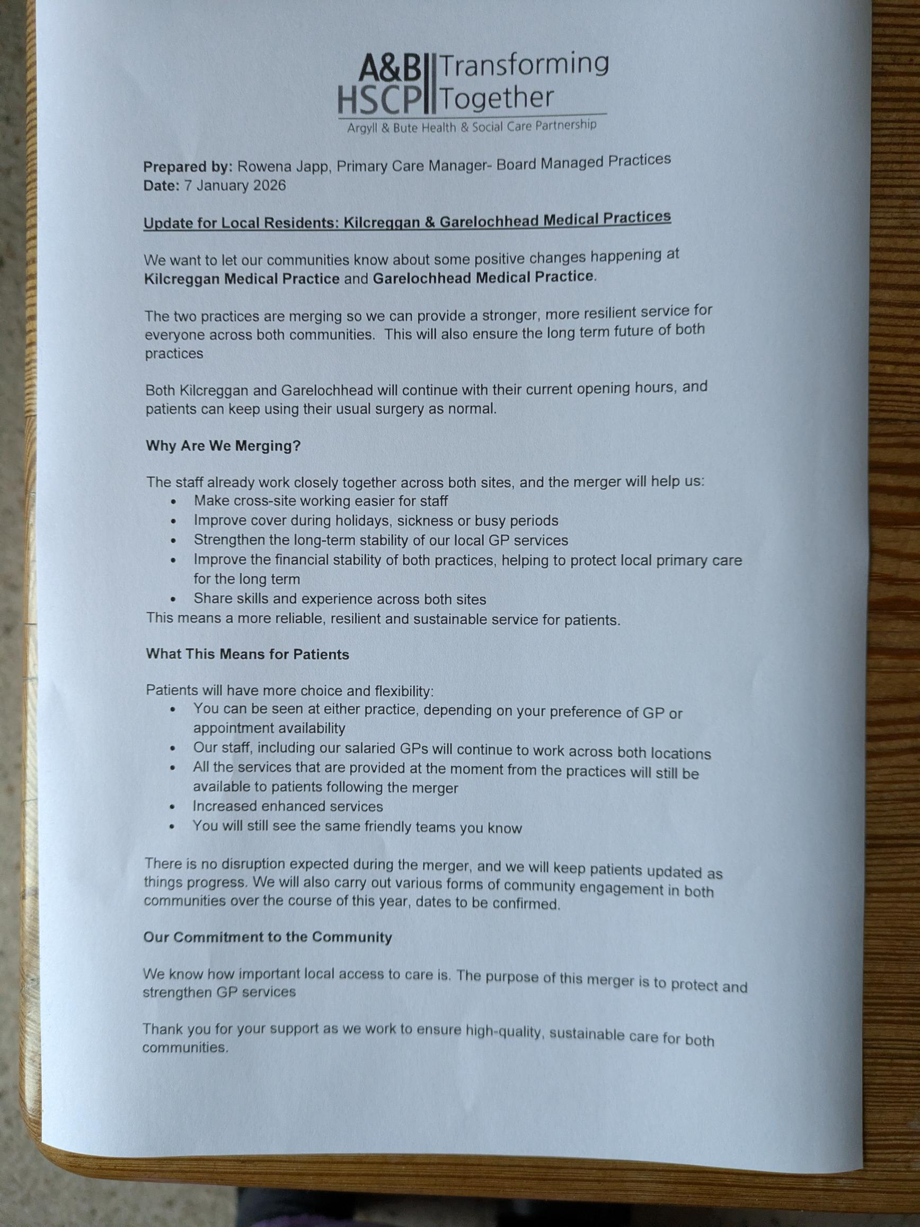

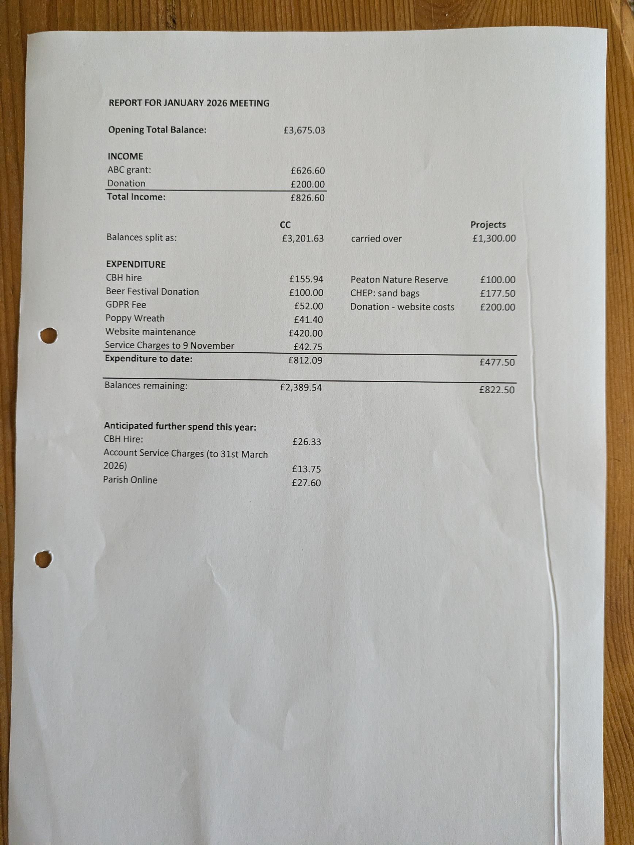
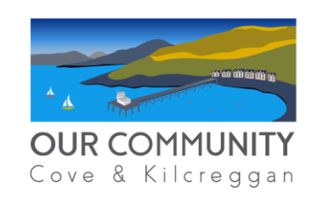
OUR COMMUNITY UPDATE FOR COMMUNITY COUNCIL
13 JANUARY 2026
OC/RPWCDT BOARD
Laurence Slavin (Convener), Euan Wright (Vice Convener), Paul Munro (Treasurer), Mairi Benton (Secretary), Sheena Edwards, Christine Menhennet, Gauri Raje, Karen Clayton, Tom Walker, Ali Mills, Tim Drew
WEBPAGE - www.coveandkilcreggancommunity.com
RECENT ACTIVITY
Governance
- Tim Drew added as a new board member
- Invite issued to all members for AGM on 26 February 2026
- Website further updated to include minutes of OC Board meetings, key governance documents, info on trust membership, info on OC Directors, FAQs and news about recent activity
Community Enterprise Update
- Further progressed work as delivery partner to transition from Local Place Plan to Community Delivery Plan including meeting the remaining groups. CE provided presentation to OC Board summarising work to date and early thoughts on 5 potential projects which are aligned to LPP. The Board have provided feedback to be considered in a further, more complete report draft.
CEIS Funding Update
INCOME
Total Years 1-4 Funding | £207,500 | 1
Total Drawn Down | £162,500 | 2
Still to Draw Down | £45,000 | 3=1-2
EXPENDITURE
Spent to Date | £161,926 | 4
Committed to CE | £30,840 | 5
Total Spent and Committed | £192,766 | 6=4+5
Total Uncommitted | £14,734 | 7=1-6
POTENTIAL FUTURE SPEND
Housing Study (circa) | £10,000 | 8
Misc Admin Expenses | £4,160 | 9
Residual | £574 | 10=7-8-9

General Funding Update
- £1,000 for Green Group Polytunnel from ABC
- £250 from Loch Long Salmon Farm for Green Group
- Heritage Group - An application has been submitted to the Space, Places and Belonging Community Hub fund to support a pilot project focussing on digitalising archives held by the library and others
Community Lottery Update
- £2,000 target reached for Scouts and funds paid over. Board now considering next beneficiary.
- £318 current balance
Awards for All Funding to Support Volunteer Activity
 | Allocation | Spent | Left
Path Group | £2,400 | £0 | £2,400*
Green Group | £1,115 | £1,115 | £0
Beach clean | £313 | £313 | £0
Community artist | £4,539 | £4,539 | £0
Hi viz equipment | £470 | £470 | £0
Masonry paint | £42 | £42 | £0
Village | £456 | £456 | £0
 | £9,335 | £6,935 | £2,400
*Quote received for range of foothpath signage which takes care of majority of the £2,400.
Other Updates
- Arts and Heritage Groups unveiled the ‘Highland Boundary Fault Stile’, a new public sculpture by Maya Rose Edwards, at King George V Playing Fields.
- Tim Drew taking over as lead on Cove and Kilcreggan 10k run – next one in 2027.
- Cove Village and Fairfield phone boxes now bought – Board considering future uses
- Two Village Tidy up sessions held in November
- Craigrownie Park Funday to be held in Summer 2026 to commemorate 10th anniversary of the playpark
- Progressing with invitations to tender for Craigrownie Park Feasibility Study
- Next Board Meeting 2 February 2026

For information the LDP2 documentation regarding Settlement strategy https://www.argyll-bute.gov.uk/sites/default/files/2025-10/Argyll%20and%20Bute%20LDP%202%20February%202024.pdf
Amendment made by CC Secretary as agreed with the OC Convenor.

