Community Council Meeting

Date: 8th April 2025 Location: Cove Burgh Hall, Small Hall @ 1930

- Fire Alarms and Housekeeping
- Present
John Auld (Convenor), Kenny Barlas, Susannah Conran, Nick Davies, Sheena Edwards (part) Kathy Gostick Sheena Lamont, Lynda Mackenzie, Ellen McVey, Ali Mills, Christine Murdoch (Vice Convenor), Sheelagh O’Reilly (Secretary). Anne Strachan (Treasurer).
One member of the press was present.
- Apologies
Derak Fowlis
Cllr Corry , Cllr Patterson
- Declaration of interest (financial and non-financial interests)
See attached table for matrix of interests. It was agreed that this matrix will be used for each meeting and updated in the light of any changes. Additional Declarations of Interest on specific items may also still be required e.g. planning.
John Auld (Convenor): As the convenor I have had discussions with the Governance Officer at Argyll and Bute Council regarding my ownership of land that is identified for possible development in LDP2. LDP2 forms part of Argyll and Bute Council’s statutory plans for the area and has now been adopted by them. As the landowner for one parcel of land I would follow the current guidance on Declarations of Interest and would not chair the section of any CC meeting dealing with issues specific to that parcel of land.
- Police Report
No report
- Minutes of the CC meeting held on 8th October 2024
There was a dispute concerning the minutes of the 11th February and these were not approved or signed at this meeting. Following discussion (at the end of the meeting) it was proposed and agreed that a review team comprising Christine Murdoch, Nick Davies and Sheelagh O’Reilly would review and prepare a revised set of minutes taking into account the range of feedback received. These will then be circulated and if not further objections be submitted for approval and signing at the meeting on the 10th June following the AGM.
- Convenor
  - Update on the Radio Telemetry Meter issues: Local resident report indicates that the upgrade takes significant time and energy. The secretary asked that all members of the CC speak with friends / neighbours about this issue to prompt them, if required, to arrange relevant appointments. Likely that the people with these meters are not those that routinely use Facebook where additional reminders are being posted. Switch off of the RTS is end of June 2025.
  - Tourist Tax Levy: Still out for consultation (has been put on Facebook). Members encouraged to respond if not done so yet.
- Playpark update: Still in the procurement phase with other local rural sites.
- Update on Helensburgh Leisure Centre: Not available. Concerns about rumours of long-term closure. Secretary to seek update from Cllr Corry who was not present. An update is also likely to be made at the H&L CPP in May.
- Preparing for the AGM on 10th June: AGM starts at 1930, and the CC meeting follows this. For the purposes of the AGM the CC discussed the online vote regarding dates. The proposed dates are given below.
  - It was also noted that there was a request to start the meeting at 1915. The CC had no objection, and this will then be put to the AGM.
  - Secretary to confirm with the CBH issues of availability and timing.
- Public Disclosure and implications for CC. Link to Disclosure Scotland PowerPoint; https://coveandkilcreggan.org.uk/documents/ The CC agreed to check on a case by case basis.
- Funding Opportunities: The CC noted three possible opportunities i.e. A&B Supporting Communities / SPT Communities / A&B Council Aspiring Place. At this stage no action to be taken.
- Sailing Club : CC welcomed the new sailing club house and also noted the seasonal opening of the 26th April.
- Bowling Club: Noted the opening on the 12th April.
- OC Heritage Group: The CC noted two items:
  - Event on 13th April starting at 1530 at the Creggans regarding the Pier.
  - Boundary Fault Art project applications now open.
- Banking Hub in Helensburgh: Noted the letter from the MSP regarding this but no details on approach, timing and operations yet available.
- The CC did not raise any additional issues to be pursued at the H&L CPP in May. (Digital Switch Over and Telemetry already covered).
- Treasurer
- Update from Treasurer – account circulated. See below.
- Peaton Nature Reserve received an additional £100 for preparation of a short video of the work.
- Forward budgeting including question so cost of website. Secretary exploring other approaches including suggestion of contacting Rhu and Shandon CC.
- Update on Our Community Project
- OC Management group on a break so no written update. The CC noted, with thanks, the submission of the Local Place Plan to Argyll & Bute Council. Report and Annexes are on the OC website.
- No decision has been taken by CEiS on a 4th year grant. yet on an additional grant
- CC thanked OC for the purchase of two notice boards – large one for Kilcreggan and smaller one for Cove.
- Community and Household Emergency Planning update
- Key lessons from the InspirAlba meeting held on the 4th April were:
  - Communications are vital and this is proving more challenging given issues of Digital Voice / lack of extended battery power at mobile phone masts (Cowal lost signal for an extended period). Whilst the close out of the use of existing copper systems is not until 2027 BT are already switching over the system in this area.
  - Electricity outages – can be lengthy. Having Village Halls and other buildings to provide food, charge facilities etc. can be vital. One village hall has put Solar Panels on the roof (around £18000) to provide battery backup during power outages. Also contributes to reducing their commercial energy bills!
  - Communities can be quite self-reliant – especially where smaller and more remote.
- Outstanding work regarding the A&B Council Supporting Communities grant include:
  - Asset register
  - Business Continuity
  - Sandbags / SFRS site (contact local farmers / builders merchants to explore donations of sand)
  - SEPA published Surface water flood maps (https://beta.sepa.scot/flooding/flood-maps/ ) where it is possible to search by post code. The data set is large, and the management of the CMS (Parish Online) are working with Scottish Government Improvement Service to see if this can available on the CMS site.
- Ferry and Pier (ND)
- Update on current situation regarding Pier / Ferry. No change.
- Noted that as a result of the Community Needs Analysis report Dunoon may lose 2 crossings.
- Infrastructure (Roads / Paths / Lighting / Drainage etc)
- Tigh Dearg : This work is coming to an end. It was noted that there is an issue with a large bump on Shore Road, but this may be overcome as surface is finished. To be monitored especially when the traffic lights are removed and traffic speeds up again.
- School Road update (Cllr Corry)
- Drainage: Gulleys, ditches and regular maintenance to minimize including plan (not yet made available to the CC) . The CC noted the good job gulley sweeper had done in clearing out leaves etc. in Church Road and South Ailey for example.
- Overhanging trees / mossy pavements. To include specific issue of South Ailey Road (overhanging trees / clearing of roads and pavements) and issues with encroachment onto pavements (hedges / weeds….).
- Kilcreggan Bus Shelter repair (Cllr Corry) – to be chased up.
- ‘Works’ List: A list was sent to A&B Council (and to CC members). The Secretary to follow up and request a site visit to look at the issues raised in the list including Fort Road and other key areas of concern. The CC also noted that there has been flooding around the Fire Station.
- Street Furniture (Benches, Notice Boards(OC bought), Phone boxes.
  - Red Phone Boxes: The CC noted that the RPW-CDT has applied to BT to take over the 3 red phone boxes in Cove and Kilcreggan. The Secretary to check if the Phone Boxes would work in the event of a power outage as could be an important means of communication. Also use for defibrillator?
  - Benches: Gift of a new bench – letter to be prepared and sent. Painting of Kilcreggan village benches. OC funding to support the use of volunteers for the work. One in Cove Bay needs to be taken away.
  - Noticeboards: OC have agreed the purchase of two new boards. A large one for Kilcreggan and a smaller one for Cove.
- Licensing
No issues for discussion.
- Communications
- Website for 2025/26 : Need to consider options. Suggestion for the Secretary to contact Rhu and Shandon and Secretary exploring other (cheaper) options but need to bear in mind our capacity for longer term management.
- Issue of ‘visibility’ of CC members from website / Facebook etc.: Concern over the material in the public domain that may be used by Chat GPT etc. CC needs to balance its need for transparency with personal privacy / security. Currently people are not ‘named’ in the minutes (unless requested) other than attendance. There is a presumption of openness for community / press / website / Facebook etc.
- Community Council Policy for engagement with the press: Following an approach from STV the CC briefly discussed this issue as there is no current policy on engagement with the press. The issue to be discussed by the Vice-Convenor and local press expert. Approach to be prepared for the next meeting (10th June 2025).
- Community Council Planning Policy
- A short paper was circulated prior to the CC meeting regarding possible option for cooperative management of the land to shore side of Shore Road in the Cove and Kilcreggan Area. (see below). Following a discussion which included a Director of the C&K Trust, the CC decided that, at this stage, they would see the outcome of the C&K Trust working group before considering cooperative engagement with other landowners. The CC is currently seeking confirmation of the different land-owners around the Cove and Kilcreggan shore side. The CC would appreciate a regular update on the progress of the work of the C&K Trust.
- There was a discussion of invasive species management and the way the CC can support the work of the Green Group which has two people trained for JK spraying. CC to help publicise work, the ‘do’s and don’ts’ of land management to prevent spread of JK when land is disturbed and to try and find out from the community the priority sites for JK control. The OC Green Group are producing a map of the JK areas. The CC agreed that the CC FB / website can be used to publicise work to reach a wide group of local residents.
- Planning Applications (details of applications on A&B website)
- Update on Fish Farm appeal. No update.
- Giants Burn and exhibition (030425) – The exhibition was noted.
- Auchengower - no formal update although one member of the CC has suggested that the Planning Department / Enforcement head followed up this issue following an informal meeting around a Horse Chestnut tree.
- The CC is concerned that despite contact with the planning department the CC is not updated on a number of outstanding issues including Auchengower, Fort Road, Portkil etc. The CC discussed how to escalate the issue and will, following the Secretaries collation of key issues (including what has already been sent but not yet resolved) and seek a formal meeting with our elected councillors on this issue. If no satisfactory resolution is found then the CC will explore escalating the complaint to the relevant individuals / agencies. It was mentioned that perhaps one major enforcement of a planning regulation may help to deter other householders / developers from ongoing infringement.

- Any Other Competent Business (To be notified to the Chair 48 hrs prior to the meeting )
- The resignation of Sheena Edwards part way through the meeting was noted. The Convenor will follow this up with her.
- A member of the CC raised the limited attendance at this CC by our Community Councillors including one local (Mark Irvine).
- It was raised that the website does not have a full set of photos / bios for the website. The discussion highlighted concerns from some around having material in the public domain. Those CC members who wished to have a photo / bio on the website were encouraged to send material to the Secretary.
- A discussion ticks – linked to deer, sheep, rabbits etc. Do seem to be increasing in number.

- Date of Next Agreed Meeting 10th June 2025 following the AGM which commences at 1930.

C&K Community Council: Declaration of Interest in relation to trusteeship, directorship, membership of bodies that may have a bearing on CC agenda items. 8th April 2025
 | Community Councillor Name | RPW-CDT Director | OC Steering Group | OC Management Group | OC Working Group (Name) | Cove and Kilcreggan Trust Director | CBH Director | Professional or business group | OTHER – name organisation
1 | John Auld |  |  | X | Business |  |  | NFU | KVA
2 | Kenny Barlas |  |  |  |  |  |  | Taxi
3 | Susannah Conran
4 | Nick Davies |  | X
5 | Sheena Edwards | X |  | X | Sports |  | X | Kilcreggan Medical Centre | Craigrownie Church  Girl Guides
6 | Derek Fowlis |  |  |  | Business
7 | Kathy Gostick |  |  |  | Green
8 | Sheena Lamont
9 | Lynda McKenzie
10 | James McLean |  |  | X | X | X
11 | Ali Mills |  |  | X | Arts
12 | Christine Murdoch |  |  |  |  |  |  | Minister Craigrownie Church
13 | Ellen McVey
14 | Sheelagh O’Reilly |  |  |  | HET |  |  |  | C&K RNLI  KVA
15 | Anne Strachan |  |  |  | Green
16 | Vacant

C&K Meeting Dates for June 2025 – December 2026

For AGM 10 June 2025

Option for Cove and Kilcreggan Community Council Meeting dates for 2025/26.
The meeting dates proposed are mindful of the following:
- That the meetings have been held on the second Tuesday of the month (either monthly or bi-monthly) for a long period.
- That the meetings are held in such a way that the Elected Councillors can attend not only our meetings but those of other CCs such as Rhu and Shandon, Luss and Arden, Rosneath and Clynder, Garlochhead and Arrochar, Tarbet and Ardlui
- We cannot have the AGM before the end of May to ensure our accounts are in order and the AGM can agree them. This enables A&B Council to then pay our administrative grant.
- A request that we try to avoid school holidays. (See A&B Council dates at https://www.argyll-bute.gov.uk/education-and-learning/schools/school-holidays )
- That it is well established that the C&K CC is held the second Tuesday of every second month. Additional meetings could be held in between these times - virtually or in-person if an urgent matter has to be resolved.
- The need to ensure that CBH has our bookings well in advance for the use of the Small Hall and availability if any changes are made.
- Having meetings monthly or 10 months a year will increase our hall rental charges and therefore reduce any funding for other things that the CC currently funds.

Preferred Option: every second month on second Tuesday of the month (odd months) PLUS AGM in June. (7 Meetings a year)
Date | Comments
2025
10 June | AGM & CC Meeting
8 July | CC Meeting (School Holiday)
9 Sept | CC Meeting
11 Nov | CC Meeting
2026
13 Jan | CC Meeting
10 Mar | CC Meeting
12 May | CC Meeting
9 Jun | AGM & CC Meeting
14 Jul | CC Meeting (School Holiday)
8 Sept | CC Meeting
10 Nov | CC Meeting
8 Dec | No Meeting

Treasurers Report April 2025

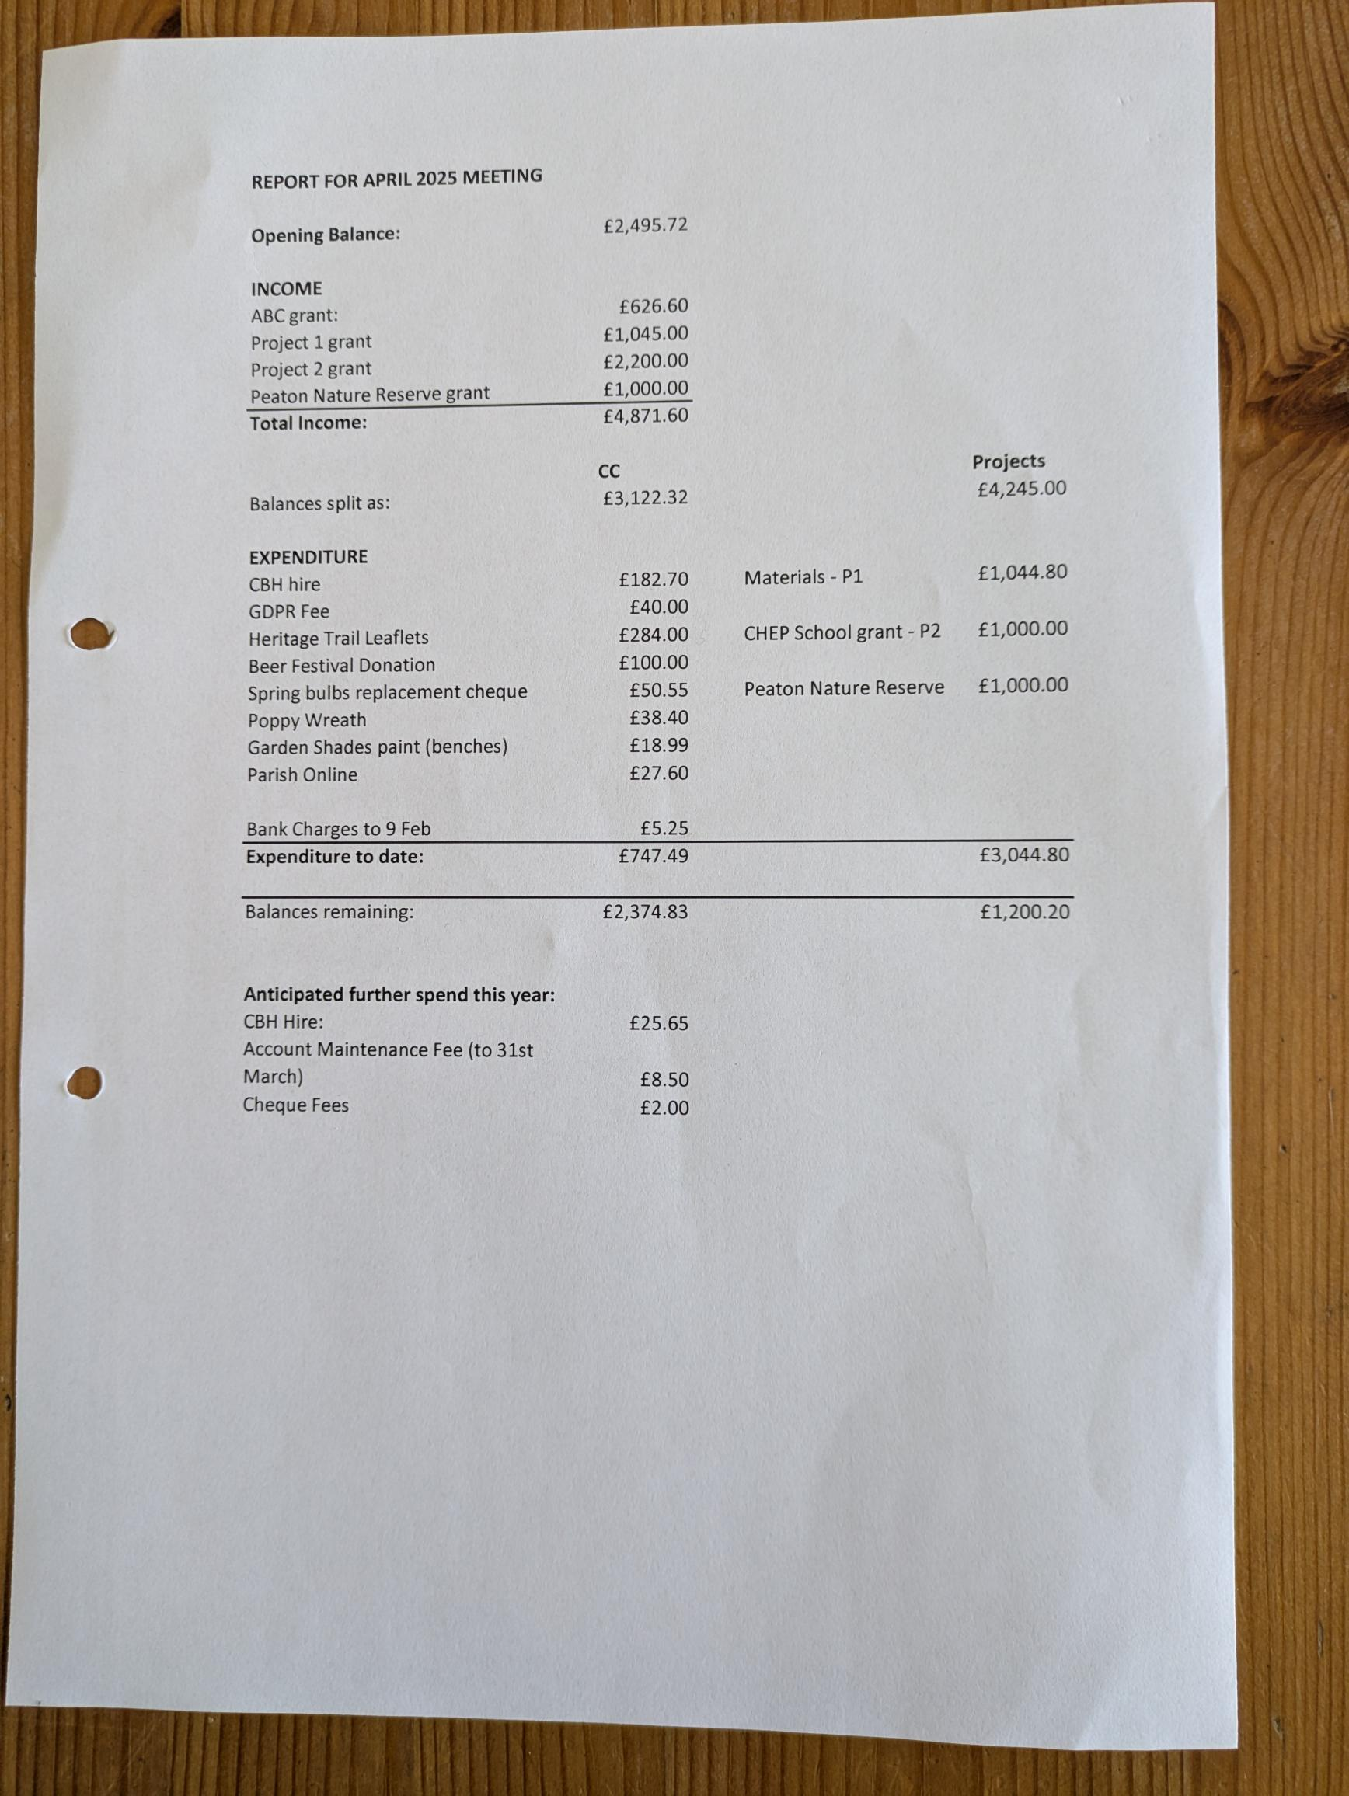

Exploring new approaches for the long term management of land to the shore side of Shore Road from Peaton to Kilcreggan Village
Note that this was tabled but has not been taken forward as the C&K Trust has set up its own working group and the CC decided that it would await the outcome of that process.

Introduction
Note that the initial focus is on the land owned by the Cove and Kilcreggan Trust but the proposal could be open to all landowners (public and private) with land on the shore side of Shore Road between Kilcreggan Village and Peaton.
- The Cove and Kilcreggan Trust manage the land on the shore side of Shore Road from near Kilcreggan Pier through to just North of Auchengower (with some ‘cut-outs’ e.g. for Scottish Water or private landowners). There are other landowners beyond Auchengower.
- The C&K Trust is both a Charity and a company limited by guarantee.
- The management of the land, including sea walls / gabions is becoming a focus of attention as resources for land / infrastructure management are highly limited and previous arrangements with Argyll & Bute Council are no longer working or possibly unaffordable;
- There is an increasing cost of the public liability insurance for the C&K Trust – taking approx. 1/3rd of income each year.
- There are approximately 130 properties (not households which may be higher due to one property having multiple apartments) between Donaldsons Brae and Auchengower. Beyond Auchengower there are approx. an additional 30 properties.
- There is an increasing ‘churn’ of ownership of properties with householders not necessarily undertaken the ‘ownership’ of the land on the shoreward side of Shore Road down to the low water mark i.e. including the beach area (according to the maps prepared when C&K Trust took over the land from Kilcreggan to Auchengower). Ownership of land north of Auchengower remains to be publicly identified but is likely to remain primarily with the main farms in the area and / or MOD.
- It is acknowledged that the land on the seaward side of Shore Road is used by many people in the Cove and Kilcreggan Community Council area and beyond.
- Pressures on the land owned not only by C&K Trust but by local landowners include (but are not limited to):
  - invasive species,
  - climate change and rising sea levels,
  - plastic pollution on the beaches and rocky areas,
  - an increased desire for memorial benches and
  - consideration of increased access to sites as well as use for ‘public’ functions;
- One significant constraint for management is that some of the land lies in the Cove Conservation Area (which runs from School Road through to Knockderry Hotel corner).
- Note that in the A&B Council LDP2 the land is part of the ‘settlement’ area (pink on map) https://www.argyll-bute.gov.uk/sites/default/files/2023-10/FULL%20Helensburgh%20and%20Lomond%20Map%20Book.pdf especially maps 47, 55 and 56
- The funding for work is limited and there is no routine engagement by the C&K Trust (and other landowners) with Shore Road householders and other users of the land on the seaward side of Shore Road.
- That some householders do manage the land opposite their property – often with the knowledge of the C&K Trust but it remains a ‘patchwork’ (may be good for biodiversity!) rather than a coherent agreed approach e.g. agreement on which areas for grass and which for bushy / scrubland.

Designing a way forward?
The C&K Trust is coming under increased pressure from some residents concerning the management of the land and, in particular, the cutting of trees / scrubland in the Cove Conservation Area.
The Community Council is interested in developing a more cooperative approach to the management of the Coastal Strip from Peaton through to Fort Road – an area that includes the C&K Trust Land.
There is a need to develop a long term management plan (25 years) which also includes a short term 1 – 5 years documentation, planning and ‘emergency’ action phase. This would lead into a more regular set of actions – including monitoring – that considers the ‘built environment (sea walls and gabions for instance), access, land management, financing etc.
Recommendation to C&K Community Council
To do this it is suggested that the C&K Trust (and perhaps other landowners) form, with the Cove and Kilcreggan Community Council, a technical working group to examine options for management including:
- Governance arrangements and ownership of land;
- Argyll & Bute inputs – especially around ‘sea defenses’ protecting the B833;
- Scottish Water inputs – relating to the sewage system / pumping stations;
- Identify key sites for maintenance including by local householders;
- Identify sites that are under ‘threat’ including from invasive species and where sea walls / gabions may be damaged;
- Consider options for funding including possible annual voluntary payments from local householders on Shore Road (and beyond if interested) to provide funds for routine maintenance e.g. grass / brush management and monitoring;
- Consider options for funding for larger scale work – including with A&B Council / Scottish Water to protect the integrity of the land and Shore Road;
- ?? Other matters

The Technical Working Group (TWG) should comprise two – three members of the Cove & Kilcreggan Trust, a representative of other landowners who own land to the Shoreward side of Shore Road and two – three representatives nominated by the C&K Community Council. The C&K CC would convene the meetings. Costs of the work to be shared between the C&K Trust and the C&K CC but meetings to be held in locations that are 'cost-free’ unless there is a public meeting when it would be appropriate to have a meeting in the CBH.
The TWG would keep formal minutes of meetings which are circulated to the C&K CC members and to the C&K Board Members and placed on the C&K website (with link from Facebook) for wider public engagement.
The C&K CC would offer a simple ‘page’ on the CC website so that key documents from the C&K Trust could be placed in the public domain (improve transparency of the functions of the trust).
Have a leaflet drop (along Shore Road by volunteers) highlighting the roles and responsibilities of the C&K Trust regarding land management and the need, especially in the Cove Conservation Area, of abiding by legal requirements around tree management – including need for planning permission for tree removal.
Note: C&K CC already has mapping software (Community Map Scotland / Parish Online) which can aid documentation of the area.

