Community Council Meeting

Date: 8th October 2024 Location: Cove Burgh Hall, Small Hall @ 1930

- Fire Alarms and Housekeeping
- Present:
John Auld (Convenor), Kenny Barlas, Susannah Conran, Nick Davies, Derek Fowlis, Sheena Lamont, Ellen McVey, Lynda McKenzie, James McLean, Ali Mills, Christine Murdoch (Vice-Convenor), Sheelagh O’Reilly (Secretary) Anne Strachan (Treasurer)
- Apologies
Sheena Edwards, Kathy Gostick,
Cllr Mark Irvine. Cllr Maurice Corry
- Declaration of interest (financial and non-financial interests)
John Auld (Convenor): As the convenor I have had discussions with the Governance Officer at Argyll and Bute Council regarding my ownership of land that is identified for possible development in LDP2. LDP2 forms part of Argyll and Bute Council’s statutory plans for the area and has now been adopted by them. As the landowner for one parcel of land I would follow the current guidance on Declarations of Interest and would not chair the section of any CC meeting dealing with issues specific to that parcel of land.
No other Declarations of Interest were made.
- Police Report
Report circulated and attached to the minutes below.
Note that Christine Murdoch has a meeting with the local Police Inspector on Thursday 10 October. She will provide further information for the Community Council from that meeting.
- Complaint against John Auld – this section was chaired by Nick Davies (ND).
- A complaint had been received from Mairi Benton concerning John Auld (JA) (attached below). This was considered in public in accordance with the agreed C&K CC Complaints Procedure. The complainant was unable to attend the CC meeting.
- CC members had been notified of the complaint in advance and a copy of the complaint had been sent with the meeting agenda. (A copy of the letter is attached to these minutes). ND had sent CC members a further copy, together with a copy of the CC Complaints procedure and the Code of Conduct for Community Councillors in advance of the meeting.
- At the CC meeting, ND explained the complaint, which had been addressed to both C&K CC and the Our Community (OC) Project. It concerned Mr Auld’s conduct at an OC ‘Community Group Consultation’ public event held on 22nd June, alleging that Mr Auld ‘showered the (OC) project with negativity’ that his comments were found to be ‘disrespectful and hurtful’. The complainant called for a Vote of no Confidence in JA as Convener of C&K CC. ND made it clear that there is no procedure for members of the public to call for a vote of no confidence in the elected officers of the CC, but that his behaviour should be judged against the Code of Conduct for Community Councillors.
- JA was invited to respond to the complaint. (copy of his response attached to these minutes). He was then asked to leave the room.
- The Community Councillors discussed the matter in open forum.
- ND then distributed a ‘Secret Ballot’ form (copy attached to these minutes) which invited Community Councillors to record anonymously their individual assessment of JA’s conduct against the Code of Conduct for Community Councillors.
- The completed Secret Ballot forms were collected in by the Secretary who withdrew, in company with (A&B) Councillor Paterson (acting as a neutral witness to the process), to count the results.
- The outcome of the vote was that the Community Council rejected the complaint by a majority vote.
- JA was invited back into the meeting, informed of the result and resumed the chair.

The Secretary will write to the complaint (as per the complaints procedure) with the results of the process and also indicate, as required by the complaints procedure, how they can, if they are not satisfied with the way the CC have addressed the complaint, take this to A&B Council.
- Minutes of the CC meeting held on 13 August 2024
- Agreement of Minutes for signature – signed
- Actions / items not included on the agenda:
  - The Bench working group had prepared a C&K CC policy for village benches (attached below). No objections were received from CC members and the policy had been publicly posted. Formal approval was sought. Members of the Our Community Management group raised the issue of ‘standardisation of signage’. The CC will review the Bench Policy should a standardization of signage be agreed formally by the Community Council when developed by OC in due course.
  - Grass-cutting on C&K Trust land – no update available so the Secretary will take forward with the C&K Trust Secretary (along with the issue raised in item 13 re trees near Knockderry Hotel bend).
  - Peaton Nature Reserve update. Two working parties been undertaken. First Sunday of each month at 10.00. Boardwalk being repaired for short term and hopefully will open again soon. Other work on general maintenance. Sight is subject to surveys from specialists for botanical / birds and invertebrates in particular. Question around the location of the site – on border of C&K area but widely used by residents. Work going forward (including any proposals) would include inputs from adjacent CCs given location and current use profile. This is a highly accessible site and consideration of its use by Cove Park / local schools and others is under consideration. Appropriate governance of any funding would be discussed with Treasurer.

- Convenor
- Community Local Liaison Committee, 30th August 2024 (notes circulated) – Plans through to 2070 and expansion / change to base facilities. See notes from meeting presented below.
- 6th October CBH Open Day: CC present. Event was well attended highlighting that this is a well used facility which caters for a wide range of interests.
- Community Hub: Welcomed the opening on the 1st October at the Post Office.
- Email from Helensburgh Community Council (see below). The CC agreed to reply suggesting that a H&L CC meeting be set up with the A&B Council Planning / Building Control department to enable sharing of lessons, common issues etc. This could be modelled on the H&L Community Planning Partnership meetings that enable efficient sharing between CCs and A&B elected officials and other agencies. This could then take place in parallel with work to be coordinated by JM regarding issues in C&K and planning (see item 16).
- Management of CC Correspondence. Written to Council. It was agreed that the current protocol where the Secretary writes to A&B and other agencies as requested at the Community Council meeting. When replies are received these are then circulated to members. Where material is relevant to discussions at the CC itself correspondence is attached to the minutes.
- Accidents on Barbour Road. The Community Council noted that there have been two recent head on collisions on Barbour Road. No serious injury / death. As CM is meeting with the police inspector on Thursday 10/10/24 she will raise this issue. Speed management on a narrow road (core path) is currently an issue given this has a national speed limit rather than a more appropriate lower level..
- Bad weather access / snow / gritting routes and state of gritting bins etc. SOR asked if any photos of gritting bins could be forwarded so that these can be documented. Will put up the current gritting lorry route onto Facebook and seek additional evidence e.g. top of School Road / Barbour Road (raised at the CBH on 6/10/24).
- Helensburgh Parking. Noted the notification from A&B Council and will continue to monitor but it looks as if paid parking is to return to key car parks in Helensburgh, but timing of this and conditions are not yet clear.
- The community council acknowledges the email from H&R Ferguson thanking them for actions regarding the clearing of gulley’s along Shore Road.
- Changes to electricity meter telemetry (see below for details). This issue was raised by Alistair Reynolds and is an issue that will affect many properties not only in C&K but more broadly across A&B and Scotland. This affects properties that have a ‘triple rate supply’ meter that is managed through Longwave signals. The longwave service is due to be switched off next year leading to a significant problem of replacement of these meters which may lead (as per the BBC) to challenges in ongoing supply for heating / hot water. Matter to be posted on Facebook and AR will take forward with the MSP on 18th October. Also of relevance for A&B Council
- Treasurer
- Current status including update on change-over of account signatures. This remains ongoing and necessitates visits to Glasgow as cannot be done in Helensburgh. Issue then of receipts for travel and car-parking. CM indicated that it might be worth exploring Affinity as seems to be more straightforward to see up an online business type account.
- Accounts circulated (see below) which highlights that the CC current has a balance of over £2500. Discussion on how to use this money (whilst keeping a reserve) including notice boards / benches/ paint costs (Proposed ND / SC for £27 for blue paint). Review costs of a picnic table for Cove (opposite shop).
- Retain records for 6 years (GDPR) or as required by the grant funder.
- Issue of difference between claim (£1044.80 based on receipts) to University of Glasgow National Centre for Resilience and their payment of £1045. All paperwork etc. is available for this grant which was paid retrospectively.
- Update on Our Community Project
- Written update provide by OC (see below).
- No grant application to CEIS was made in September (as previously indicated might happen). It is possible that this might take place in January 2025 but CEIS funding is constrained.
- An issue was raised of the publication of material from the last two meetings on the website and the fact that when the ‘contact form’ is completed no response is given (not even an automatic reply indicating receipt). AM indicated that the presentation by Scott Simmons will be published on the website in due course.
- Community and Household Emergency Planning update
- A leaflet campaign around winter preparedness has commenced and will take place over the next 2 weeks. Aiming for around 85% coverage of houses supplemented by Facebook / web material.
- Mapping of flooding sites (actually and possible) ongoing with several new areas indicated at the CBH open day on the 6th October.
- SFRS have been given permission to store sand / sandbags for local use. Now in discussions with A&B Council regarding provision of suitable sand. There is some money in the budget to purchase the hessian sacks. Question of disposal if contaminated – but will liaise with SFRS on this matter as most will be for surface water rather than sewage / oil spills.
- Payment (£1000) to Kilcreggan School now taken place. Covers work for this year and next year. Meeting with school on 2nd October to discuss approach. Will be a ‘show and tell’ event on the 4th December. Further details nearer the time.
- Will continue to work with tourist businesses around how they manage any issues with their guests to reduce the strain on local services in the event of a major outage.
- Issues of gritting routes / gritting bins raised on 6th October. Will publicise the routes and see if we can document status of the gritting bins.
- Ferry and Pier
- Transport Scotland commissioned a ‘Community Needs Assessment’ and the 100 page report from the consultant is available on the Transport Scotland website. The Community Needs Assessment will be used to support the Business Case for replacement vessels to be presented to Scottish Govt. in the future.
- The Rosneath peninsula section contains useful background statistical information and identifies that, benchmarked against an ideal service, there ought to be Sunday sailings. That is therefore identified as an option, but so is ‘no change’. Later sailings have been requested, this might be possible through triangular runs with Dunoon.
- Transport Scotland ran a ‘drop in’ consultation in CBH pm 1st October which was well attended. A good rapport was established with the A&B Ports & Harbours Officer. While no promises were made regarding potential options for Kilcreggan port infrastructure, there was a good understanding that further meaningful consultation with the community needs to take place.
- A&B Ports & Harbours Officer has been added to the Our Community stakeholders list.
- In response to a request from a Coulport commuter, Calmac adjusted the 0730 sailing from Gourock which now departs at 0725, thus connecting more reliably with the service bus to Coulport.
- Roads / Paths / Lighting / Drainage etc
- Tigh Dearg – update. ongoing
- School Road update ongoing
- Drainage: Gulleys, ditches and regular maintenance to minimize including plan (not yet made available to the CC)
  - Clearing drains above Meikle Aiden / Kyle View. Council cleared the gulleys on Barbour Road above Kyle View. Unfortunately there was then a hedge cutting event with material into the gulleys. Now been cleared but need to avoid issues of mis-communication. Gulleys will require monitoring for leaves / silt etc. in the coming months.
- Overhanging trees / mossy pavements. Update from Cllr Irvine not available.
- Deer Management – note the Nature Scot report including deer management pilots in the central belt (waiting for output from local trials). Whilst there are people licensed to shoot deer locally (usually involved around deer / vehicle accidents) there is no control plan for this area and it was agreed that the outcome of the Nature Scot work should be considered in due course to based any plan on the latest scientific evidence around deer management in built up areas.
- Kilcreggan Bus Shelter repair (Cllr Corry not present). SL sent details as requested at the last meeting.
- Mirrors at bottom of School Road. This was raised again by a local resident. For information the response from A&B Council to a previous email from Cllr Irvine is attached for reference. Whether a 20 mph speed limit on Shore Road would reduce risks of collision was discussed. Issues of the current height of the speed bumps on School Road (reduced) and whether a chicane might be better but access by school bus could be an issue.
- Trees at Knockderry Hotel corner – Secretary to send email to C&K Trust Secretary (along with the grass-cutting issue).
- Noted the issue of North Ailey Road and run-off from the farm (JM)
- Licensing
No matters for discussion
- Community Council Planning Policy
- See issue regarding engagement with planning in response to the email from Helensburgh CC above.
- Issue of developers / incomplete sites. No response received from A&B Planning Department (Fergus Murray on the suggestion of Cllr Corry) regarding this issue. There are a number of sites in C&K which are of concern regarding their status for both residents and neighbours. It was agreed that JM would produce a factual paper detailing the sites / issues for circulation to the Community Council members for discussion and agreement of approach to future actions on this issue. For instance compliance with existing legal requirements – is this not happening by developers and checked by purchasers of property (e.g. housebuilding certificates), or are the current standards not being followed up effectively by A&B Council building standards or is there a possible requirement to change current regulations. The latter would then necessitate engagement with MSPs / Housing Minister as would fall within the Scottish Parliaments remit rather than A&B Council.
- LDP3 – awaiting material from OC process re the Local Place Plan.
- Planning Applications (details of applications on A&B website)
- Update on Fish Farm appeal. Nothing and no timescale for the decision.
- Auchengower: see below for email correspondence with A&B Council regarding this site. It was agreed that CC members would send the secretary their observations on this response so that the CC can agree a full reply Is it noted that during the meeting Mr McLean referred to private correspondence he has had with the Planning Dept on issues surrounding Auchengowerl.
- Giants Burn. Request that there is on-going engagement with this. Issue of potential ‘compensation’ to local communities. No response to previous update on Facebook – is there a community interest in this? Consider again at the next meeting when dates for further consultation with Statkraft may be available.
- Concern raised regarding the road access to the site at top of Millbrae and the B833. Secretary to write to Roads Department regarding clear road marking / delimitation especially in winter / dark conditions. .
- Any Other Competent Business
- The Community Council was asked to note the state of the shop at the bottom of North Ailey Road – which is in the Cove Conservation Area. .
- Wreath for Remembrance Sunday ordered by ND. Cost £38.40..
- Noted local connection to the last time UK were involved in the America’s cup final.
- Date of Next Agreed Meeting December 10th.

INSERT NAME | Community Council
Dates covered by this report: | 13/08/24- 05/10/24
Location: | Cove and Kilcreggan
Reporting Officer: | PC Ailsa Gill and PC Cameron Macpherson


Appendix: Police Report for 08 October 2024

Number of calls to police | Between the dates of 13th August 2024 and 5th October 2024, there have been a total of 19 calls to the Police from the Cove and Kilcreggan area.

Local Policing Priority | Local Good News | How can you help?
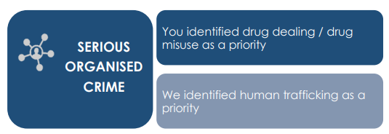 | Cowal, Bute & Helensburgh benefits from a dedicated Pro-active Serious and Organised Crime Team (SOCT). These specialist officers are supported by dedicated intelligence officers in tackling serious and organised crime in our communities.  We have been upskilling officers across Argyll ensuring they understand and appreciate the importance of community intelligence and information. This information is key are often results in the targeting of those involved in the sale and supply of controlled drugs. | Community information is key for us and may just provide us with the last piece of evidence required to apply to the courts for a warrant.  We encourage our communities to share concerns and suspicions around drug dealing either by calling 101 or by reporting anonymously via Crimestoppers 0800 555 111  Crimestoppers in Scotland | Crimestoppers (crimestoppers-uk.org) 0800 555 111
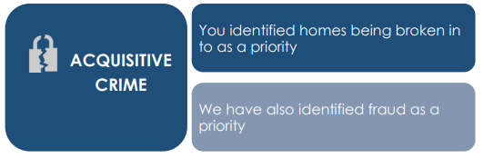 | Acquisitive crime remains a local priority. Figures across the country are on an upward trajectory, which in part is a result of the cost-of-living crisis. We are working with our Preventions team looking at maximising our crime prevention opportunities and looking at innovative ways to increase local awareness.  We are working with our communities to identify areas of vulnerability where we can engage with our partners to maximise our response.  In the local area we encourage everyone to be extra vigilant when it comes to the security of your household and other external buildings. We understand that most homes in the community do not benefit from public street lighting which can leaves some properties not being lit well. We encourage everyone to take appropriate action when it comes to improving the resilience of their security.  Fraud Prevention  Frauds and scams continue to be a focus as offences are still being reported on a regular basis and we would welcome invites from any community groups or organisations in the Helensburgh and Lomond area who feel they could benefit from an input from our preventions team. | Your local police would like for your Community Council to help us by following us on our social media channels and help us spread crime prevention advice and guidance.  Security could be improved by simply installing security lighting and or CCTV, by doing so this gives an extra barrier to stop potential housebreakers from entering your homes. We would also like you to report any suspicious behaviour you see in your local community.

Local Policing Priority | Local Good News | How can you help?
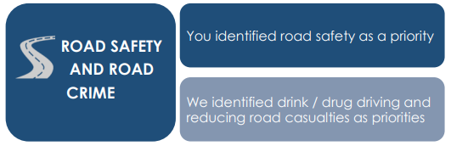 | Road Safety remains a local policing priority across Argyll & Bute. We have been working closely with a host of partners delivering various initiatives and events to improve decision making and influence driver behaviour across our communities. For example, at the end of April this year, within the grounds of Hermitage Academy we hosted an event where our communities are encouraged to attend to hear and learn from driving specialists and health professionals. These events have had great feedback and really help us to influence driver behaviour.  We participate in the Cowal Transport Forum which provides a wide range of community members the opportunity to engage directly with local policing giving us a great opportunity to listen and identify local risk and to provide a suitable policing response. | Your local police would like for your Community Council to help us with ensuring Road Safety by  by reporting anyone who is suspected of drink or drug driving within your community either in person via 101 or via crime stoppers online:  Crimestoppers in Scotland | Crimestoppers (crimestoppers-uk.org) 0800 555 111
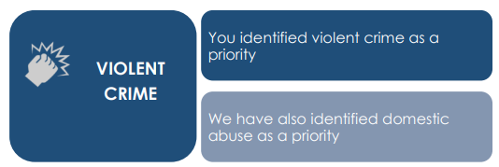 | Violent crime continues to be closely monitored and reviewed with investigations being resourced across Local Policing Teams and the Criminal Investigation Department.  Each crime is subject of daily review and scrutiny and thereafter allocated to the most appropriate department to progress to assist in identification of repeat victims, offenders and locations. Any emerging issues and risks are shared, and appropriate actions identified  Across Helensburgh and Lomond, we continue to support our nighttime economy by providing a visible presence in our licensed premises. Weekend policing plans allow us to maximise our efforts across our towns as we look for opportunities to reduce early signs of anti-social behaviour which may escalate into violence. We often work with partners to maximise our presence.  In Helensburgh the Royal Navy Police continue to attend shift meetings learning about priority tasking and supporting local policing across the town. | Your local police would like for your Community Council to help us with tackling Violent Crime by reporting any ASB or community concerns either in person via 101 or via crime stoppers online:  Crimestoppers in Scotland | Crimestoppers (crimestoppers-uk.org) 0800 555 111
 | Throughout the summer months, we have been engaging with partners across various organisations to consider how we can work together more efficiently to tackle the seasonal Anti-Social Behaviour that we often see.  We have a team of 3 Local Community Officers who work from Helensburgh who are the eyes and ears for the local community. They aim to:  - Build positive relationships with local business and community.  - Engage with and support night-time community  - Robust ASB plans at the weekend  - Not solely for the town centre and will ask them to patrol small villages across area | Your local police would like for your Community Council to help us with helping Public Protection by reporting any concerns you may have regarding potential victims of Domestic Abuse or vulnerable persons, who may be being exploited or who may just need additional crime prevention support to us either in person or anonymous

Useful Links/Contacts

- Argyll and Bute Communtiy Directory - https://abcd.scot/ including warm spaces information
- Crimestoppers – Crimestoppers in Scotland | Crimestoppers (crimestoppers-uk.org) 0800 555 111
- Scottish Partnership Against Rural Crime – www.scottishparc.co.uk
- Women’s Aid - Home - Women's Aid (womensaid.org.uk)
- Citizens Advice – 0808 164 6000
- Argyll and Bute Council Trading Standards – 01546 605 519
- Argyll and Bute Council – https://www.argyll-bute.gov.uk/my-council/how-contact-us
- Transport Scotland – road related incidents and road closures - https://www.traffic.gov.scot/traffic-information/incidents
- Scottish Water - https://www.scottishwater.co.uk/Help-and-Resources/Contact-Us 0800 0778 778
- NHS24 (including mental health support) – 111 or https://www.nhsinform.scot/

Follow us on Social Media and help share loacl appeals and education messages
- Facebook - Police Scotland Argyll and West Dunbartonshire
- X (formerly Twitter) – PSOSArgyllBute and PSOS ArgWestDunb

Sign up to Neighbourhood Watch to receive local alerts and bulletins for your community area - https://neighbourhoodwatchscotland.co.uk/#0

Have your say on your local policing priorities - https://consult.scotland.police.uk/strategy-insight-and-innovation/your-police-2023-2024/

Please Contact the officer below with any feedback or concerns raised at the meeting for further considerations or police action.

Report Completed by | PC Ailsa Gill and PC Cameron Macpherson
Contact | Email Adress Ailsa.gill@scotland.police.uk cameron.macpherson@scotland.police.uk

Appendix: C&K Community Council Bench Policy

C&K CC policy for village benches
The villages of Cove and Kilcreggan are blessed with a south facing seafront with attractive views across the Clyde estuary. The provision of benches and picnic tables allow both locals and visitors to enjoy the scenery.
Argyll & Bute Council will no longer provide or maintain benches and so maintenance inevitably falls to local volunteers or the Community Council. Replacement or provision of new benches occurs through local initiative, paid for by the Community Council, or by groups such as The Women’s Institute, or provided by families ‘in memoriam’.
Given the voluntary aspect of bench provision, it is not practical to define a standard bench design, however persons or groups considering the provision of a bench in Cove and Kilcreggan are encouraged to consider durability and robustness. Soft wood is best avoided as it doesn’t last; Hardwood or re-cycled material are better options, being longer lasting and requiring less maintenance.
It is essential, before arranging a bench on the Cove and Kilcreggan seafront, that the ‘Cove & Kilcreggan Trust’ are consulted as they own the coastal strip.

Appendix: Key points from the meeting held on 30th August 2024 of the Clyde Local Liaison Committee
- Attended by 3 elected councillors (Irvine, Corry and Howard), regulators including DNSR (Defence Nuclear Safety Regulator), SEPA. Local Community Councils including Cove & Kilcreggan, Rhu & Shandon, Rosneath & Clynder, Helensburgh and Ardentinny. Ambulance Service, SFRS, Police Scotland present along with A&B Council Civil Contingencies Unit.
- Issue of how ‘adequate’ is measured in relation to ratings by regulators. This is a binary definition (adequate / not adequate) in relation to the relevant regulations used by the regulator to assess Faslane, Coulport and related assets.
- Development of Clyde 2070 ongoing which is likely to lead to an investment of 10 – 20 Billion to transform HMNB Clyde both in / outside the wire. Includes a contribution to the community and economy, upgrading of facilities and assessment of Value for Money / Capacity of Suppliers. This is a ‘vision’ for the base which was not previously in place.
- To end of 2023 there has been a reduction in visits of Nuclear Powered warships but an increase in maintenance and therefore days on site. Partly due to the increasing age of submarines. There were visits from 7 non-UK Nuclear Powered Warships.
- Nuclear Support Hub not yet finished and so commissioning still to take place. Decommissioning of the old site will see waste processing in line with SEPA regulations using specialist contractor.
- Crane demolitions on going.
- In early stages of work in Glen Mallan re submarine weapons loading work.
- Working (project Euston) on increasing docking site at Faslane.
- Coulport (linked to 2070 plan) upgrading of security and other infrastructure including the EHJ and crane. Question asked around A814 road closures but not seen as likely.
- w/c 22 August say a Level 2 ‘scenario’ test at the off site centre to examine / test procedures and processes in the even of an emergency around an incident relating to a nuclear reactor. The last one of this scale was in 2018. This is a ‘what-if’ stress test and does include issues such as weather restricting access to / from area. A multilevel process which also includes consideration of use of Police Scotland Govan Response Centre in the even of of access challenges. Lessons learnt inform future planning (A&B Council access to systems) in relation to HMNB, wider MOD systems as well as cooperation in the event of other major incidents. Note that A&B Council work on Civil Contingencies includes all risks except Nuclear Power Station and Prison. Work of CCU also helps to promote resilience / Business Continuity etc.
- Radioactive waste management. Faslane deals with solid and liquid (Cobalt 60) waste and Coulport with gaseous waste (Tritium). Inspections carried out by MOD / SEPA / DNSR. This is under the Radioactive Substances Regulations. Small volumes – solid waste to incinerator down south.
- With the development of the Nuclear Support Hub SEPA new approvals with new disposal limits and conditions. These are comparable with civilian permits e.g. nuclear Power Stations. This new permit then consolidates all existing permits.
- Identification of number of near misses i.e. reporting and identification of risks before accidents happen. Proactive development of a good culture in this area. The increased activity also sees increased reporting. Looking more at trends. Triage reporting to enable attention on issues.
- With Nuclear Site Reporting there has been an overall decrease in events (prevention) and of those raised an increase in the number below the ‘scale’ i.e. very small.
- Inputs from the Regulators:
  - SEPA: 4 new staff in Radiation Services. Review of Letter of Agreement to one new agreement. Joint inspections with ONR / DNSR. Production of RIFE (Radioactivity in Food and the Environment https://www.sepa.org.uk/environment/radioactive-substances/environmental-monitoring-and-assessment/reports/ ) with RIFE 29 due out in October. Levels low and similar to previous years.
  - DNSR: spend 1 week per month at Faslane. Undertakes comparison with other sites. Report on recent work due soon.
  - ONR (Office of Nuclear Regulation) – apologies. Was involved in the review 22/8/24.

Email from Helensburgh Community Council
Dear Secretaries and Convenors (in some instances)
We are mailing you as peer community councils in Argyll and Bute to alert you to a methodology being used by A&BC to push through yet another proposal for a supermarket on Helensburgh’s waterfront.
We have, through our own surveys, made A&BC aware that the community neither wishes, nor requires a supermarket on the pierhead, but a Councillor recently suggested that it made sound financial sense for Kilmory, And that’s that!
The Council-propelled development is notable for the following characteristics:
Secrecy: Very tightly maintained. The concept and information has been generated by the officers and is held by the officers. Questions from the public are not forwarded to Councillors- our locally elected Councillors are largely in the dark… FOI questions to the Council are brushed aside or delayed.
Community Engagement: The Helensburgh Waterfront Community Engagement of June 2023. Hastily convened and advertised, the A&BC report is devoid of any real data, moreover the sessions were exceptionally poorly attended (total of 83 people). Helensburgh’s population is ca.15,000+
Retail analysis: barely! A revision of Collier’s ‘town centre’ data originating from 2007. Inaccurate, underestimates total meterage already available; makes no allowance for growth in online shopping.
We would appreciate your support from two angles:
Firstly, we wish to learn if this is an endemic issue (as we suspect)- or a local one.. If you recognise these traits from A&BC projects in your own areas, then we would really like to hear about them.
Secondly, we would ask for your support. Please email your local A&BC Councillors in support of our community that wants the Council to reject this ill-thought proposal for a supermarket on this key site. Please ask your communities, through social media, to support our petition at https://www.change.org/p/stop-the-supermarket-on-helensburgh-s-waterfront
Hoping to hear back from you!
Norman McNally
Joint Deputy Convenor
Helensburgh Community Council

Appendix: Replacement of Radio Telemeters
I live at Ardpeaton and I have run up against a problem which may be of significance to others in the Cove and Kilcreggan Community Council area. Since there is no mains gas supply in this area, like many others I rely on electricity alone for all my home energy needs so I have a triple rate supply for day, night (off peak) and control (for storage heaters). I pay Scottish Power for my electricity by monthly direct debit based on monthly meter readings from my telemeter which I have to provide. Two years ago, I had new replacement modern storage heaters installed as the only practical method of heating my old Victorian property. I believe there are many thousands of consumers in Scotland and the wider UK who are in a similar position and you may have seen press coverage about this recently.
Scottish Power advised me a few weeks ago in a circular email to contact them about making an appointment to have a smart meter installed in view of the termination of the radio telemeter service, which relies on long wave radio signals, in June next year. I was advised that I could not make an appointment to replace my meter yet, to register my interest (which I did) and to await further advice. Based on my past experience with Scottish Power I was not totally reassured by this and wrote to them by email and an unsatisfactory exchange of emails ensued which referred to the incompatibility of my supply and even suggested I find another source of heating! As I mentioned, there is no mains gas here and anyway I thought we were supposed to be moving away from fossil fuels. I spoke to the very sensible and practical electrician who installed my heaters: he sympathised but could not provide any further information.
I decided to ring Scottish Power and after some consultation with a colleague, the adviser I spoke to referred me to an Ofgem press release which can be found here: Energy sector taskforce unites to tackle Radio Teleswitch challenge | Ofgem (https://www.ofgem.gov.uk/press-release/energy-sector-taskforce-unites-tackle-radio-teleswitch-challenge ) She said that whilst SP do not have a suitable meter for people like me at the moment, they will not leave us without a supply and they will be in touch by 31/12/24 to advise me what they propose as per the Ofgem press release. I was asked after the call for my satisfaction rating – I gave them 2 out of 5 and said that I am not reassured!
There would appear to be a very large problem here which the electricity companies have failed to address in a timely manner and I have serious concerns that they will fail to do so by the deadline as there are apparently hundreds of thousands of meters to be replaced nationally in a period of 8 months! There would seem to be a very real risk that many of us might suffer significant disruption to our electricity supplies next year. I think that some additional political pressure might need to be applied and I have written to Jackie Baillie MSP asking for her assistance. I will hopefully meet her at her next surgery in Helensburgh on 18th October. One possible solution might be to extend the radio telemeter service until new equipment has been fitted for everyone affected but I think that would require political pressure.
I would appeal to others who may be affected to pursue this issue.
Alasdair Reynolds 08.10.24
From C&K Secretary - For additional information posted on the BBC website see:
BBC News - Customers face heating problems if meters not replaced
https://www.bbc.com/news/articles/cx2402zzwg1o

Appendix: C&K Accounts at October 2024

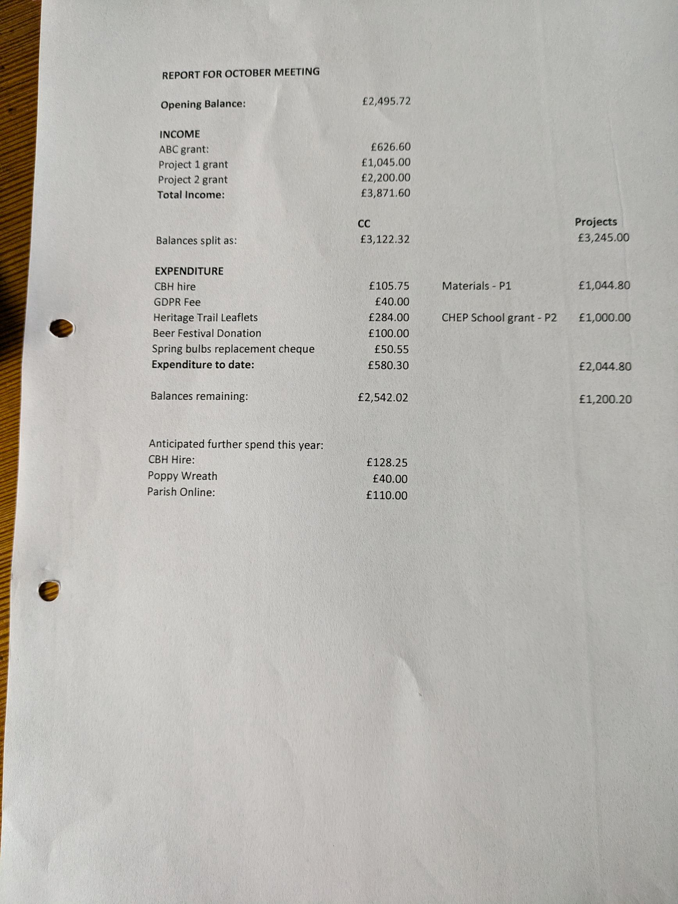

Appendix: Written update from Our Community

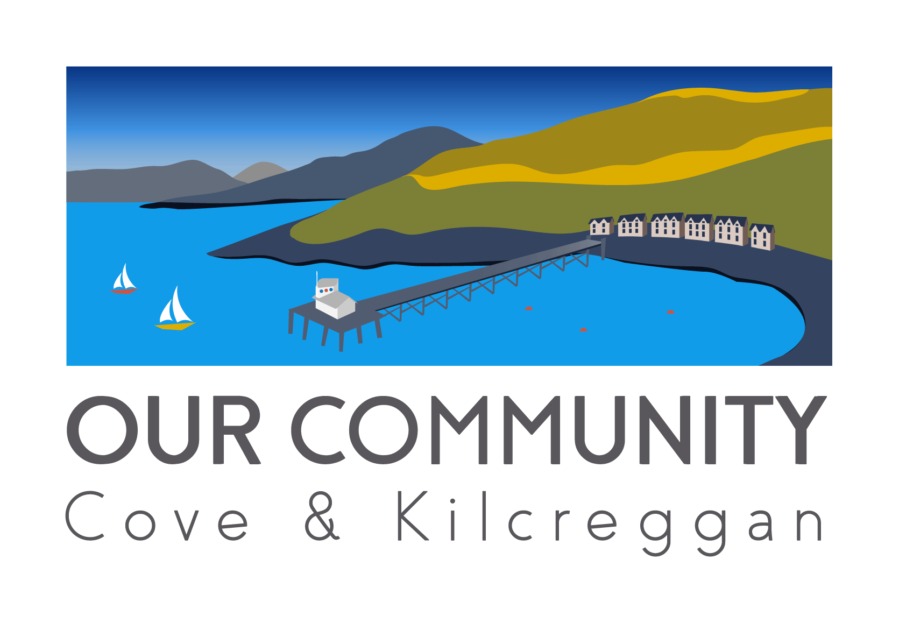
Coveandkilcreggancommunity.com

Our Community Update for Community Council September 2024

Various website links:
See the latest financial statement (September 2024) on the website, here.
See the updated Road Map to the LPP here
See more information on the October community mapping (What Goes Where?) process here
Feedback is very welcome on any website content. Please contact hello@coveandkilcreggancommunity.com.
Year 4 Funding
The Strengthening Communities Program is no longer issuing funding, except extension funding to communities already on the program. As such, we have been automatically included in the decision process. Communities from all three of the governing bodies (CEiS, DTAS and HIE) are being considered, not all will be successful. There is no additional application process. CEiS have confirmed with us that a decision will not be made until early spring 2025 and that, if awarded, the funds will have the similar constraints as the current funding.
We remain consistent in meeting with CEiS monthly in the meantime.
Further updates
Kilcreggan Village
There are number of on going initiatives relating to the priority area of KV Village and Bay.
3 workshops have currently been delivered. One in the Creggans, one in the Scout Hut and one in the CBH. The first two were consultative, the third bringing together those ideas into presentations, delivered by the OC groups.
Details of the presentations given were written about in a recent Lochside Press article and on the OC facebook page. The sessions were captured on video and will also be available for viewing on the website in due course.
The fourth event in the series (5th October, 10.30 Scout Hall) will see Scott Simmons Landscape Architects produce draft spatial and functional diagrams for comment, from the ideas from the first two workshops, and from the community groups.
Also in process is the commissioning of a parking survey.
Mapping for the whole area
Please see Geodesignhub for more information on the external team who are coordinating the process.
The KV work will also feed into this process.
This series of events is called ‘What Goes Where?, all events and event details are on the website.
Technical assistance will be provided at the 26th October event to promote accessibility and inclusion in the process. Further assistance is being organised at a drop in session during the survey period (TBC… I write this 2 weeks before the CC meeting).
The publicity for the process will, in addition to our usual advertising, go out to all households via an advert in the Community Advertiser (and a separate flyer included in the September edition).
In addition to it being a public process, additional stakeholders are invited to take part (ABC, Councillors, MSP’s etc).
Inclusion, publicity and further consultation
Footpaths group have compiled an upcoming survey monkey to be released shortly and continue to look at knotweed options to support path initiatives.
Clearwater ran a survey following a well-attended beach use event, over 80 respondents.
Members of the OC team recently had a place at the very well attended School Fete to continue to raise awareness of the project and to keep momentum and engagement through these last phases of consultation. ( On a side note, congratulations to the Primary School PTA who raised over £1200 net to fund the whole school going to the Christmas panto).
OC beach clean 29th September.
The OC team also have taken a table at the CBH Open Day on the 6th October where more information will be available.
All OC events are publiced via website, facebook, posters, village banners and word of mouth (and community advertiser).
On going regular updates via Facebook (https://www.facebook.com/CoveKilcreggan)
All decisions, strategy, challenges, opportunities and spends continue to be run through CEiS, the Steering Committee and the Board of Directors of the RPWCDT.
A reminder that the funding is not for capital investment. The funding profile and project milestones (indicated at awards stage) are available in the documents section of the website.
The Trust is now registered with Volunteer Scotland and able to process PVG checks to promote a safe space for youth inclusion.
Thank you for your ongoing support, interest and engagement in creating opportunities for change in our communities. Please get in touch anytime with questions via Facebook messenger or e mail (hello@coveandkilcreggancommunity.com).

Appendix: Mirrors at bottom of School Road (previous correspondence from A&B Council)

From: Argyll & Bute Customer Service <customerservices@customerservices.argyll-bute.gov.uk>
Sent: 13 October 2023 11:35
To: Irvine, Mark <mark.irvine@argyll-bute.gov.uk>
Subject: Roads Safety Incident [Incident: 231011-000642]

 | 
  You recently requested assistance from us on a Council related matter. Below is a summary of your request and our response.
  Subject
  Roads Safety Incident
  Community Council
  Cove & Kilcreggan
  Response By E-mail (Ewan McKellar) (13/10/2023 11.34 AM)
  Dear Councillor Irvine,
  Thank you for your recent enquiry regarding the placement of roadside mirrors. Whilst I can appreciate why you may wish to install a roadside mirror I would advise that Argyll and Bute Council to not permit mirrors to be placed on the roadside for the following reasons:
  • In certain lighting a mirror can reflect light and interfere with a passing driver’s visibility and/or create a distraction
  • In winter conditions, mirrors can become obscured by frost/snow, becoming ineffective
  • It is difficult to accurately judge the distance and approach speed of vehicles in a roadside mirror
  • If a mirror is not well aligned, or if there is a wide approach, it can be difficult to see approaching vehicles when they are further away, so drivers may be under the impression that the road is clear even though there are oncoming vehicles
  • Pedestrians and cyclists may not be particularly visible as they are often in the periphery of a mirror
  • Drivers using mirrors may unreasonably rely on the mirror without using normal caution (driving slowly, listening for traffic), resulting in a false sense of security
  • If a mirror becomes dirty or damaged then they become ineffective
  I trust this is of assistance.
  Kind regards,
  Ewan McKellar
  On Behalf of Raymond Kane
  Response By E-mail (Ewan McKellar) (12/10/2023 10.41 AM)
  Dear Councillor Mark Irvine,
  Thank you for your enquiry, I've sent this across to the relevant officers regarding the placement of a traffic mirror, I'll look to provide an update within the next couple of weeks.
  Regards,
  Ewan McKellar
  On behalf of George Morrison
  Roads and Infrastructure Services
  Customer By (Mark Irvine) (11/10/2023 06.55 PM)
  This enquiry was shared with the following members:
  iainshonny.paterson@argyll-bute.gov.uk
  maurice.corry@argyll-bute.gov.uk
  Customer By (Mark Irvine) (11/10/2023 06.55 PM)
  Subject from Member: Emerging Traffic - visibility Mirror
  Enquiry Details: Traffic emerging from School road have no visibility splay - and are emerging into traffic by 'guessing'.
  Given that this is the main road used by parents with children in their cars it would seem sensible to consider a mirror mounted on the opposite side of the road (on the bus shelter perhaps) that would offer much improved visibility for drivers - particularly in the dark, winter and poor weather conditions.
  Auto-Response By (Administrator) (11/10/2023 06.55 PM)
  Thank you for your recent Road Safety enquiry (ref: 231011-000642.). We aim to resolve your issue as soon as we can.
  To avoid you having to contact us for a progress update, we aim to respond within 5 working days for simple issues and 20 days for more complex issues. If required, you are welcome to contact us after that by replying to this email.
  Question Reference # 231011-000642
  - Date Created: 11/10/2023 06.55 PM
  - Date Last Updated: 13/10/2023 11.34 AM
  - Status: Follow-up Response Provided



Appendix: Achengower
Good morning,
Please see below the email from Emma Spence (Argyll & Bute Council) regarding Auchengower and my ‘holding’ response.
This item is on the agenda for the meeting on the 8th October.
With best wishes,
Sheelagh

From: Sheelagh O'Reilly <sheelaghoreilly@hotmail.com>
Sent: 04 October 2024 17:56
To: Spence, Emma <Emma.Spence@argyll-bute.gov.uk>
Cc: Sweeney, Kirsty <Kirsty.Sweeney@argyll-bute.gov.uk>; Corry, Maurice <Maurice.Corry@argyll-bute.gov.uk>
Subject: Re: Auchengower Update [OFFICIAL]

Dear Emma
Thank you for your email with the update on the situation at Auchengower. I will circulate your email to the Cove and Kilcreggan community council members.
The issue is on the agenda for the meeting if the 8th October. I will, of course, update you with any ongoing concerns following that meeting.
With best wishes
Sheelagh O'Reilly,
Secretary Cove and Kilcreggan Community Council
Sent from Outlook for Android

From: Spence, Emma <Emma.Spence@argyll-bute.gov.uk>
Sent: Friday, October 4, 2024 5:22:52 PM
To: Sheelagh O'Reilly <sheelaghoreilly@hotmail.com>
Cc: Sweeney, Kirsty <Kirsty.Sweeney@argyll-bute.gov.uk>; Corry, Maurice <Maurice.Corry@argyll-bute.gov.uk>
Subject: Auchengower Update [OFFICIAL]

Classification: OFFICIAL
Sheelagh,
As discussed please see below update to share at the next CC meeting on 08.10.2024
- Planning enforcement case 24/00057/ENOTH2 refers to the siting of three unauthorised caravans adjacent to Shore Road within Auchengower Caravan Park.
- The Park is not within the Conservation Area.
- Whilst the siting of the caravans are unauthorised, it is considered that with the application of planning conditions- such as landscaping and occupancy, this development may be supported.
- It appears that trees and vegetation have been removed to allow for the siting of the caravans. A planning condition can stipulate landscaping requirements and compensatory planting. It is noted that the existing surrounding woodland is overgrown with invasive species and is of generally poor quality.
- As the breach in planning control could be resolved through a retrospective application it is not expedient to take enforcement action at this time.
- As the breach can be resolved through retrospective planning permission, the level of planning harm is moderately low.
- Failure to resolve the breach with the land owner may result in formal enforcement action, but only once efforts to resolve the breach have been exhausted. Please see the Council’s Planning Enforcement Charter online for ore on the planning enforcement process. Appendix A Planning Enforcement and Monitoring Charter March 22 draft ABC corporate template.pdf (argyll-bute.gov.uk)
- Please note that enforcement action is a discretionary power and it is the Council’s position to work with the land owner to resolve the breach prior to resorting to formal measures.

- Another matter raised is the demolition of B-Listed Auchengower House in 2018. The demolition followed a demolition order issued by Building Standards. We are currently looking into whether any administrative processes related to the demolition are still to be completed. Due to the demolition order, and that the building would have met the requirements under LDP2 Policy 16 (Listed Buildings) to support demolition (i.e beyond economic repair and incapable for re-use) no formal enforcement action in relation to the demolition is currently under consideration.

- I note from previous correspondence that a site visit has been requested. I do not have the time or resources to meet on site and would have no further information to share than what’s listed above. The complaints listed on this case and the CC will be updated when there is a significant update in this case- such as a valid planning application.

Emma Spence
Planning Enforcement Officer (Bute, Cowal, Helensburgh and Lomond)
Development Management
Development and Economic Growth
Argyll and Bute Council
t: 01436 658712
e: Emma.Spence@argyll-bute.gov.uk
w: www.argyll-bute.gov.uk
w: www.abplace2b.scot

Further detail on Planning Service Status is available on the Council website.

Appendix: Details of the Complaint

Original Complaint:
For the attention of Cove & Kilcreggan Community Council and Our Community Project

On 22nd June 2024, I was involved with the ‘Our Community Group Consultation’ informing the local community about the groups initiatives. As leader for the sports group, I was very keen to be part of this and enjoyed explaining projects we had been planning.
I noted that John Auld arrived well after the event started, having not assisted in the set up or running of the event. I was very dismayed to observe John Auld showering the whole project with negativity especially as he is Convenor of Cove & Kilcreggan Community Council and a member of Our Community Management Group. I found his behaviour to be appalling and disrespectful to all involved with the event who had put in so much hard work and effort.
During the event, John Auld approached me whilst I was at the Sports Group display. He stated to me that we had a tough job on our hands as no-one in the community was interested in the projects and no-one wanted to volunteer for anything. He also stated that we would have trouble gaining funding for the projects because we would not be able to prove the need or gain any interest from local people. He commented that should we succeed in the projects then no-one would volunteer to help run them. Mr Auld also commented that the village was shrinking, Kilcreggan Primary School is likely to close and nobody wanted to live here because there is nothing here for anyone.
I found his comments extremely disrespectful and hurtful to all the people who had given up their spare time to help improve facilities for the community. He, of all people, should be encouraging all of the projects but he was the absolute opposite. Part of the remit of the Community Council is to effectively represent their community by being proactive in consulting and engaging with local residents. It makes me question whether he is really the best person to be involved in running these groups. I feel he should be passionate about improving the community in which we all live and encouraging villagers to get involved and be excited about all of the amazing projects these groups could achieve. Instead, he is disparaging and dismissive of the whole process.
How can John Auld possibly represent the views of the community when his own personal views are so at odds with the wishes of the community which were clearly outlined by the ‘Our Community’ survey?
I wish it to be noted that I have no confidence in him as the Cove & Kilcreggan Community Council Convenor or as a member of the Our Community management group. I believe his positions in these groups to be untenable. As such, I request a vote of no confidence to be added to the next Community Council meeting agenda. Attending members of the community should be allowed to vote on this.
If I do not feel that this complaint has been dealt with sufficiently, I will not hesitate to escalate it to Argyll & Bute Council.

Yours Sincerely,
Mairi Benton
.

John Auld Response
We all contribute in many ways to Our Community, and in going along in a personal capacity to see the progress of the process, and the workgroups aims, for which the meeting was for, and indeed listening too many there to see where their passion and direction was aiming for,
In speaking to Mairi I was interested in the proposal the sports group was putting forward, and as with many OC topics, I can be questioning and challenging with ideas, for in my considering of merits for any idea or proposal I will take a devil’s advocate approach to test the ambition and strength of any proposal, and only asked what I felt would be realistically asked by community members if these proposals were taken forward, (and indeed was impressed with the answers),
Certainly, though I did not determine whether I would be for or against such a proposal and still have not,
There has been no Community Council discussion on any proposals from the sports group for improved sports facilities near the school, and I fully expect that if there was, I would be fully supporting the collective view of the Community Council,
Given it was a busy event and I was distracted at a late point in the conversation and event, it was not tidied up as I would have liked and had not the chance to offer encouragement as I would have liked to have,
Would still feel that if Mairi were to bring forward her proposals to the Community Council, we would hear her proposals fairly and positively.

Details of the Process used for addressing the complaint
Mairi Benton Formal Complaint – Secret Ballot.
C&K CC are required to consider the complaint submitted by Mairi Benton. The complaint concerns the behaviour of Mr John Auld at an ‘Our Community’ event on 22nd June 2024.
Firstly we need to decide whether this complaint is ‘vexatious’ (i.e. raised just to cause annoyance).
Assuming it isn’t vexatious we need to consider whether Mr Auld has behaved contrary to the ‘Code of Conduct for Community Councillors’ (which is part of the ‘Best Practice Agreement’ 2022.
The complaint concerns Mr Auld’s comments made at an ‘Our Community’ (OC) public consultation.
(It is relevant that you take into consideration that this incident took place at an OC public meeting which is entirely separate from a Community Council (CC) event.)
The complainant states that Mr Auld was observed “…showering the whole project with negativity….” Which she found”….appalling and disrespectful to all involved with the event….”
She states that she “….found his comments extremely disrespectful….” . She states that Mr Auld should be “…passionate about improving the community….encouraging villagers to get involved….” Instead he is “…disparaging and dismissive of the whole process….”
The complainant requests a ‘Vote of no confidence’ in Mr Auld as Convener of C&K CC, with attending members of the community being allowed to vote.
There is no procedure for members of the public to direct a ‘vote of no confidence’ in CC elected office bearers and members of the public do not have the right to vote at CC meetings.
Issues to be decided
Is this complaint vexatious? YES/NO
Did Mr Auld’s conduct at a public OC meeting fall short of the ‘Code of Conduct’ for Community Councillors? YES/NO
If YES, then write in the space below which specific part of the ‘Code of Conduct’ you consider Mr Auld failed to observe.

In the event of a majority YES vote the C&K CC complaints procedure requires us to decide what action we then take (please tick):
- Censure Mr Auld.
- Issue a formal warning to Mr Auld.
- Suspend Mr Auld
- Above Sanctions insufficient, refer Mr Auld to A&B Conduct Review Panel

