Community Council Meeting

Date: 13 August 2024 Location: Cove Burgh Hall, Small Hall @ 1930

- Fire Alarms and Housekeeping
- Present:
John Auld (Convenor), Kenny Barlas, Nick Davies, Sheena Edwards, Derek Fowlis, Sheena Lamont, Ellen McVey, Ali Mills, Lynda MacKenzie, James McLean, Sheelagh O’Reilly (Secretary), Anne Strachan (Treasurer).
Cllr Maurice Correy, Cllr Mark Irvine
5 members of the public including the two invited speakers.
- Apologies
Susannah Conran, Kathy Gostick, Christine Murdoch
Cllr Shonny Patterson
- Declaration of interest (financial and non-financial interests)
- John Auld re LDP2 land allocation on Argyll Road. .
- Cllr Irvine re Planning matters (

- Police Report
A report was received after the meeting and was then circulated to all CC members. It is appended to the minutes for information.
- Minutes of the AGM held on 11 June 2024
Minutes of the AGM held on the 11th June 2024 were agreed. These will be formally adopted at the next AGM in June 2025
Note that the minutes have already been shared with A&B Council to release the annual administrative grant.
- Minutes of the CC meeting held on 11 June 2024
Minutes of the CC meeting held on 11th June 2024 were agreed (Sheena Lamont / Nick Davies) and signed.
Items not included on the agenda:
- Bench Design: Discussion was held on a ‘referral’ from the OC Footpaths group regarding whether or not Cove and Kilcreggan should have a ‘standard’ design for benches placed in the area (memorial and community). Agreed that the ‘Bench Team’ (Sheena Edwards, Sheena Lamont and Nick Davies) would review options.
- No update available on C&K Trust and grass cutting. Awaiting a Board meeting to discuss. (JM to take forward).
- Peaton Nature Reserve: Nick Davies explained the current situation regarding Peaton Nature Reserve (raised by a member of the public at the meeting on the 11th June). PNR was established in 2006 as a collaboration between MOD / Scottish Government. MOD owns the land. Currently only 3 people are highly engaged in maintenance but deterioration of the Boardwalk has lead to closure of sections of the footpath for safety reasons. The site is highly accessible to C&K, Garelochhead, Portincaple, R&C etc. and appreciated as ‘on the level’ for people with limited mobility and for those with children and buggies.
  - Community Council agreed that the PNR is a valuable community asset and worthy of community support.
  - Agreed that the CC would work with the current team to have a community working party (open invitations to neighbouring local CCs / residents). ND to set up with the current PNR team.
  - Aim to build evidence of community support to enable further engagement with MOD and other funding sources e.g. ABCAN to support the maintenance work. This to build on the recent meeting of ND & SOR with the PNR team (John Simpson, Mick McManus and Alistair McIntyre). Work could include upgrading notice board, paths, signage etc. This will be an ongoing issue given the nature of the terrain in PNR so looking to build long term volunteer and funding linkages.

- Invited visitor presentations (Taken prior to Item 7)
- Roni Ferguson re Youth Café:
  - Handover in period May / June as Susie Will moved to Orkney.
  - Work has been focused on repairs / upgrades to ensure the building met required standards and was insured / fire regulations etc.
  - Also updating relevant policies etc.
  - Effective support from parents who are PVG checked through support from Youth Scotland (for 10 people).
  - Plan to open 3 times a week – large time commitment from volunteers.
  - Important work and space for those that attend. Can enable young people to spend time with youth worker etc. Also support for the transition from primary to secondary school. Provides space for young people ‘to hang out’ safely.
  - Working with OC to align and apply for relevant grants. Costs a minimum of £14,000 per year to run (lease, maintenance, insurance, public liability, Youth Scotland membership etc. ). Applications for funding e.g. through Lottery (approx. £10,000+)
  - Also looking for relevant support from A&B Council. Maurice Correy engaging on this. Catchment is from around the peninsula but ebbs and flows over time!

- Lindsey Young, Argyll & Bute Climate Action Network (ABCAN)
  - Operating in H&L (one of 4 areas in A&B) with funding from the Scottish Government.
  - Lindsey Young is the lead for H&L.
  - Run training courses and have small grant funding (OC just applying for one)
  - Training includes:
    - Climate Resilience Training 25th September (1.5 hrs),
    - Carbon Literacy Training (2 days 26 / 27th September).
    - Warm Home event (23rd November) in Helensburgh Parish Church looking at barriers to grants especially for elderly / vulnerable living in old housing stock. Will be major interest groups in the morning and open to the public in the afternoon (similar to events held in Cardross).
    - Also wanted to know if there were any community caring groups who could bring vulnerable people round.
  - From visiting other CCs to look at issues key issues for H&L are:
    - invasive species (talked with Kathy Gostick from OC) as this is a major challenge across H&L. There is the Scottish Invasive Species Network in east Scotland. Ongoing engagement with Cove Park regarding a leaflet for community (what you can do, what is not advised to do and other steps on eradication and how to keep it going) There will be a launch event in Cove Park (date to be advised soon). Question raised on funding from A&B and issue of mapping to make the case. Possible funding from NatureScot. Question on the links (or not) to agri-environment / climate scheme for farmers and landowners?
    - Flooding (this could tie in with the work of the CC through CHEP).
  - Question on Scottish Government and Energy Targets for new builds etc. Recognised that one of the biggest challenges is the training of engineers for the installation / retrofitting work.
- Convenor
- Play Park update? Mari Benton, who was involved in the setting up of the original Cove Play Park, gave an update on the situation regarding the A&B Council allocation of £40K for repair of equipment. No progress has been made on this with issues around procurement frustrating the award. In the discussion it was raised as to whether the grant could be transferred to the community (but then 20% would be spent on VAT for work) or whether rather than competitive tendering a ‘sole source’ tender could be used given that the company that put in the equipment is able and willing to take this forward. Mark Irvine to follow this up and feed back (quickly) the response. The children at the school gave feedback on the playpark earlier in 2024 and it would be important for them to see action on their, well-used, park! Community Council support this work and help in any way possible. It is also noted that the RPW-CDT has approximately £9,000 in an account for work on the Play Park.
- CBH Open Day: 6th October 1 – 3pm to be followed by the CBH AGM. Agreed to be present and that we will use the event as a way of trying to get some early mapping on invasive species and flooding issues.
- Meeting with HMNB Clyde on 30th August (Convenor & Secretary invite) A written report will be provided after the event.
- Treasurer
- The balance of the Treasurer's account as at 17 July is given as £2733.52,
- Confirmed BACS payment of £2200.00 from ABC sent through on 12 August for the Supporting Communities grant.
- The change over of account signatures is ongoing.
- The treasurer is reviewing expenditure, our current bank account and whether a deposit account should be set up (interest paying).
- Data Admin payment (£40 for annual license) – in relation to Data management under GDPR.
- Update on Our Community Project
- Update from the OC team – none available
- CC gratefully acknowledged that the OC project has agreed to pay the CC website charges for 2024/25 (due in November 2024).
- Community and Household Emergency Planning update
- Outline workplan circulated (see below)Circulated paper was noted (see attached).
- Volunteers requested for leafleting in September and to join the group.
- Thanks to the CBH Board for agreement on use of the CBH for a ‘safe-space’ in the event of an emergency e.g. in January power failure in Kilcreggan. Also in the past for a water pick-up point. Board also examining issues of a generator for the future.
- As agreed above on the 6th October at the CBH open day the CC will ask people attending for points of flooding risk (from land, sea and blocked drains / gulleys).
- Ferry and Pier
No change from last report.
- Roads / Paths / Lighting / Drainage etc
- Tigh Dearg: Work ongoing and unlikely to be completed before end October. Work under the sole management of A&B Council, including funding (previously thought Scottish Water would have inputs).
- School Road : some initial work regarding cameras to spot problems. Cllr Corry to send an update regarding work in School Road to prevent further flooding
- Drainage: Gulleys, ditches and regular maintenance to minimize . Need greater clarity on roles and responsibilities of land owners / householders, A&B Council and other agencies. Key material from A&B Council is on the website. CHEP will may help to identify priority sites for maintenance to reduce the risks of flooding due to blockages of gulleys / drains etc. Awaiting list of key sites from A&B Council. Cllr Corry to chase up.
- Over hanging trees and mossy pavements. A general concern was raised of slippery pavements notably Donaldsons Brae where green algae and moss were causing a issue, due to tree cover and running water. It was also noted the usual suspect Temperance Brae wasn’t currently a problem at this time, but in other locations overhanging branches and brambles were causing issues. Cllr Irvine indicated that A&B Council is in the processing of issuing letters regarding these issues.
- Kilcreggan Bus Shelter: Requires repair with some urgency. The crash was reported to A&B Council and the police. Sheena Lamont has some details and will forward to Cllr Corry. Some work e.g. gutters / down-pipe not crash related and also require attention.
- Speeding / traffic calming. Resident complaint about speeding in Cove (little enforcement of current speed limits). OC Footpaths group also had raised issue of traffic calming. With the current work of the Scottish Government on 20 mph limits. It was agreed that the Community Council should monitor this plan as it would be acheaper option than on-road traffic calming through changes in road layout etc. A complex issue and for this area could also include Barbour Road which is currently a national speed limit section despite being a Core Path.
- Deer issues were not discussed at this meeting.
- Licensing
No issues for discussion.
- Community Council Planning Policy / Meeting with Planning
- Update on arrangements for meeting with H&L Planning Department and neighbouring Community Councils. Email sent recently to CC members by JM but limited response. Issue to be raised informally with other CCs (by the Secretary) through the pre-meeting to the H&L Community Planning meeting on the 20th August and inform JM..
- Posting of weekly planning material to Facebook seen as good. Secretary will continue with this.
- No discussion on LPP / LDP3 preparation.
- Planning Applications (details of applications on A&B website)
- Update on Fish Farm appeal. No change.
- Auchengower: Complaint made by the CC concerning the ongoing work around new ‘permanent units’ which are both visible from the road and which do not appear to have planning permission as part of the past application. The CC is concerned about the time being taken to see a resolution to the issue. The CC has been in email contact with H&L but it was agreed that the Secretary should write again including the Head of Planning for A&B Council regarding the slow process. Cllr Corry was also to follow up this issue.
- Giants Burn: a note was prepared by CM (as per agreement on 11th June) which was circulated to members and is available below. The CC agreed the action to set up a neutral working group to seek views, concerns in the community and with other affected Community Councils. As in the note should consider inviting Statkraft to a public / CC meeting in due course. Those willing to join CM should contact her directly.
- Developers, business failures and planning / enforcement. Issue raised by JM regarding whether A&B Council has any policy / process for this issue given the number of local examples. The CC agreed to raise the issue with other CCs in H&L to see if they have a similar issue and how it is being addressed. Also agreed to a suggestion from Cllr Corry to raise the issue with Fergus Murray at A&B Council. The issue is further highlighted by the status of the company developing Portkill / Fort Road which now appears back in business. The CC agreed that the Secretary will write to the planning department regarding this and the implications for the current enforcement notice regarding Fort Road and the junction with Shore Road.
- Any Other Competent Business (To be notified to the Chair 48 hrs prior to the meeting )
- Garden Waste collection? (Raised with Secretary) . The position in Argyll & Bute is that there is no garden waste collection (and if there was in line with other councils likely to be subject to a separate charge). On A&B Councils website (https://www.argyll-bute.gov.uk/rubbish-and-recycling/recycling#:~:text=Green%20garden%20waste&text=Alternatively%2C%20you%20can%20take%20it,garden%20waste%20be%20fly%2Dtipped. ) the following is displayed:

Green garden waste
We encourage residents wherever possible to recycle their green and garden wastes. One option is to compost at home which supports the environment and saves money by providing free compost for next year’s gardening.
Alternatively, you can take it to your local recycling centre where it will be sent for composting or recovery.
Finally, garden waste can be placed in your green bin where it will be disposed of appropriately.
On no account should garden waste be fly-tipped. This is an offence, costs public money to remove and can result in a fine.
- Street Bins collections and pick up problems. This was noted and ongoing challenges should be reported to A&B Council so we have a ‘record’ of any failures e.g. at Cove Bay.
- Noted with thanks the Beach Clean on 10th August. Pick up of the rubbish has been arranged with A&B Council.
- Following a request from NHS Highland Argyll and Bute Health and Social Care Partnership to post material on social media on mental health / suicide prevention training the CC agreed that the Secretary will post this material, even if potentially sensitive, on Facebook given the need for wider understanding of mental health challenges.

- Date of Next Agreed Meeting October 8th.

INSERT NAME | Community Council
Dates covered by this report: | 11/06/2024 – 13/08/2024
Location: | Cove and Kilcreggan
Reporting Officer: | PC Ailsa Gill and PC Cameron Macpherson


Number of calls to police | Between the dates of 11th June to 13th August 2024, there have been a total of 54 calls to the Police from the Cove and Kilcreggan area.

Local Policing Priority | Local Good News | How can you help?
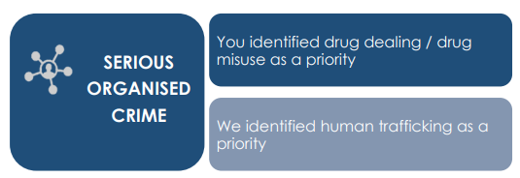 | Our community police team have been maximising their presence across Helensburgh and Lomond. They have created and enhanced new local links with partners from housing, RNP, Live Argyll.  The officers are tasked daily with supporting the local community where it is needed most.  PC Haining has been working with Live Argyll to support a diversionary and supportive programme for young persons in the grounds of Hermitage Academy on Friday evenings. As well as this PC Haining has been leading the Police Scotland Youth Volunteers at various events. These experiences have not only supported local communities but provided these young persons with valuable development and evidence for future employment. | Your local police would like for your Community Council to help us with tackling Drug related crime by reporting any suspicions you may have either in person or anonymously via 101 or via crime stoppers online:  Crimestoppers in Scotland | Crimestoppers (crimestoppers-uk.org) 0800 555 111
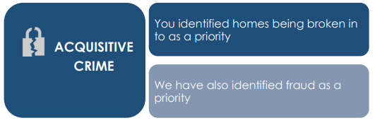 | Acquisitive crime remains a local priority. Figures across the country are on an upward trajectory, which in part is a result of the cost-of-living crisis. We are working with our Preventions team looking at maximising our crime prevention opportunities and looking at innovative ways to increase local awareness.  We are working with our communities to identify areas of vulnerability where we can engage with our partners to maximise our response.  In Helensburgh Our community policing officers are engaging with local businesses in the retail sector to reduce shoplifting. Officers are taking ownership by identifying those responsible, collating information and seeking bail conditions restricting access by the perpetrators.  Theft of fuel from petrol stations continues to be an increasing trend. Along with our preventions team we are supporting local business to ensure that we are proving crime prevention advice and seeking local business to review practises to reduce the volume of these crimes. | Your local police would like for your Community Council to help us by following us on our social media channels and help us spread crime prevention advice and guidance.

Local Policing Priority | Local Good News | How can you help?
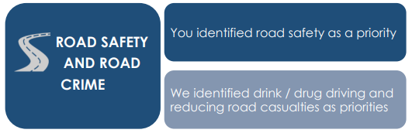 | Road Safety remains a local policing priority across Argyll & Bute. We have been working closely with a host of partners delivering various initiatives and events to improve decision making and influence driver behaviour across our communities. For example, at the end of April this year, within the grounds of Hermitage Academy we hosted an event where our communities are encouraged to attend to hear and learn from driving specialists and health professionals. These events have had great feedback and really help us to influence driver behaviour. | Your local police would like for your Community Council to help us with ensuring Road Safety by  by reporting anyone who is suspected of drink or drug driving within your community either in person via 101 or via crime stoppers online:  Crimestoppers in Scotland | Crimestoppers (crimestoppers-uk.org) 0800 555 111
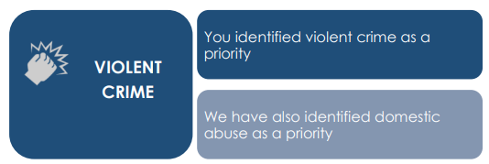 | Violent crime continues to be closely monitored and reviewed with investigations being resourced across Local Policing Teams and the Criminal Investigation Department. Each crime is subject of daily review and scrutiny and thereafter allocated to the most appropriate department to progress to assist in identification of repeat victims, offenders and locations. Any emerging issues and risks are shared, and appropriate actions identified  Across Helensburgh and Lomond, we continue to support our nighttime economy by providing a visible presence in our licensed premises. Weekend policing plans allow us to maximise our efforts across our towns as we look for opportunities to reduce early signs of anti-social behaviour which may escalate into violence. We often work with partners to maximise our presence.  In Helensburgh the Royal Navy Police have been attending shift meetings learning about priority tasking and supporting local policing across the town. | Your local police would like for your Community Council to help us with tackling Violent Crime by reporting any ASB or community concerns either in person via 101 or via crime stoppers online:  Crimestoppers in Scotland | Crimestoppers (crimestoppers-uk.org) 0800 555 111
 | Throughout the summer months, we have been engaging with partners across various organisations to consider how we can work together more efficiently to tackle the seasonal Anti-Social Behaviour that we often see.  We have a team of 3 Local Community Officers who work from Helensburgh who are the eyes and ears for the local community. They aim to:  - Build positive relationships with local business and community.  - Engage with and support night-time community  - Robust ASB plans at the weekend  - Not solely for the town centre and will ask them to patrol small villages across area | Your local police would like for your Community Council to help us with helping Public Protection by reporting any concerns you may have regarding potential victims of Domestic Abuse or vulnerable persons, who may be being exploited or who may just need additional crime prevention support to us either in person or anonymous

Useful Links/Contacts

- Argyll and Bute Communtiy Directory - https://abcd.scot/ including warm spaces information
- Crimestoppers – Crimestoppers in Scotland | Crimestoppers (crimestoppers-uk.org) 0800 555 111
- Scottish Partnership Against Rural Crime – www.scottishparc.co.uk
- Women’s Aid - Home - Women's Aid (womensaid.org.uk)
- Citizens Advice – 0808 164 6000
- Argyll and Bute Council Trading Standards – 01546 605 519
- Argyll and Bute Council – https://www.argyll-bute.gov.uk/my-council/how-contact-us
- Transport Scotland – road related incidents and road closures - https://www.traffic.gov.scot/traffic-information/incidents
- Scottish Water - https://www.scottishwater.co.uk/Help-and-Resources/Contact-Us 0800 0778 778
- NHS24 (including mental health support) – 111 or https://www.nhsinform.scot/

Follow us on Social Media and help share loacl appeals and education messages
- Facebook - Police Scotland Argyll and West Dunbartonshire
- X (formerly Twitter) – PSOSArgyllBute and PSOS ArgWestDunb

Sign up to Neighbourhood Watch to receive local alerts and bulletins for your community area - https://neighbourhoodwatchscotland.co.uk/#0

Have your say on your local policing priorities - https://consult.scotland.police.uk/strategy-insight-and-innovation/your-police-2023-2024/

Please Contact the officer below with any feedback or concerns raised at the meeting for further considerations or police action.

Report Completed by | PC Ailsa Gill and PC Cameron Macpherson
Contact | Email Adress Ailsa.gill@scotland.police.uk cameron.macpherson@scotland.police.uk

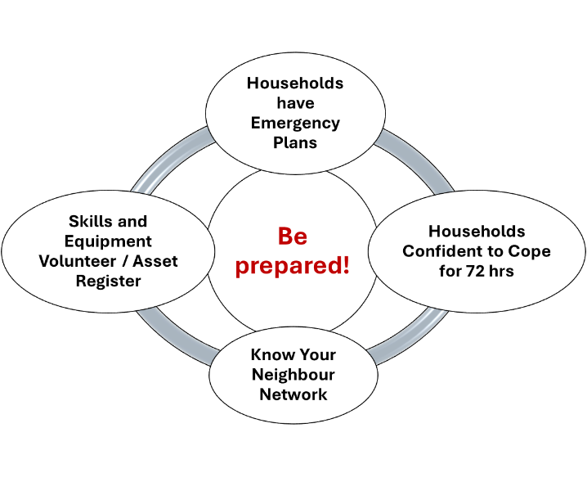
CHEP DRAFT OUTLINE PLAN August 2024 – December 2025
To support the ongoing work of the Community Council on Community and Household Emergency Planning this is an ‘outline’ plan for the work over the next 17 months. This plan may change depending on opportunities and challenges during this period. Reports will be made to the community council at its regular meetings.

Points to Note
- The award from the Argyll & Bute Supporting Communities Fund is for £2200 of which £1000 is for the partnership with the Kilcreggan School (as a donation). Will need to agree requirements for financial accounting with treasurer;
- We have printed material available from the NCR grant which we will use for leafleting / flood risk mapping and for publicity.
- The award goes to the Community Council and can only be used for the proposal (previously circulated to the CC members).
- CC member volunteers to support the task of organizing work will be required to supplement wider volunteer network.

Seven strands of work (which will operate in parallel)
- Increasing ‘Confidence to Cope’ through Informal events in both villages. This uses the ‘bus shelters’ and sits alongside household leafleting in September 2024 for Winter Preparedness. We will also include additional work on information sharing through the website, Facebook and non-electronic means;
- Building the volunteer network across the two villages and on the Rosneath Peninsula;
- Working in partnership with Kilcreggan School to build the confidence of young people and their families – including attention on those individuals and families with specific needs;
- Working with local businesses, including tourism / residential centres, to build their resilience to challenges such as 72 hr power cuts and/or flooding, in a way that reduces the risks to local services and visitors;
- Mapping of areas floods are occurring (usually surface water run-off but may include coastal flooding) – using both Facebook and the website for photographs and other documentation. These will be used to increase local awareness and to share with A&B Council and other stakeholders – including land-owners and householders so that respective roles and responsibilities are clearly understood. We will use the Community Map Scotland software to map this based on the use of a ‘banner map’ of the Peninsula to enable effective community engagement.
- Working with local SFRS around a site for sandbag management and ensuring clarity around the roles and responsibilities of statutory and voluntary inputs in an emergency;
- Link into wider networks around Civil Contingency Work and building Resilience – including in social care/ medical services / pharmacy (Business Continuity) to enable learning around best practices. This could include work with neighbouring Community Councils – especially Garelochhead and Rosneath & Clynder – given the likely shared issues in a widespread weather event.

Key Dates for each strand
Strand 1 – Confidence to Cope and Winter Preparedness September – December 2024
- Leafleting (volunteers required)
- Informal meetings in Cove and Kilcreggan
- Use of website and Facebook so ‘spread the messages’
Strand 2 – Building the volunteer network September 2025 – December 2025
- Linking in to volunteers and understanding the where, what and how of this work
Strand 3 – Partnership with Kilcreggan School August 2024 – December 2025
- Meeting held on 21st June (prior to school holidays with Headteacher
- Work with children: Two phases. First in 2024 between late October and December 2024. Likely presentation of work on 4th December. Second phase in 2025.
- Resilient School: Focus on two areas with first in relation to School operations (linked to the Critical Assessment Risk Plan (CARP) of Argyll & Bute and second in relation o School as Place of Safety in a widespread emergency.
Strand 4 – Local businesses, tourism and residential centers September – December 2024
- Discussions with local businesses (shops etc.) about their plans for an emergency
- Discussions with tourist businesses / residential centers regarding their plans for emergency management that does not increase the strain on local services (clarity on the what, where, how……) for their guests / residents.
Strand 5 – Local flood risk mapping – September 2024 – March 2025
- Using large scale map note where there have been recent floods and where local residents are increasingly concerned about flooding. (? Use the CBH Open day as a first step here based on what is already known from discussions with residents and actual floods e.g. on 7th October 2023)
- Set up a ‘layer’ on the CMS software regarding flooding over winter 2025 – using Facebook for reporting, including where possible photographs.
- Increase awareness of roles and responsibilities of different agencies, landowners, householders etc for riparian system management (material already on Facebook / website).
Strand 6 – Working with local SFRS around sandbag management. September 2024 – March 2025
- Establish with the local SFRS a secure site for storage of sand / sand-bags in the event of local requirement. Options and protocol for access.
Strand 7 – Link into wider networks. September 2024 – December 2025
- This will be opportunistic both in relation to training opportunities, meetings, sharing of experiences etc.
- Link with A&B Council Civil Contingency Unit, HSCP, Medical Centre, Pharmacy, First Responders etc.
- Could include work with neighbouring CCs in 2025 to share experiences as issues such as flooding on the peninsula do not affect C&K alone.

Proposed Giant’s Burn Wind Farm
Firstly apologies that I am not presenting this in person. At our last CC meeting it was proposed to have a small group to look at the pros and cons of the proposed wind farm at Giant’s Burn on the Cowal Peninsula. I am not going to present arguments for or against at this point, except to say that as the National Air Traffic Service (NATS) is intending to object to the proposal, I do not see it going ahead. That said, those who oppose the development should not be relying on a third party to object, no matter how powerful their objection would be.
As I said at the previous meeting I am neutral on wind farms, therefore I am suggesting a group of three or four other folks who are also neutral to form a working group to try to ascertain the thoughts of the community. As funds will not cover a proper survey, we will have to come up with a few different ways to engage with the community on this matter.
As well s using social media, one way would be to invite Statkraft to a public meeting. A short presentation would be followed by an Q&A session. At that meeting there could be a confidential ballot for or against the proposed development. Another place to start would be to speak to those involved in the former proposal for a wind turbine here on the peninsula.
Our working group would also consult with the other CCs involved, namely, Dunoon, Hunter’s Quay, Kilmun, Sandbank and South Cowal.
I look forward to working with the others on the group.
Christine Murdoch

See the Scottish Government scheme: https://www.ruralpayments.org/topics/all-schemes/agri-environment-climate-scheme/
See for instance https://framework.roadsafety.scot/info_hub/scotlands-national-strategy-for-20-mph-speed-limits/#:~:text=The%20Scottish%20Government%20is%20committed,but%20pedestrians%2C%20cyclists%20and%20communities.

