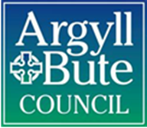

Argyll and Bute Council– advice and assistance in the Cost of Living Crisis

The council and partners are working to support people and businesses affected by the cost of living crisis in Argyll and Bute.
Please find here a summary of that work, the sources of help and advice that are available and please feel free to share this with third parties and other organisations.

DETAIL

Argyll and Bute’s island, rural and mainland geography brings additional cost to our citizens’ day to day lives (as highlighted in a report to Council on 29th September). For fuel costs alone this means that 70% of our households are at risk of fuel poverty or extreme fuel poverty; impact on additional key areas of living are outlined in the graphic below and at the end of this information note.
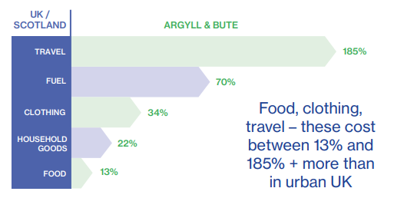

Working with partners to support people and businesses

The council’s FIAG group (Financial Inclusion and Advice Group) brings together council services and support agencies. To make it as easy as possible for people to get support when they need it the council provides a ‘one-stop-shop’ of information on our website to provide key information and also help and information on money saving initiatives such as cheaper deals for internet connection and the availability of warm spaces provide by other organisations: www.argyll-bute.gov.uk/advice-services
We summarise below some of the help available.

Fuel
- FIAG brings together different sources of support specifically with fuel costs on our website: Heat your home - managing rising costs (argyll-bute.gov.uk). This includes information about warm spaces –
https://www.argylltsi.org/warmspaces.html

Money
- Bute Advice Centre and ALIenergy produced a booklet highlighting financial support services available across Argyll and Bute. This includes for example maximising income, foodbanks, energy and budgeting advice. It has been widely circulated to Elected members, across the NHS, Schools, support agencies and is available on the Bute Advice Centre website.
- Argyll and Bute Scotland Loves Local Gift Cards The Council is rolling out an initiative to provide £120 gift cards to around 6,650 Council Tax Reduction recipients. This will support households on low incomes and the local businesses registered for the card.
- The Council is looking at a proposal to develop Welfare Rights & Health Partnerships in Argyll & Bute. The pilot is looking at 5 practices within Mid-Argyll, Kintyre & Islay where the Council would embed Local Authority welfare advice specialists within the practice’s healthcare setting for an average of one day per week per practice.
- Data mining to identify benefits eligibility and maximise household income The Council’s Data Advisory Group is working on matching data from relevant council systems to identify unmet benefit eligibility so we can support eligible households to maximize their income.
Food
- Flexible Food Fund: The Fund provides a one-off cash payment to families on low incomes to help with food and fuel. The size of the payment is based on their household composition. Claimants are offered a second cash payment if they have engaged with support agencies, the Bute Advice Centre and ALIEnergy, in financial management. The project achieved national acclaim in October 2021 for Excellence in Innovation from the Institute of Revenue Rating and Valuation. Over 96% of people receiving the first grant payment engage, get the support they need and get a second payment; applicants, through different routes, have received a total of £2 million they could otherwise have missed out on.
- Food banks: there is a list of food banks on the council’s website
Clothing
- Preloved School Clothing Project. The Council and its schools are working with community groups to give every child in Argyll and Bute access to a school uniform, by developing a uniform re-use scheme. There is a reused school uniform hub in Helensburgh, one nearing completion in Campbeltown, and work in in planning for schemes for Dunoon, Rothesay, Oban and Lochgilphead, Tarbert, Islay and Mull.
Support
- Additional funding for advice agencies. The Council has provided £40,000 in funding to ALIenergy, Bute Advice Centre and the Argyll and Bute Citizens Advice Bureau to help them meet increasing demands from the public between 1 April 2022 to 31 March 2023.
- Anti-poverty training. The Poverty Alliance has delivered training across the Council and Community Planning Partners on anti-poverty actions and this will be extended to elected members on 30 November.

Promoting information
- The Council’s Communications Team is already using social media and also statements provided to local press in the area to reach groups and individuals who perhaps don’t use social media to make people who need it, aware of support available, using for example digital and traditional media channels, and word of mouth, inviting the help of Councillors, council employees, partner agencies and the public in passing information on, via whatever channels they have, to people who need it.

Please use the information and links above and pass to those who need it.

Remember key information and links to other advice and assistance can be found at:
www.argyll-bute.gov.uk/advice-services

Heat your home - managing rising costs (argyll-bute.gov.uk).

